Young Leaders training 2025: Session One
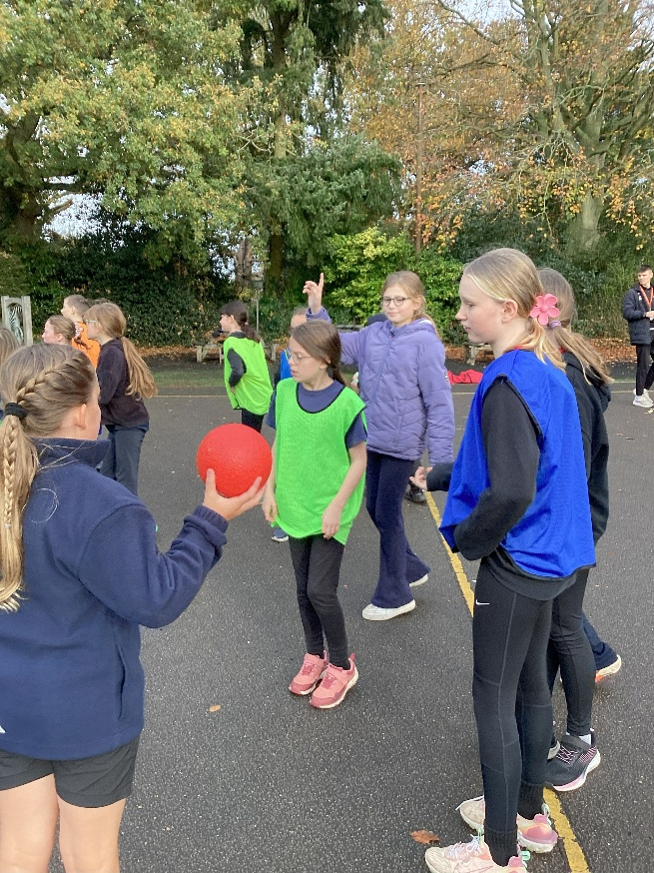
On Tuesday 11th November, Class 4 children began their Young Leaders training.
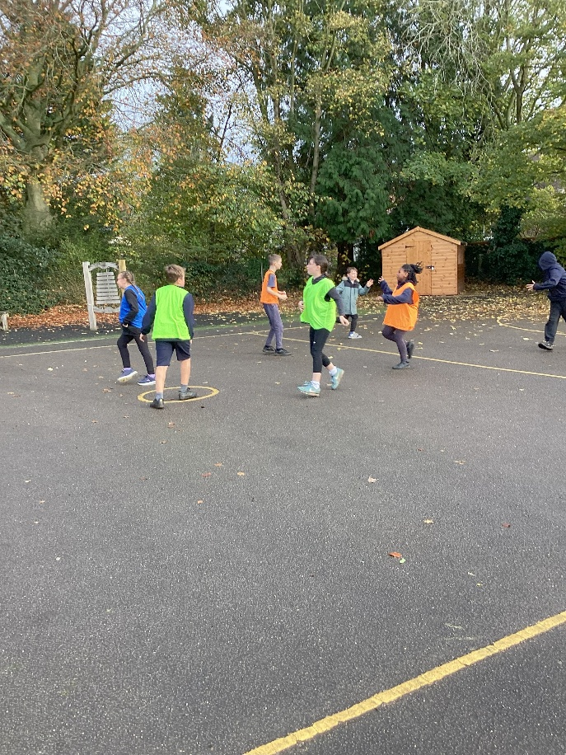

Shaun from Alive Leisure at Lynnsport came to run the session. He began by asking the children to consider good leadership qualities and to share their hopes and aspirations for the course.
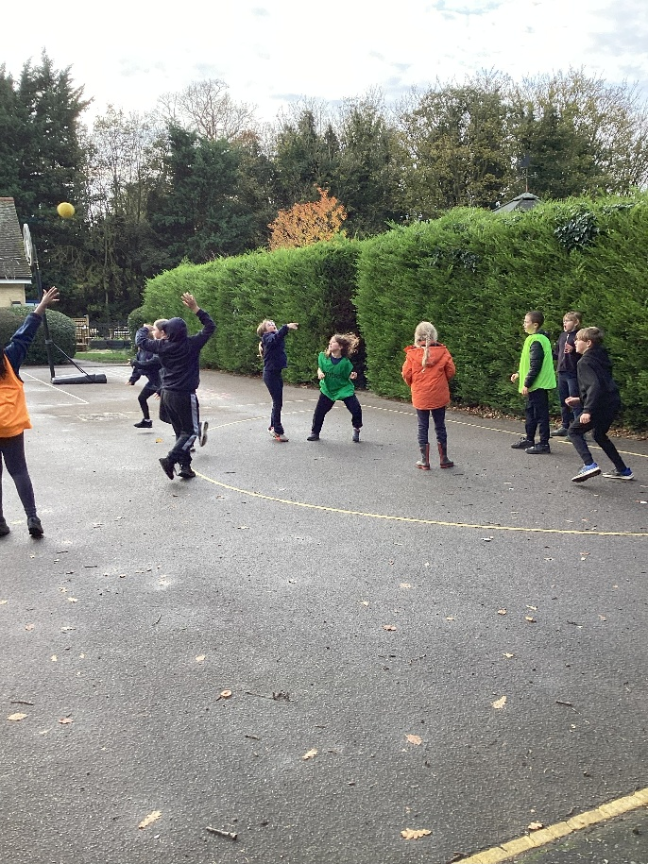
The main activities in this first session focused on participants. Shaun taught the children a game and talked through how he led and managed the people playing the game.
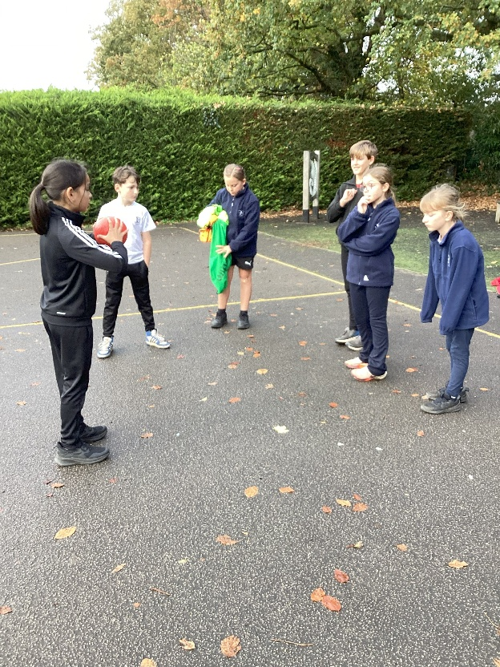
Then the children were put into groups of three and tasked them with organising six other children into teams and clearly explaining how the game was played. They then had to make sure that they kept the game flowing and bringing the game to an end.
At the end of the session, the children reflected on what they had learnt.


