Fitness Tracker Training 2025
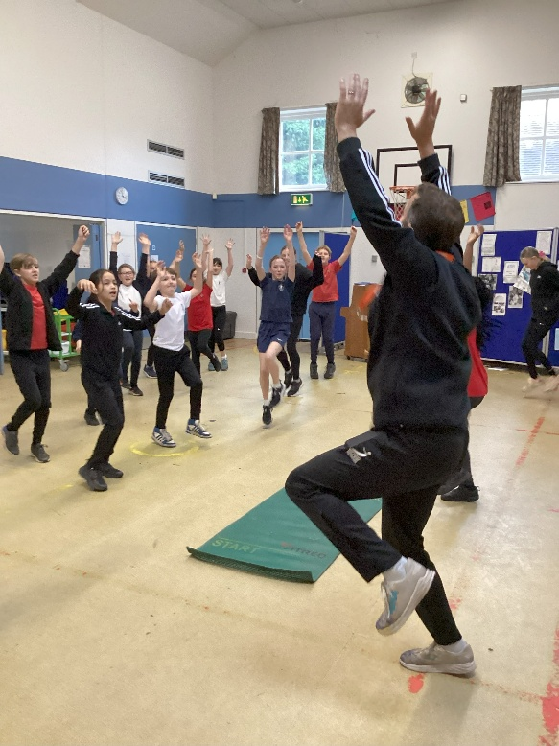
On Tuesday 11th November, Classes 3 and 4 were joined by Gary Hawkins from West Norfolk School Sports Partnership to begin Fitness Tracker challenges. On this initial visit the children were measured for their abilities in throwing, jumping, agility and flexibility. Class 3 then completed an endurance challenge around the Daily Mile track. He was impressed by the high level of skills displayed by many of the children. Class 4 ran out of time to complete all of the challenges so Gary will return to finish these very soon.
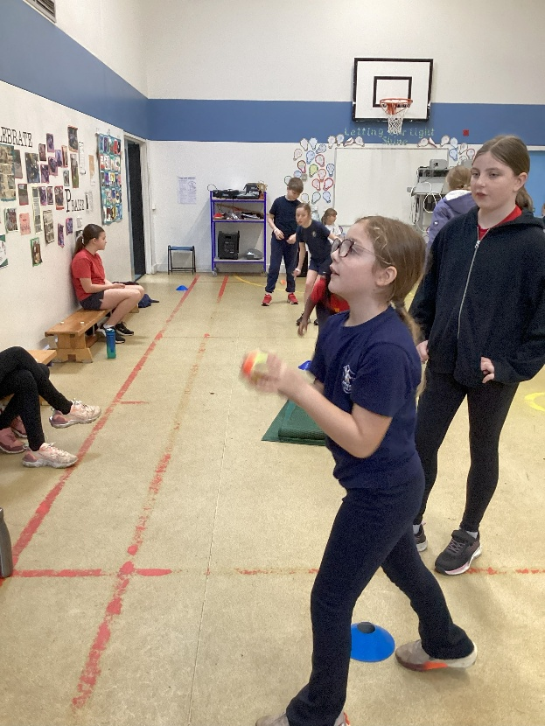
Following on from Gary’s visit we will be given a record of our current personal bests. Gary will set some training tasks to do that will support us in beating these when he next visits at the end of the academic year. The children will retake the challenges to see how much they have improved in each of the areas. We look forward to being able to improve our fitness and ability across the range of fundamental movement skills for sports.



