Downham Market Cluster Football Tournament
Having been postponed due to Storm Benjamin, the cluster football tournament for years 5 and 6 finally took place on Thursday 13th November on what was fortunately a lovely late autumn morning.

The school entered two teams: Denver Dynamos (light blue) and Denver Rangers (dark blue) . Each team played in a round robin against the other teams.
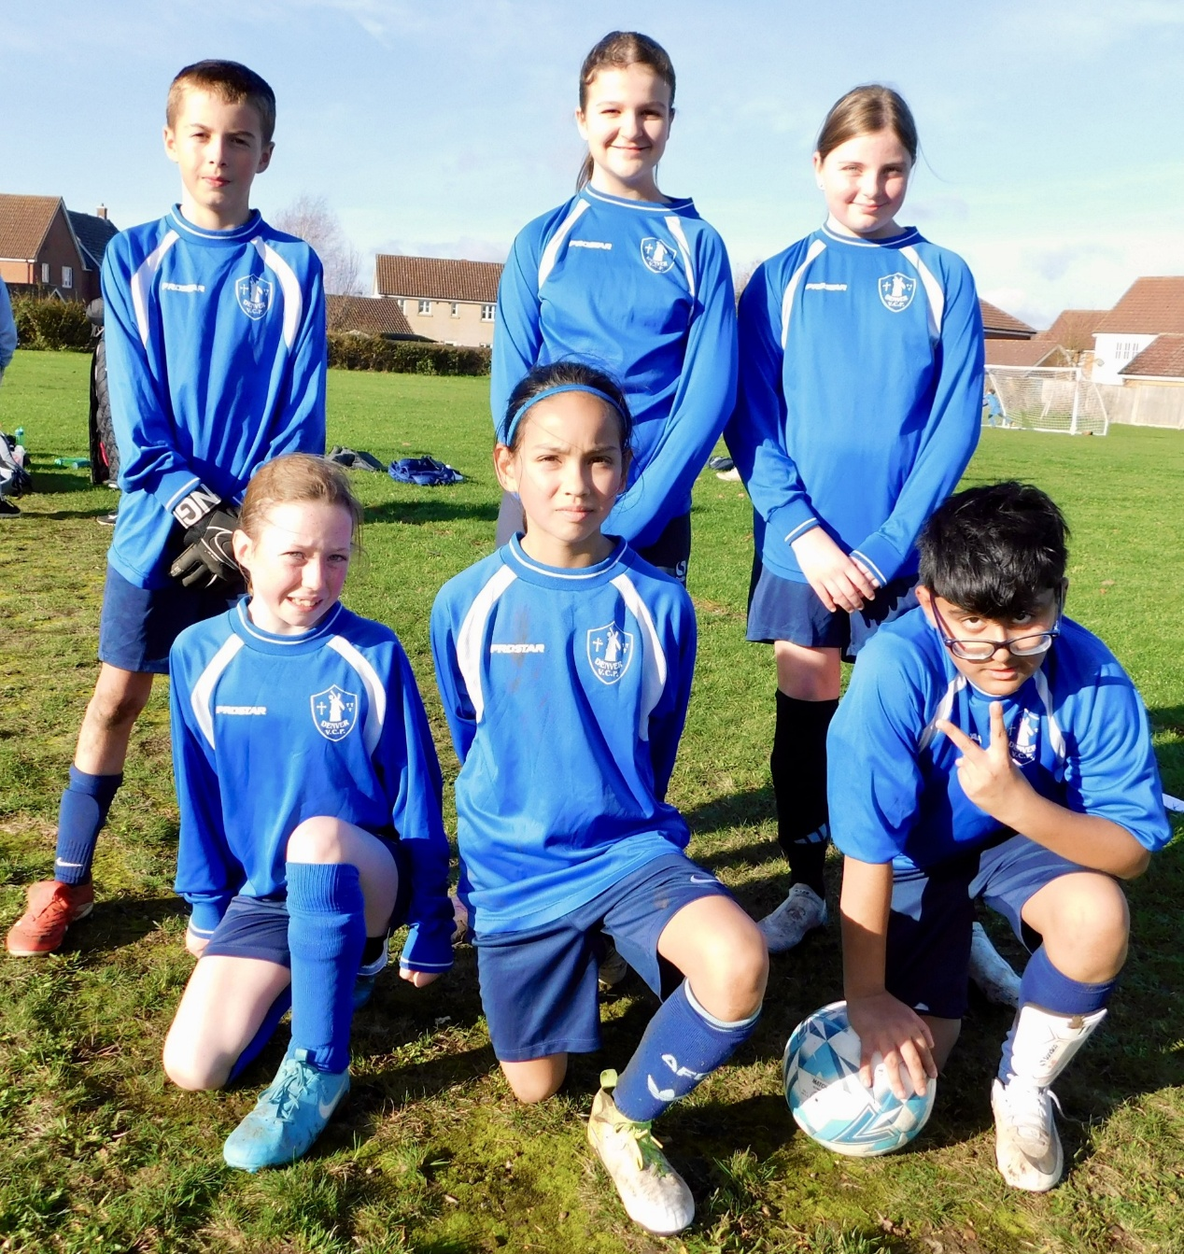

The final outcomes were Denver Dynamos in 3rd place and Denver Rangers in 6th place.
The children let their lights shine with their efforts and sportsmanship. We are very grateful to Miss Boddy and Mrs Stansfield for supporting the visit. Well done!



