Music Workshop
On Wednesday 5th November, we were treated to a special whole school music workshop by Rosie and Gemma from the Benadetti Foundation.
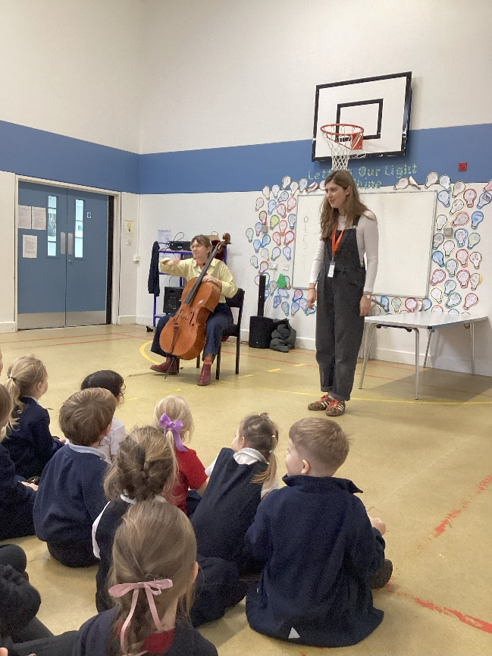
We gathered in the hall where they warmed us up by creating sounds using body percussion.

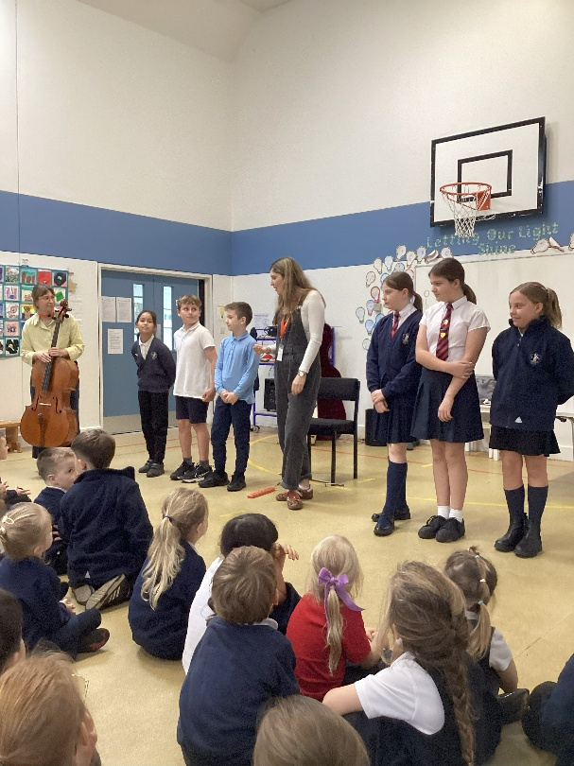
Rosie then played a piece on her cello by the composer Giovanni Solomon. We had to listen carefully to work out how many stages there were to the piece and think about what story might be being told by thinking about the emotions the music made us feel.
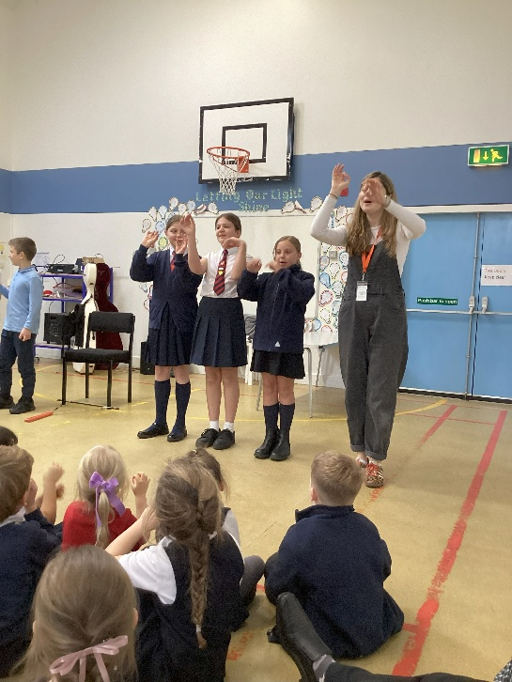
The next activity was to use body percussion to create a musical storm scene. Gemma taught us a song about a storm which we then sang in rounds with leaders from Class 4 at the front guiding the people on their side of the hall in when it was their turn to sing.
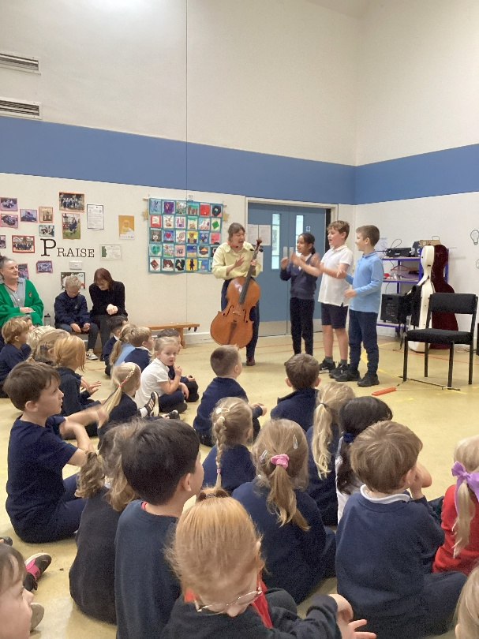
It was an enjoyable and interesting workshop. Thank you to those who made this possible.

