Bikeability training 2025
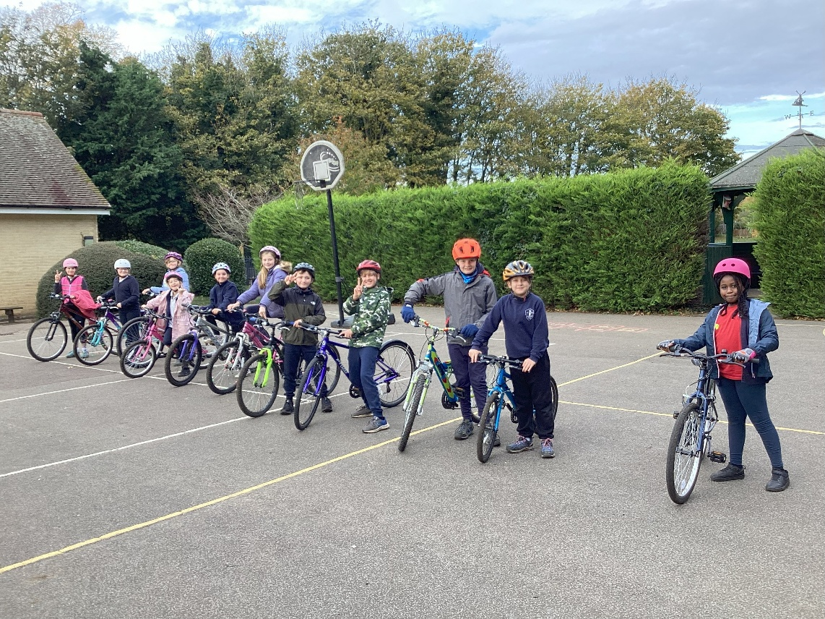
Trainers from Outspoken Training visited the school from Monday 3rd November to Thursday 6th November to carry out Level 1 and Level 2 cycling proficiency training.
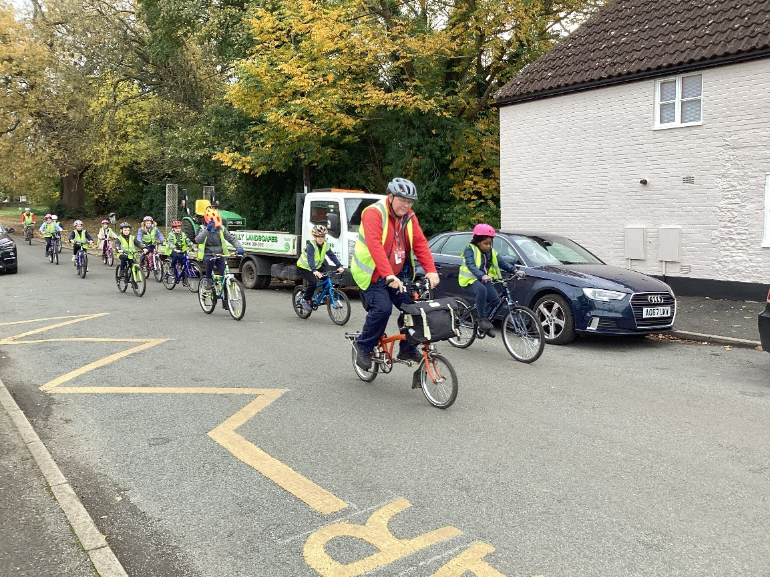
Most children from Year 5 took part. The first morning was spent on the school grounds to achieve the skills for Level 1.
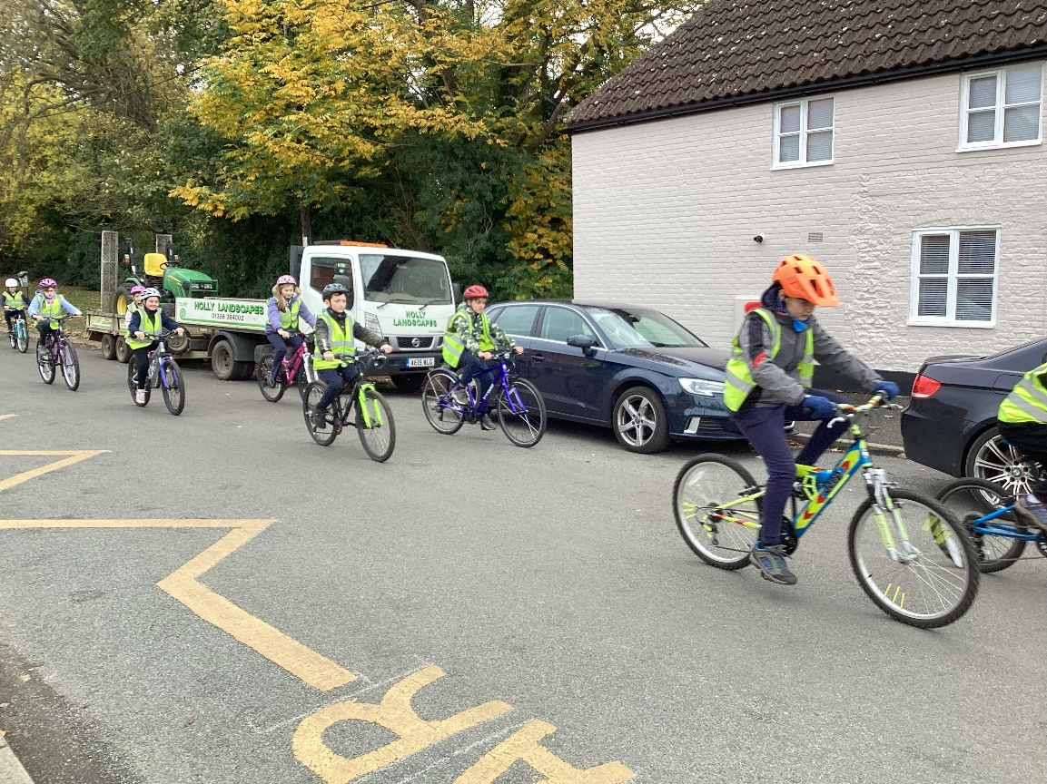
Successful completion of this enabled the children to progress to Level 2 training on the road by the school.
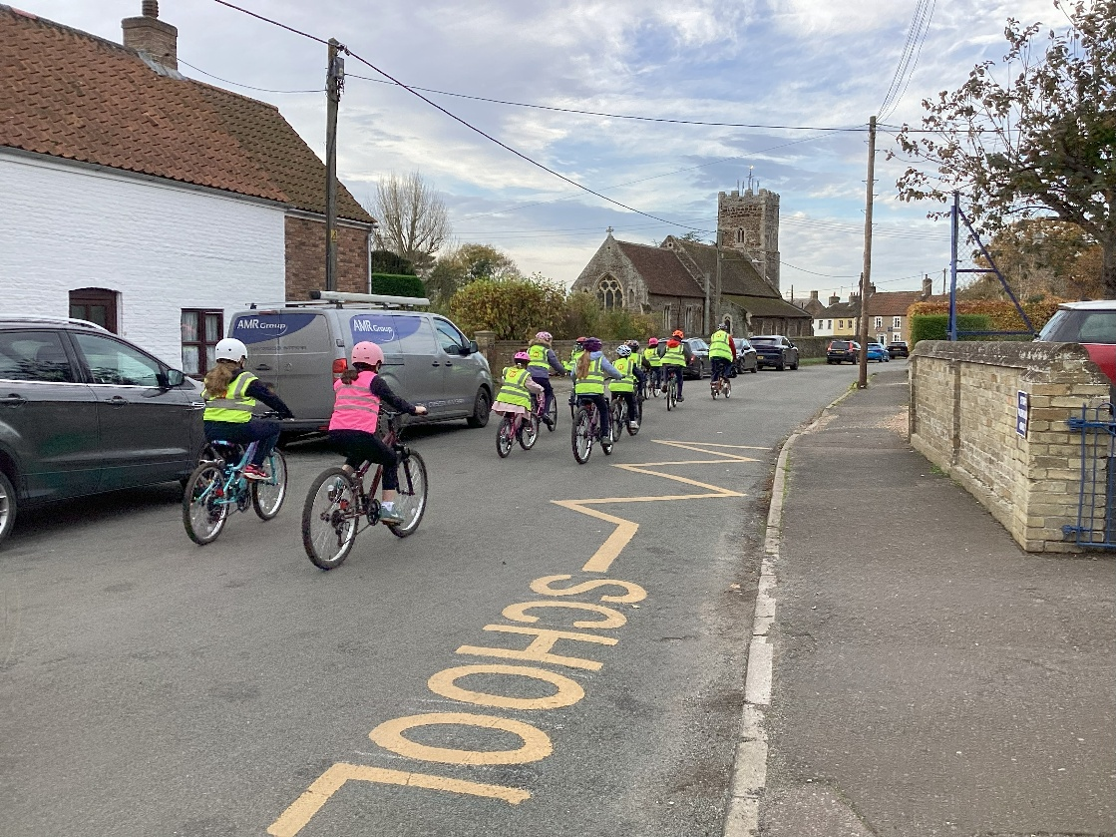

The third and fourth days of training, once confidence and skills had been developed, saw the children using busier roads.
The children are now much more confident in making safe manoeuvres when out on the roads, in their road safety awareness and how to maintain a bike.
Well done to everyone who took part. We look forward to welcoming our trainers back next year.

