Downham Market Cluster Cross Country 2025
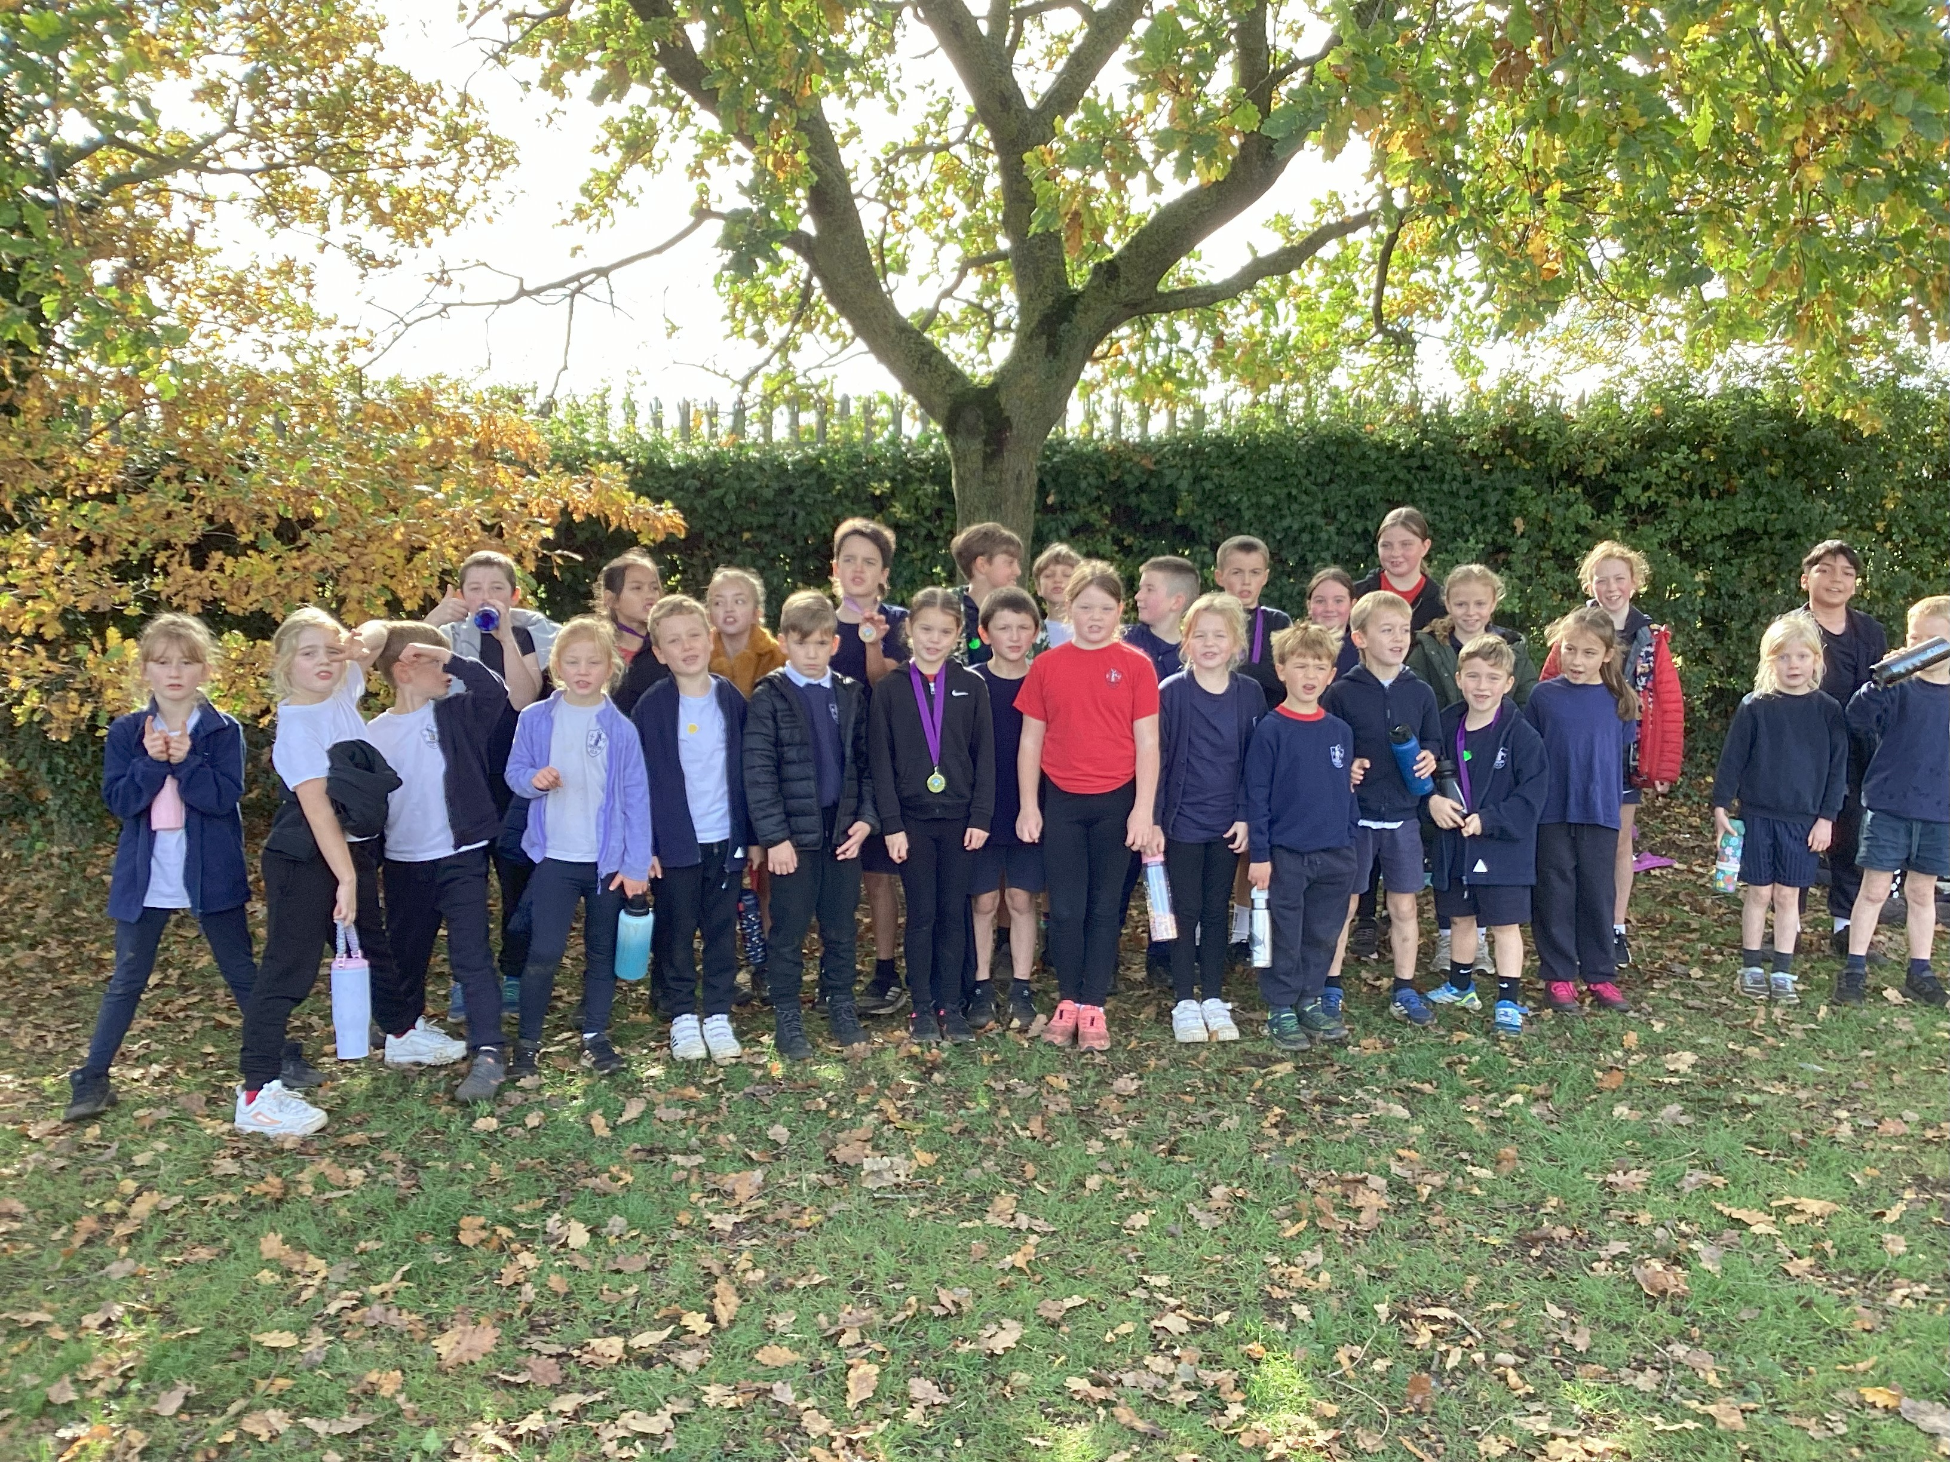
On 21st October, 29 children travelled to Hillcrest Primary with Mrs Henden and Mrs Williamson for the annual cluster cross country event. These were the children that had achieved a top three finish in the school’s own cross-country festivals held within our classes earlier this month.
Just as in the most recent years, numbers attending from across the cluster were high. Year 2 pupils raced 500 metres, years 3 and 4 raced 1000 metres and years 5 and 6 raced 1500 metres.
A top ten finish in the event for children in Key Stage 2 gave automatic qualification to the next round, the SSP area finals to be held at Lynnsport Dutton Pavillion on 10th November.
Congratulations to our 11 qualifiers:
Eve (Y3)
Finn (Y3)
Monty (Y4)
Libby (Y4)
Rebekah (Y4)
Oliver (Y4)
Bryn (Y4)
Osian (Y5)
Lauren (Y5)
Isla (Y4)
Chase (Y5)
Esther (y6)
Children in Year 2 were once again able to compete at cluster level and we had excellent results with Elizabeth in 5th, Esme in 8th and Mae in 19th. In the boys event, Max came 3rd, Sammy 4th, Jack 5th and Ralph 12th. Great potential for next year! Well done!

A special mention to our medallists with Libby getting gold for Y4 girls, a silver medal for Chase (Y6 boys) and bronze medals for Lauren F (Y5 girls), Monty (Y4 boys) and Max (Y2 boys). Congratulations!

We are proud of everyone who took part today. Great running!

