International Space Week
To mark International Science Week 2025 and in conjunction with our learning in RE about the links between science and faith (and theories about creation), Class 4 children watched a webinar by astrophysicist Victoria Loddon.
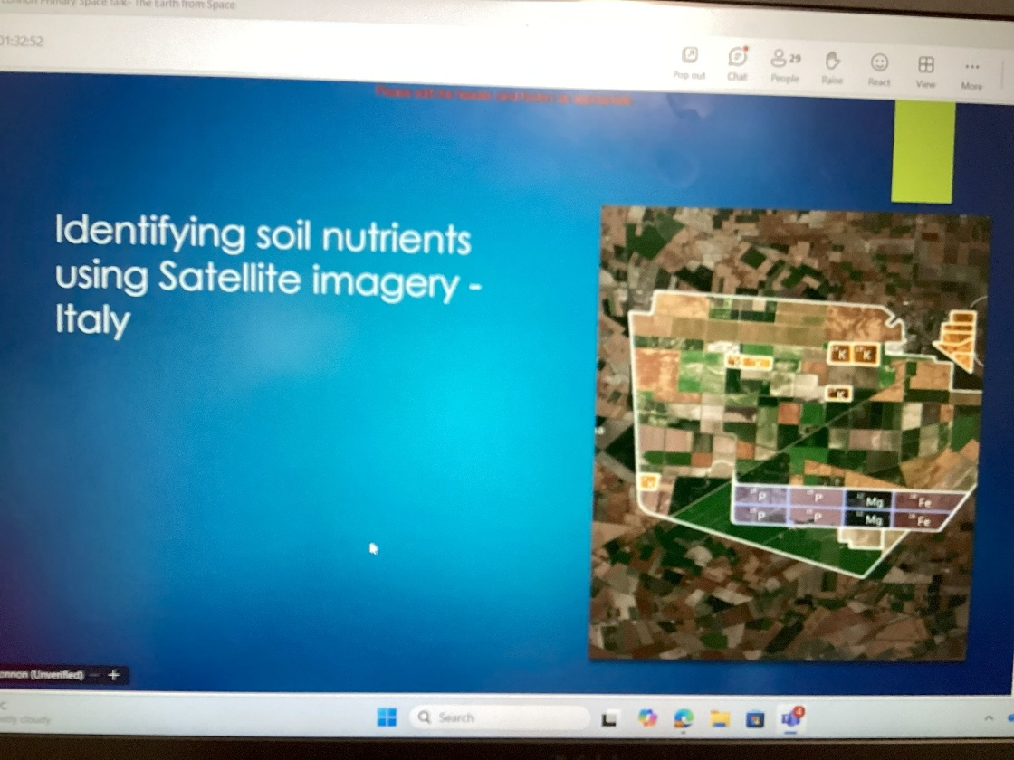
The webinar was called ‘Earth from Space’ and covered the topic of how satellites support life on the planet. This links to the Christian idea that humans are the custodians of God’s creation and how the work of space scientists have a role in this.
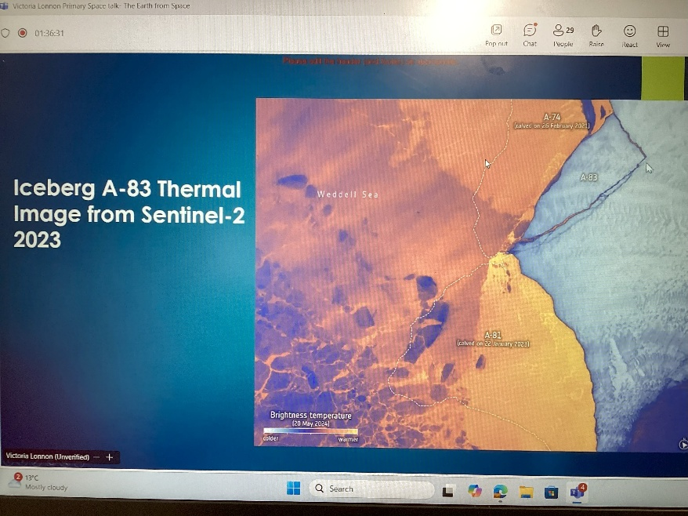
We learnt that satellites are used to track wind and weather patterns so that people can be better prepared for forthcoming storms. The satellites also help people to understand where wildfires will spread to so that people can safely evacuate. It also helps firefighters to know where to focus their energy. Satellites that study soil quality enable scientists to support farmers in growing crops for harvest to ensure that living things have adequate supplies. It also helps to prevent areas of land becoming a desert because of over farming.
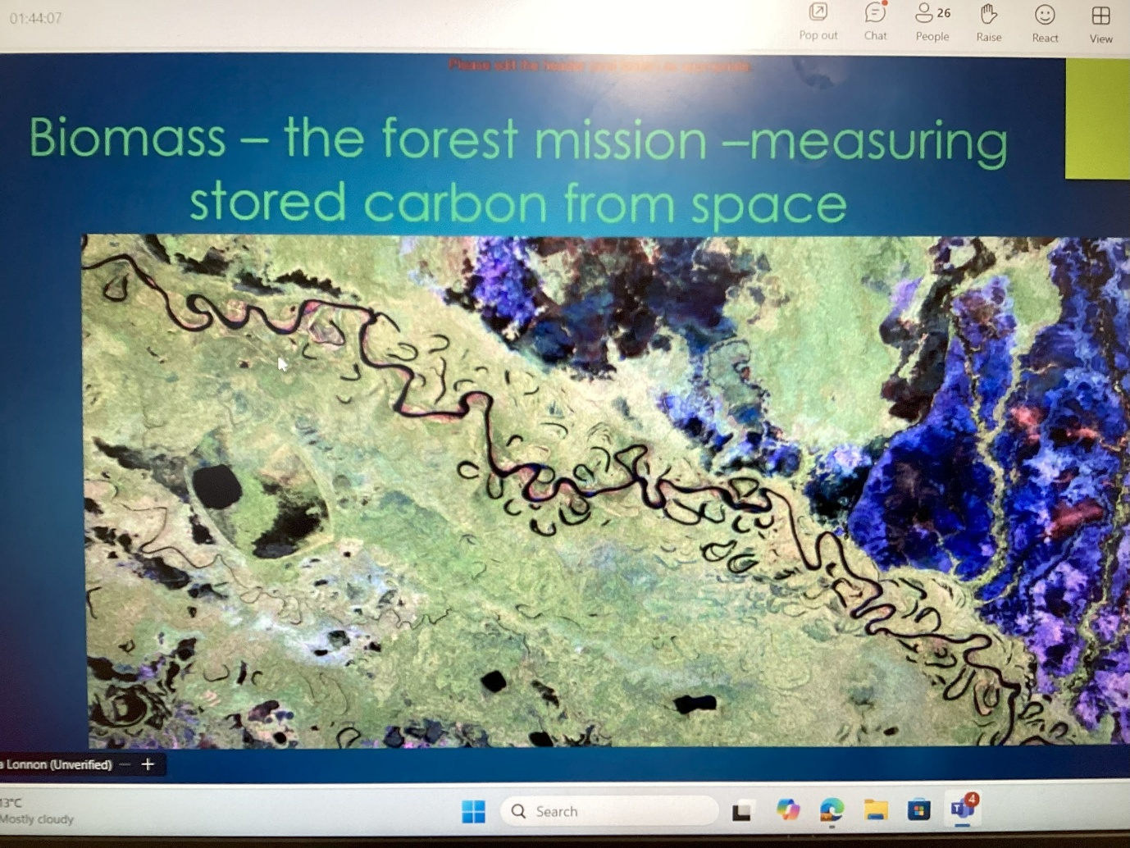

We also found out that satellites can track where masses of water are gathering so that they can be drained off before they end up causing landslides or floods.
Space scientists also have a role in protecting the planet from the effects of climate change by actively finding ways to reduce carbon emissions. They use their satellites to track methane levels around the globe so that things can be done to bring levels under control in fighting global warming. They also keep track of icebergs and icefields which can raise sea levels and temperatures leading to loss of habitats from flooding.

