Key Stage 2 Visit to St Mary’s, Denver
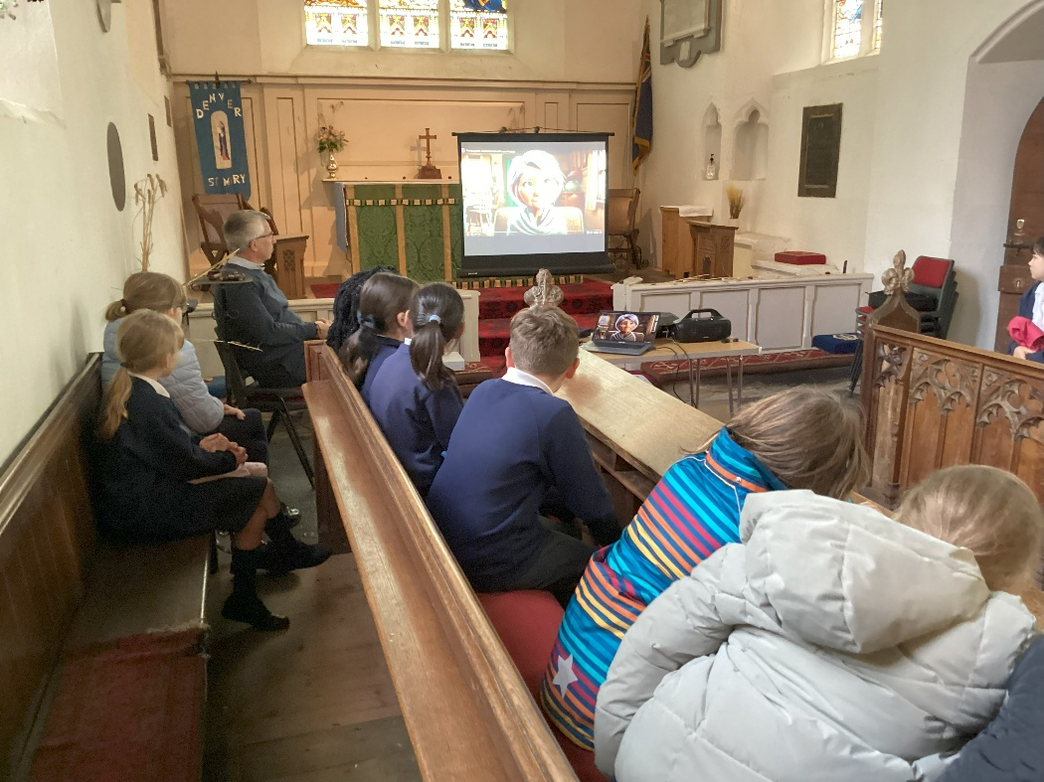

On Wednesday 15th October, collective worship for Key Stage 2 took place at St Mary’s church in Denver. 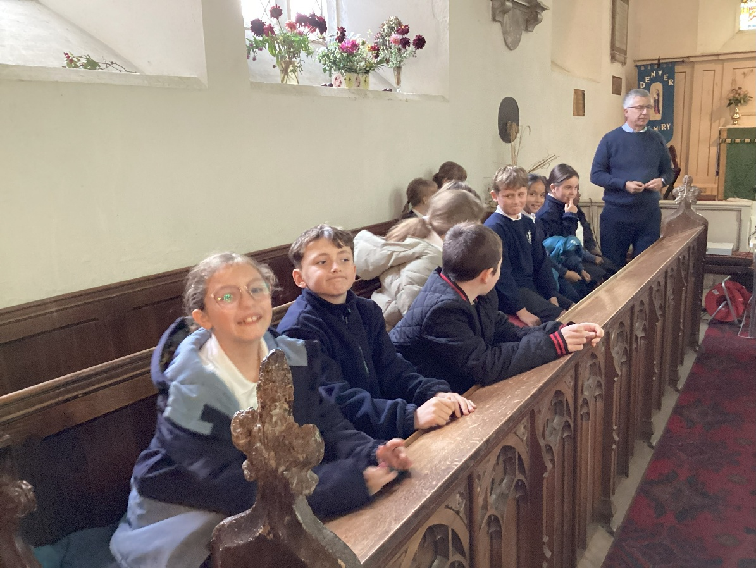

The children enjoyed having collective worship saying that it felt more special and more memorable being in the church.
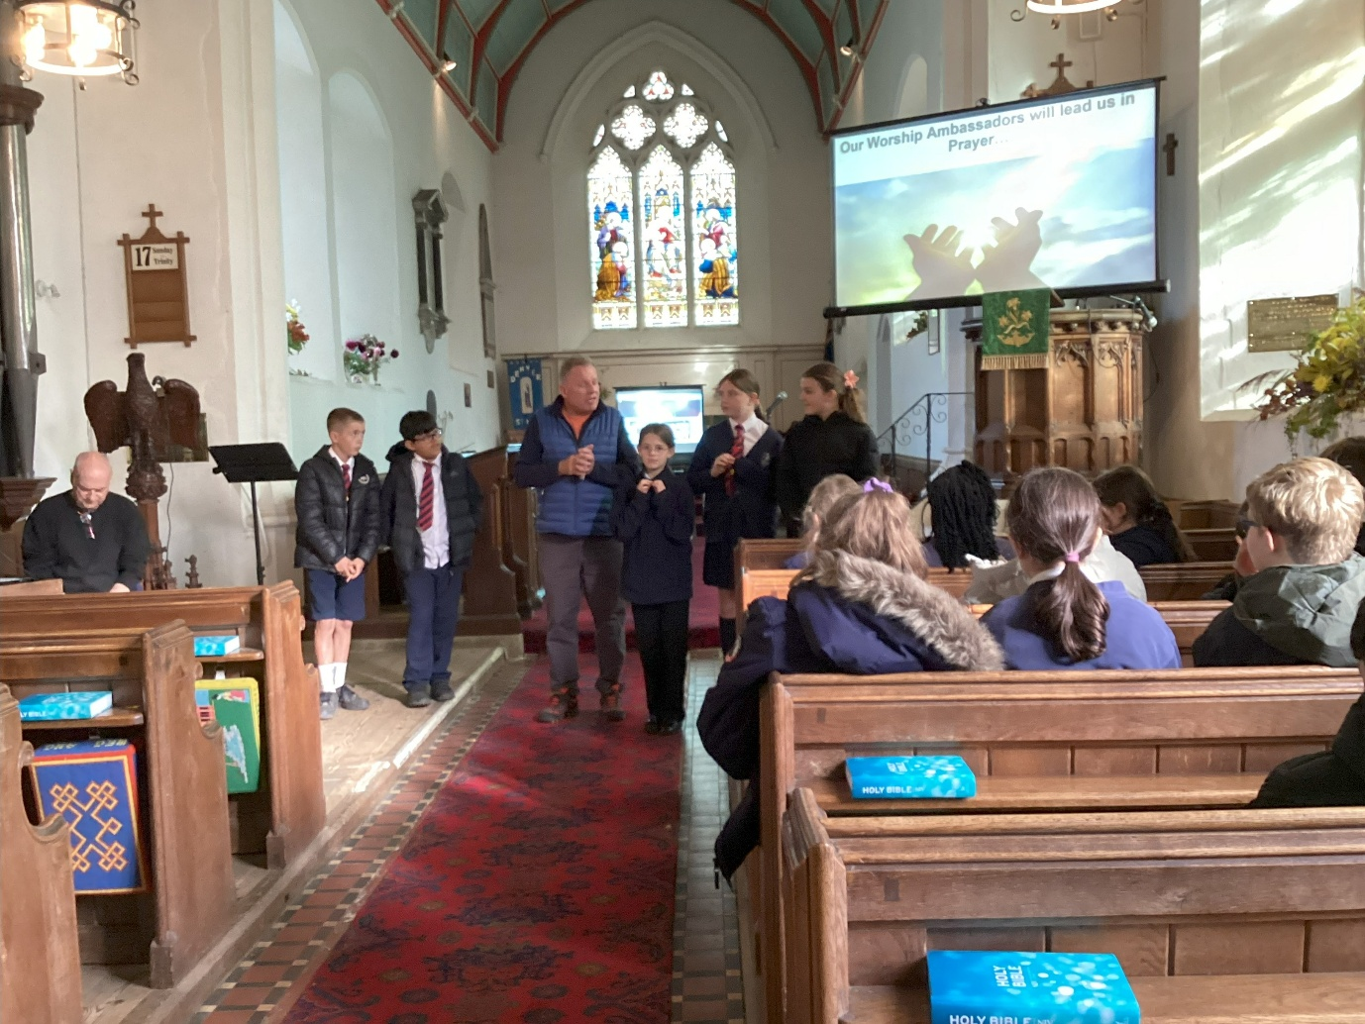

We look forward to further visits in the coming terms.

