Class 4 cross-country intra-tournament
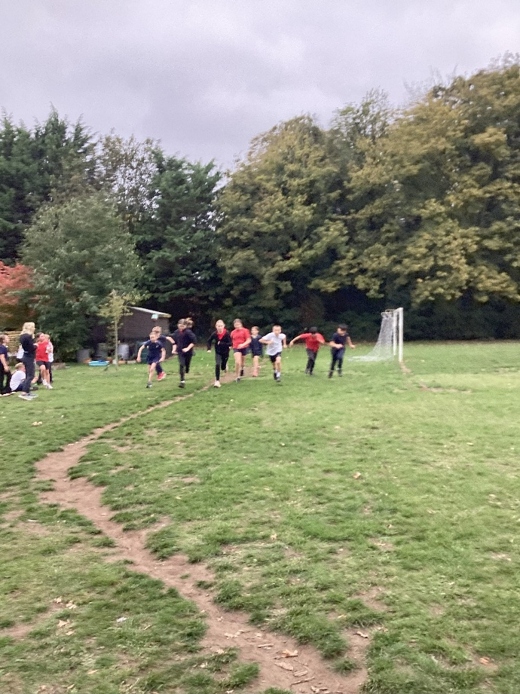
Children in each class from Year 2 upwards have been having mini-tournaments using our Daily Mile track in readiness for the forthcoming cross-country inter-schools event at Hillcrest.
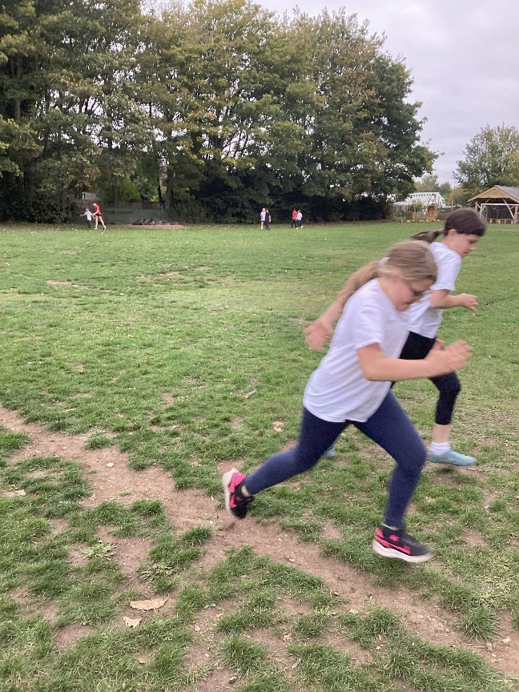
On Friday 10th October it was the turn of Class 4. A top three position would secure a place at the Hillcrest tournament.
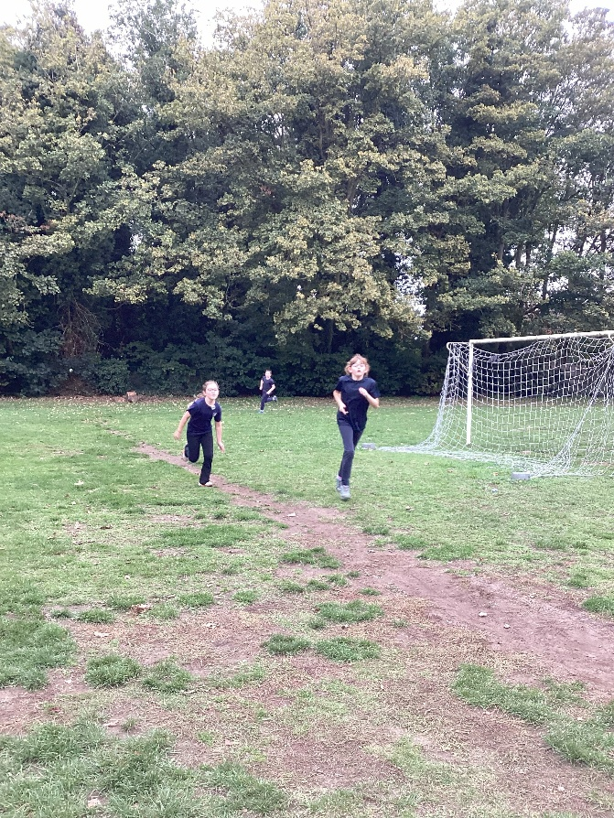
Everyone gave their best, supporting and encouraging each other. Well done to them all.
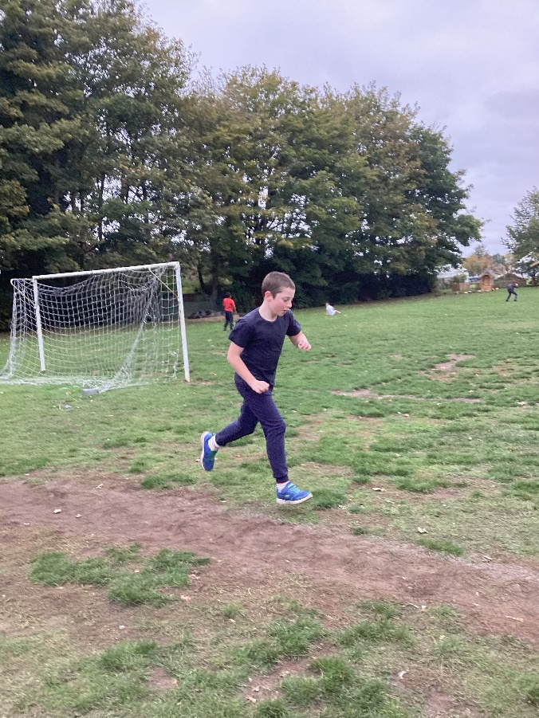
Here are the results:

Year 5 boys  Osian  Hugo  Charlie | Year 5 girls  Lauren  Olivia  Indi
Year 6 boys  Chase  Onur  Sonny | Year 6 girls  Flora  Lyla  Esther

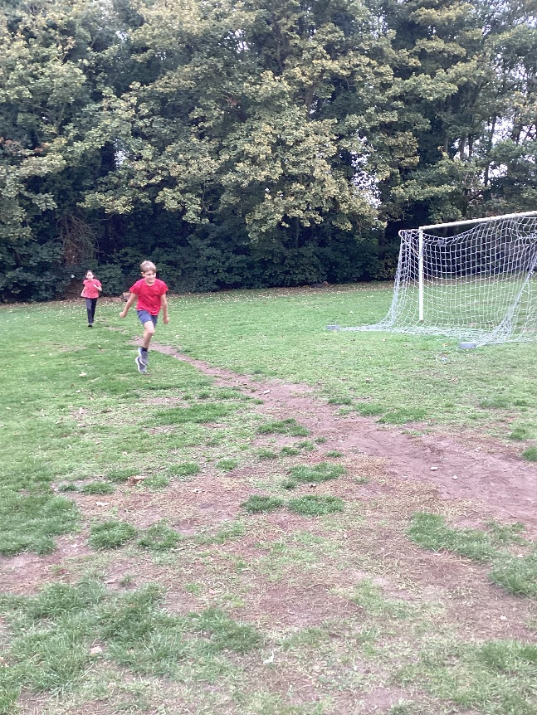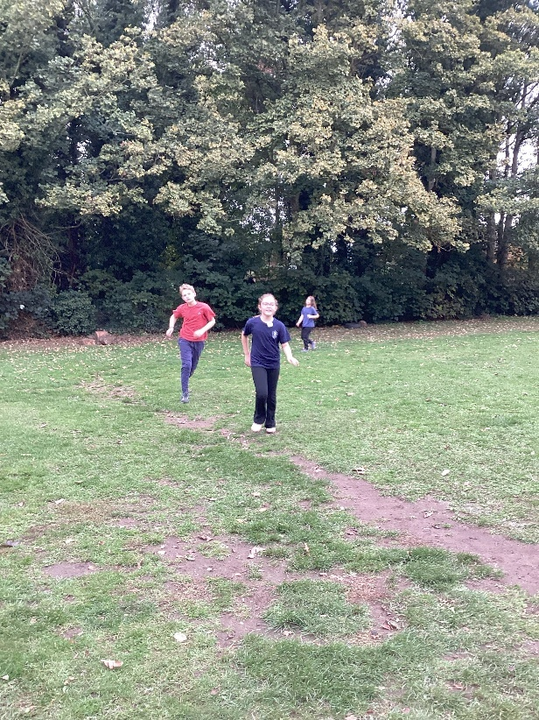

Good luck to them all on Tuesday 21st October where a top ten position will allow them to progress to the area finals.



