Rugby Coaching Session 2
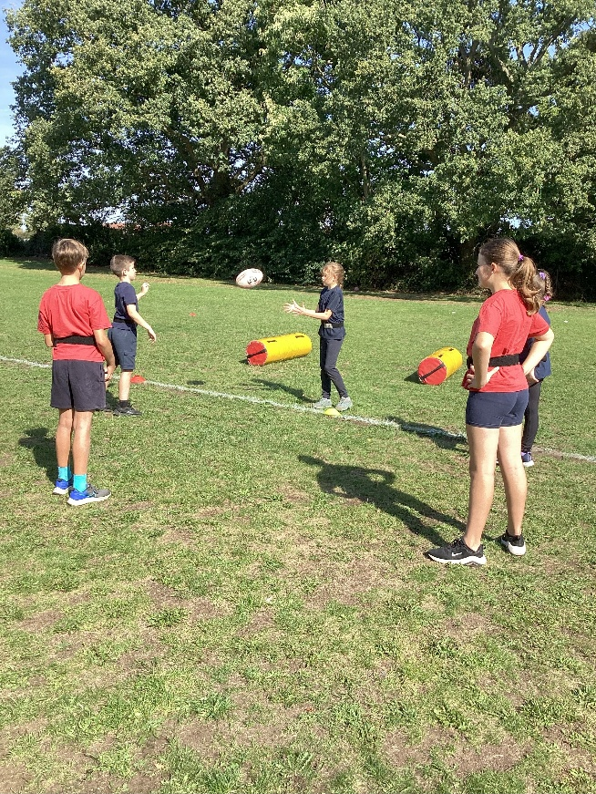
The second of our three rugby coaching sessions by James Burroughs of West Norfolk Rugby Club on Friday September 19th was thoroughly enjoyed by all of Class 4 in some perfect late-autumn sunshine.
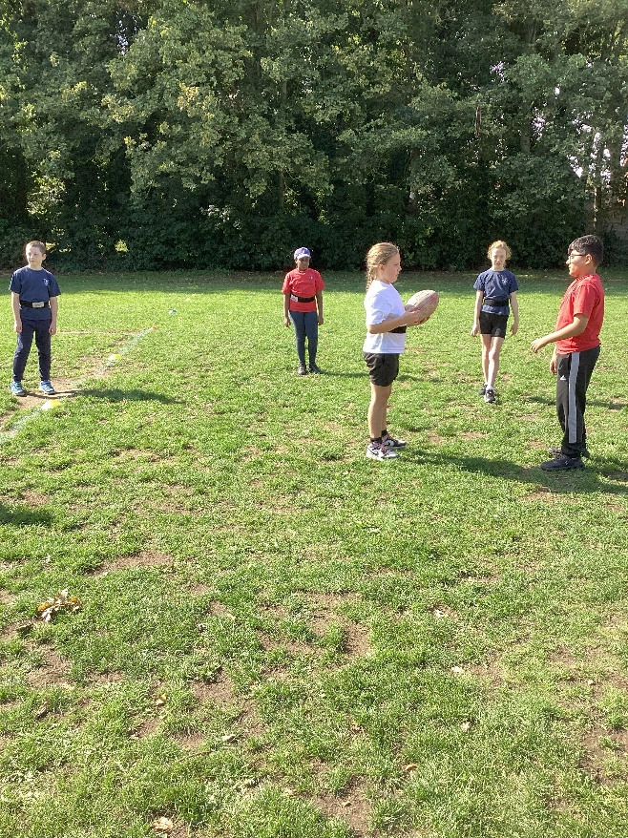
Passing drills and games were followed by some tackling competitions using the tackle bags. Next, some time to learn how to pass backwards while in motion and thinking about finding space. The class learned how to form a line of defence and then had some tag rugby match play time to put all of the skills and rules into practise. They are doing well.
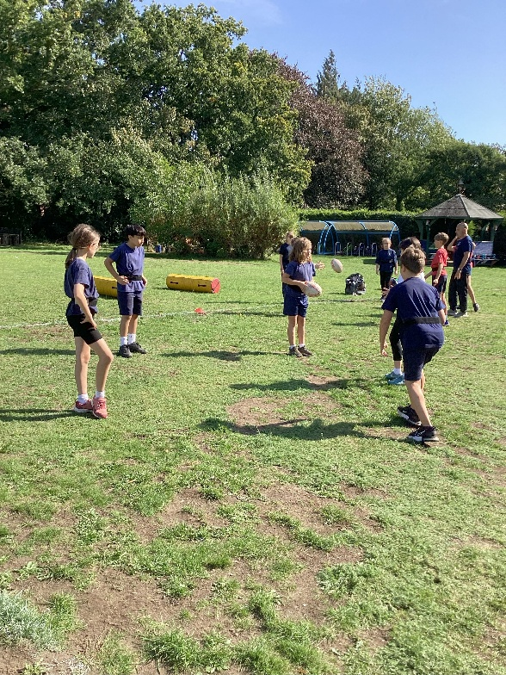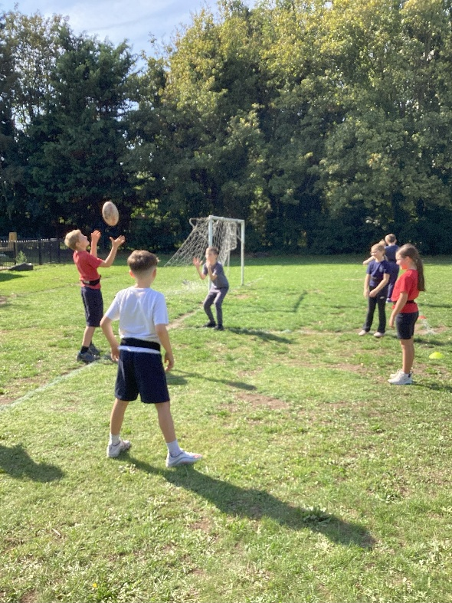

Attendance at the after-school club was excellent with 22 members. They developed their skills and got stuck into some matches. Fantastic!


