Class 4 Tag Rugby and KS2 after-school club session 1
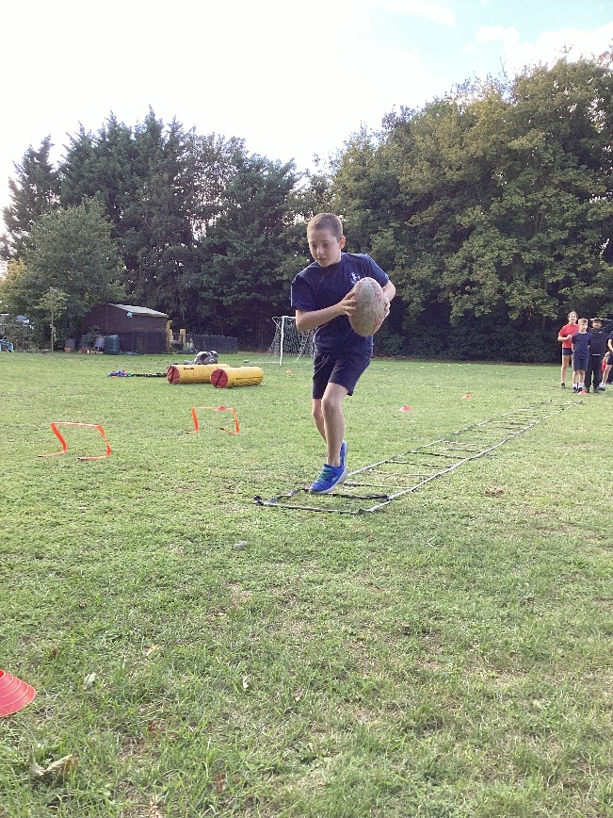
On Friday 12th September, Class 4 children began the first of three sessions of tag rugby delivered by coach James Burroughs from West Norfolk Rugby Club.
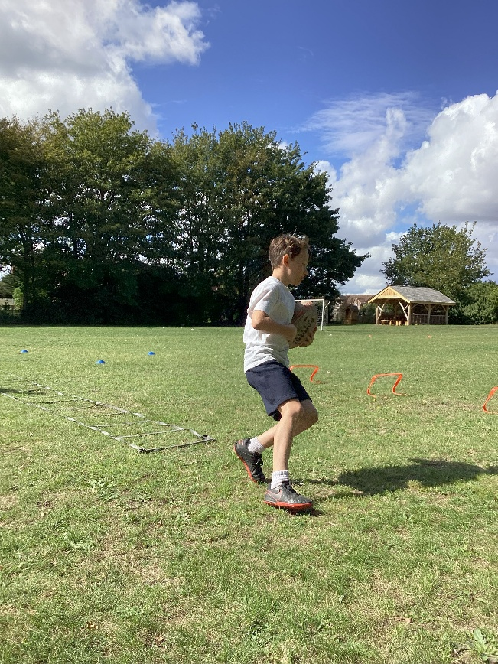
In this first session, the children performed agility drills that encouraged swift changes of direction and pace and how to handle and pass the ball.
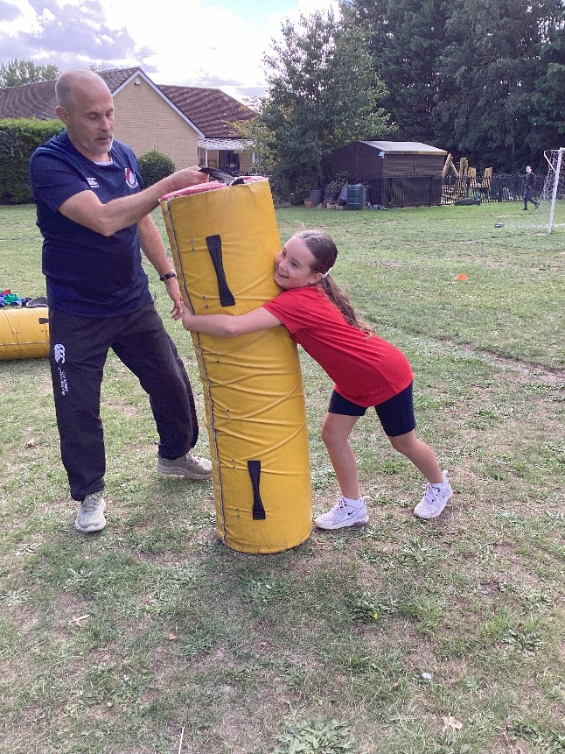
Next, the children learnt how to tackle using the pads.
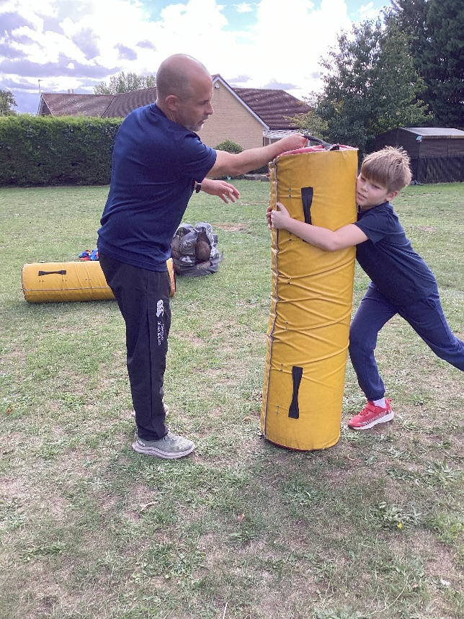
This then led to some practise in tagging one another to teach the children how to form a defensive line to block the other team from scoring a try.
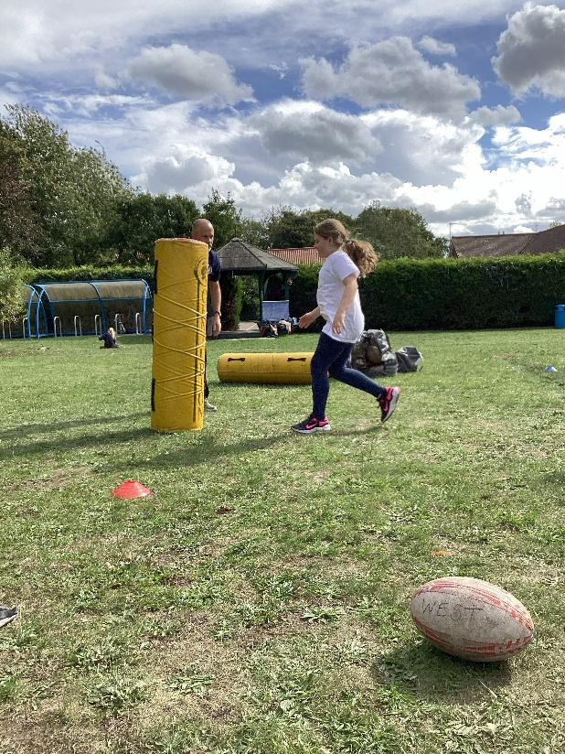
The after-school club was very well attended by children of both classes who stayed on to learn about skills and drills. They enjoyed some friendly games as they got used to the rules.
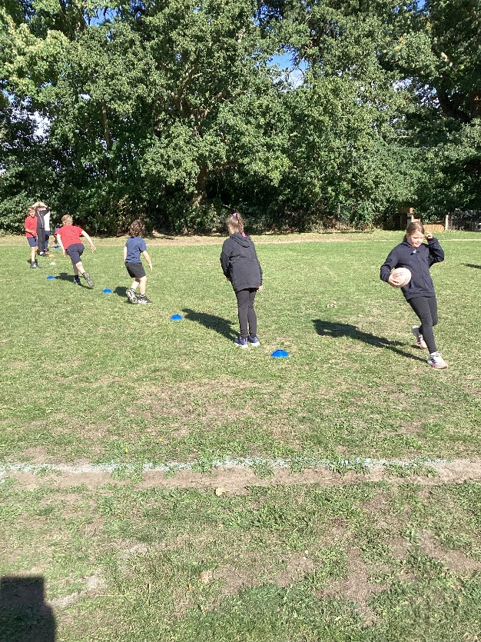
We look forward to next week.


