Downham Market Cluster Netball Tournament
On Tuesday 18th March, nine children from Class 4 travelled to Downham Market Leisure Centre to take part in the cluster competition with a place in the area finals at stake.
Despite being relative novices at the sport, the team were impressive throughout with three wins and a draw. This meant that they are now cluster champions and have succeeded in their quest to reach the area finals which take place on 28th April at Lynnsport.
Here are the results of their games:
Hillcrest Thunder 0 – Denver 3
Denver 0 – Nelson 0
Southery 0 – Denver 2
Hillcrest Lightning 0 – Denver 1
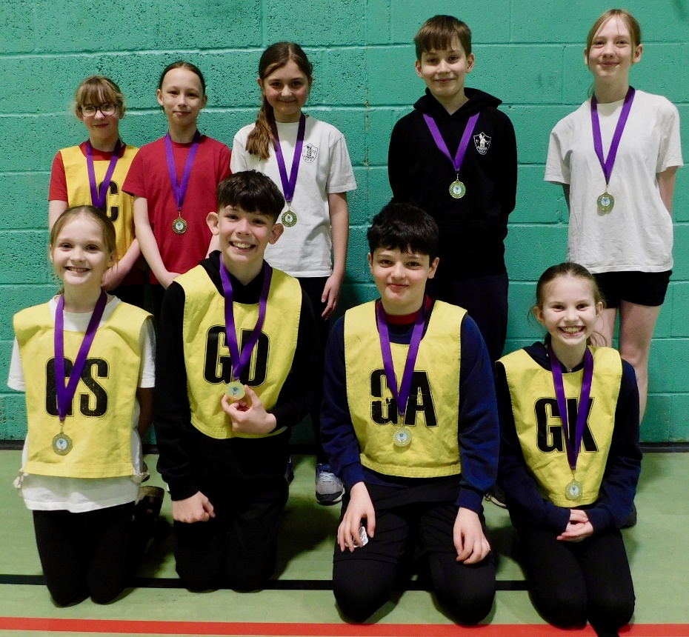

Many thanks to Mrs Williamson and Luke Fenn for taking the team and supporting them.

