Christmas Learning Café
Class 1 were joined by our parents for our second learning café of the year. The children shared ‘The Jolly Christmas Postman’ story that we had been reading in class that week and then we got a special letter from Father Christmas! The class worked on creating lists of their Christmas wishes for Santa before putting them in envelopes and sending them off in the class post-box.
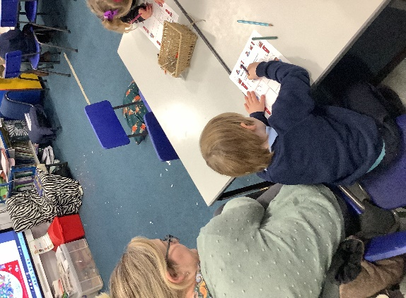
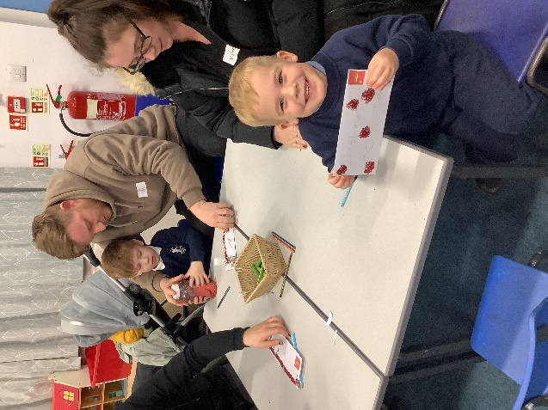
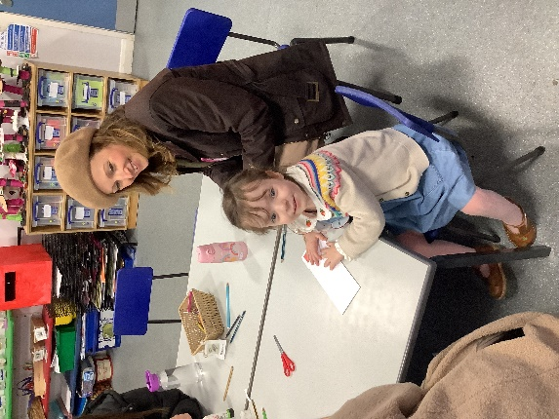
Thank you to all parents who attended and we hope you all have a merry Christmas!

