Georgie Lingham visits Class 4
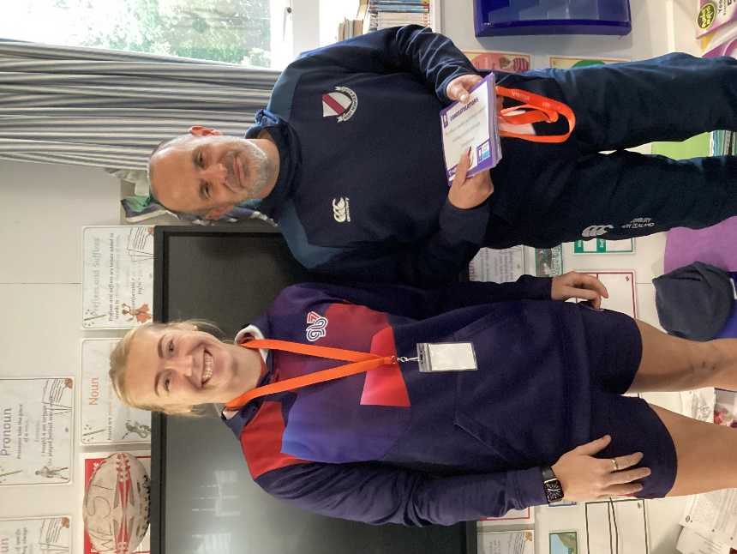
England Rugby Sevens International, Georgie Lingham, came to Class 4 to congratulate the children on completing their tag rugby training and to award them with certificates.
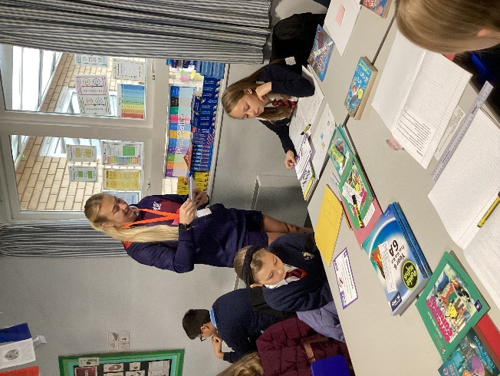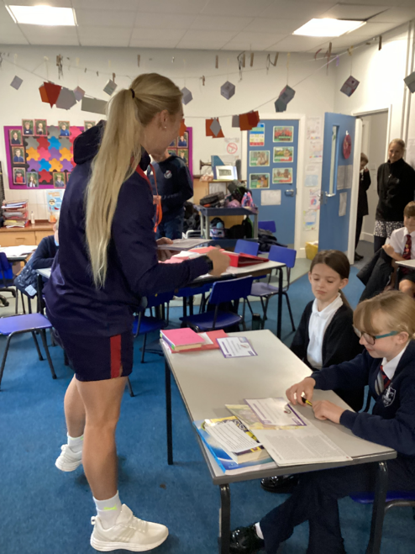
It was an honour to have been visited as Georgie was flying out to Gibraltar for training that afternoon. It was inspiring to see hear about this local woman’s achievements. There will be another opportunity to see her in June when Class 4 are invited to a tournament at West Norfolk Rugby Club.

