Tag Rugby – our final session
On Friday 18th October, James Burroughs from West Norfolk Rugby Club joined Class 4 to deliver his final coaching session.
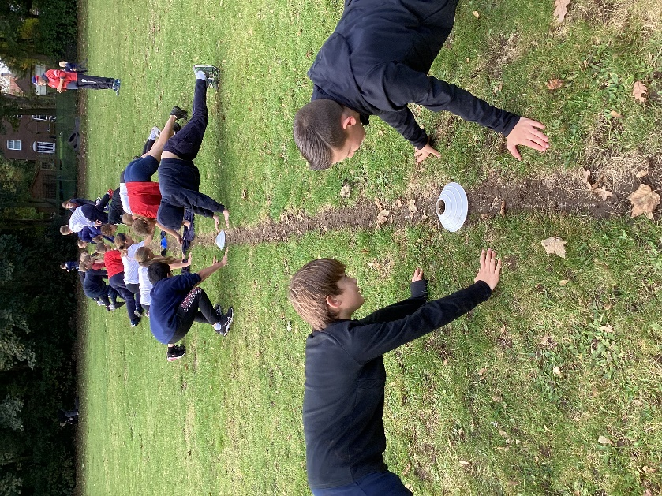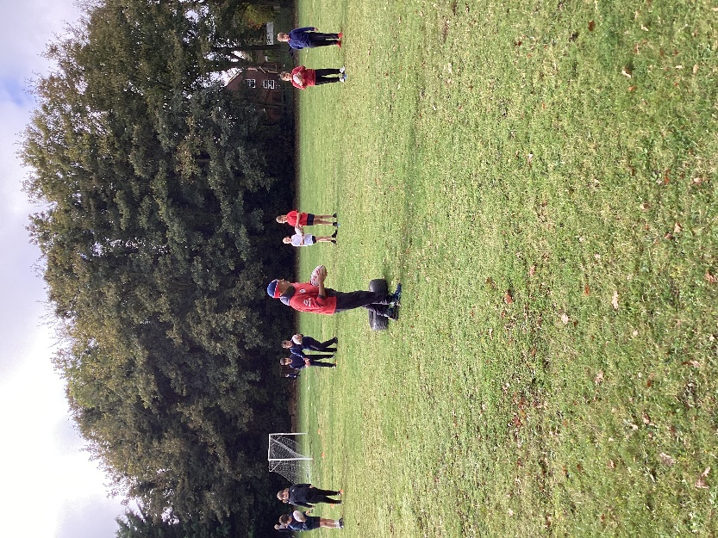
In this session, the children were taught how to do rugby kicks, including drop kicks for precision and for length. Then the children got involved in some mini matches.
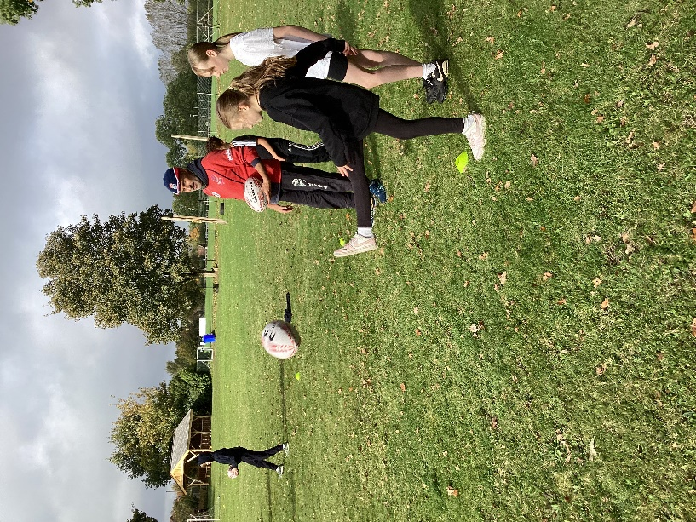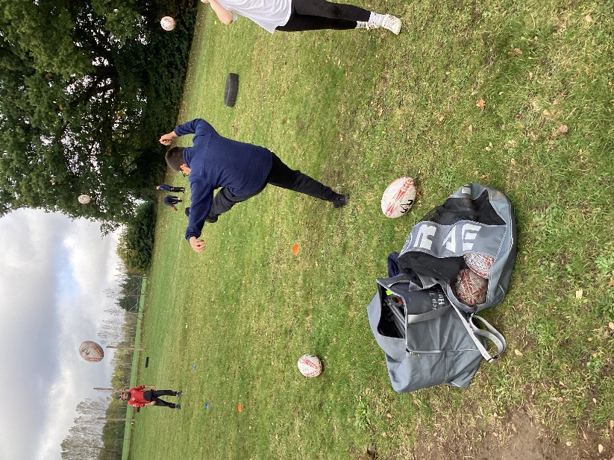

On Monday morning the class will be joined by an England international, Georgie Lingham, who will be coming in to present them with their certificates. Georgie is an English rugby union player. She plays for the Great Britain women's national rugby sevens team. From North Wootton, she began playing rugby at West Norfolk Rugby Club. She was first selected for the England women's national rugby sevens team in January 2020. In January 2023, she was called-up to the Great Britain women's national rugby sevens team.
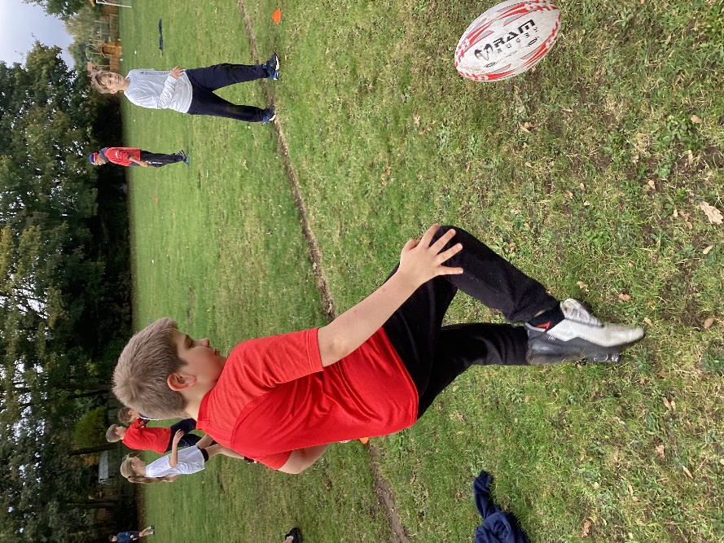

We are very grateful to James for his excellent coaching. In the Spring/Summer term, the whole class has been invited to attend a tournament at West Norfolk Rugby Club against the other schools that have been receiving James’s and his colleagues’ coaching. He was impressed by the skills of many in the class and if the children are interested in taking up rugby as a hobby, please contact West Norfolk Rugby Club for further information.

