Rugby session 4
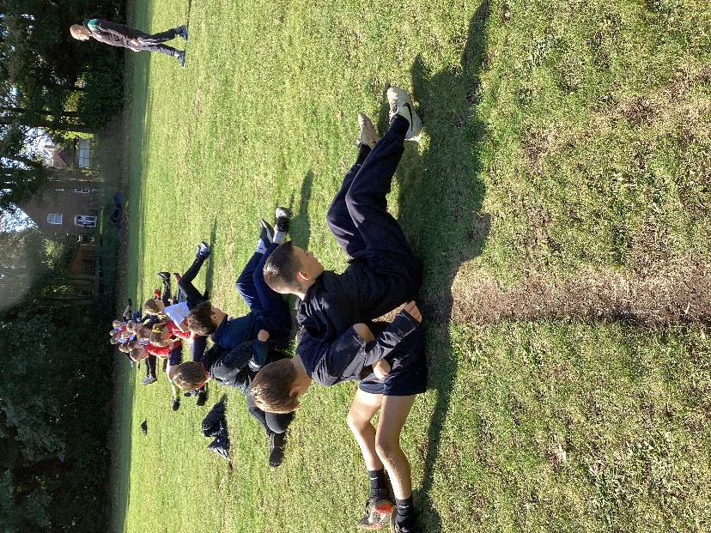
With just one more week to go, the fourth of our sessions with James focussed on developing tackling and passing skills.
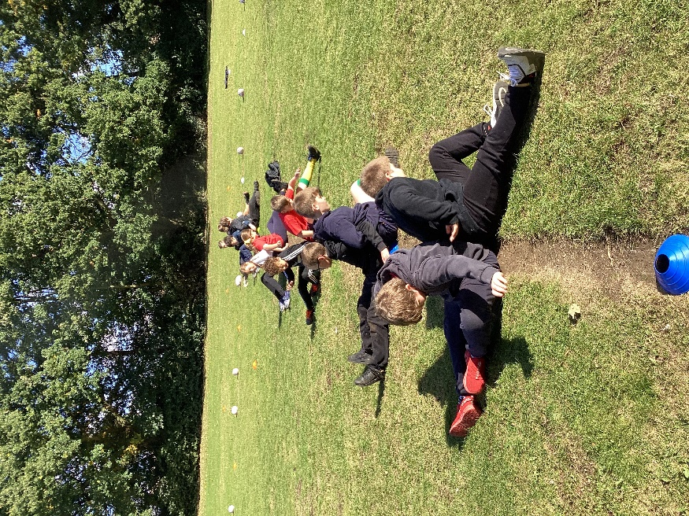

We then had a lengthy opportunity to play some mini matches to get used to the idea of moving with the ball, using all of our available players and passing backwards while on the move. Defence techniques were also practised.
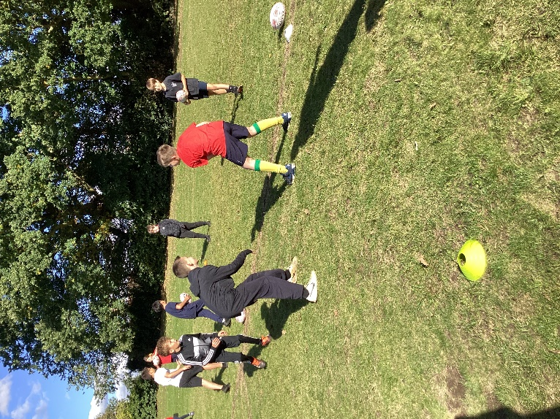
The final session will have a competition format to prepare us for the forthcoming tag rugby tournament at West Norfolk Rugby Club.


