Bikeability training 2024
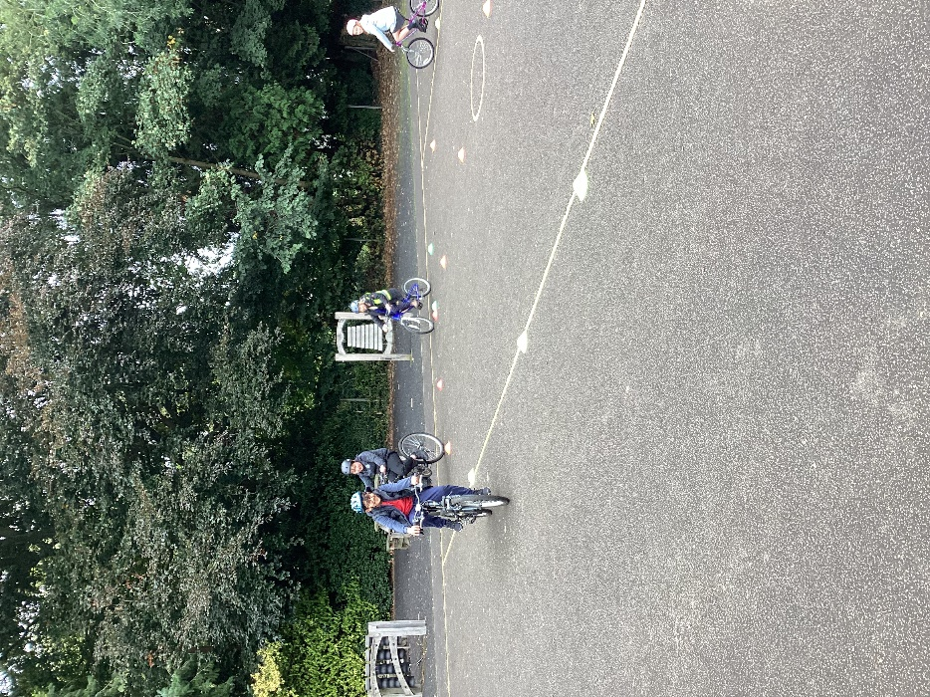
Trainers from Outspoken Training visited the school on Wednesday 25th and Thursday 26th September (coincidentally during national Cycle to School week) to carry out Level 1 and Level 2 cycling proficiency training.
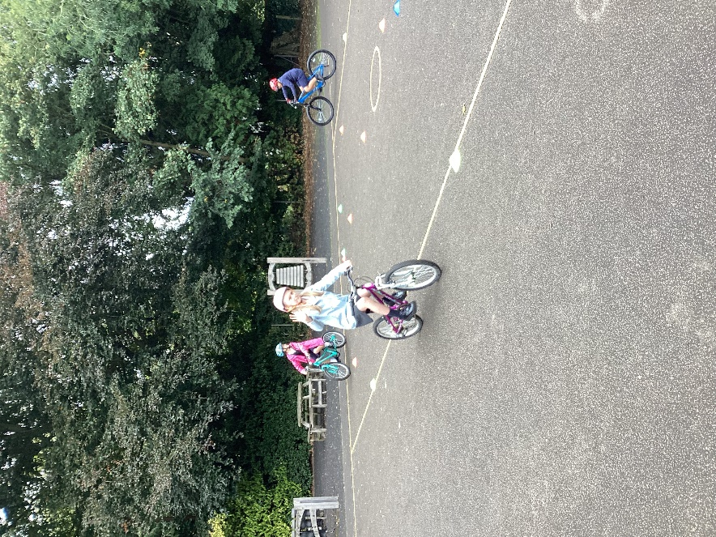
Children from Y5 and Y6 took part. The first morning was spent on the school grounds to achieve the skills for Level 1.
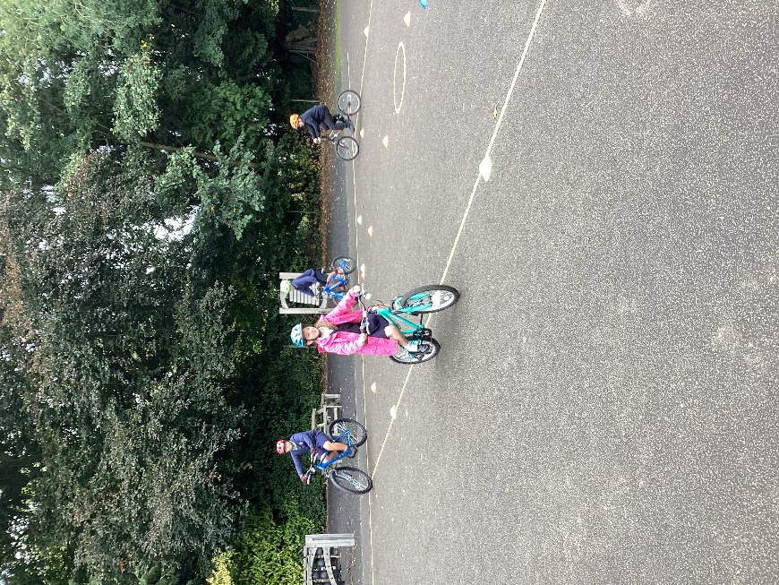
Successful completion of this enabled the children to progress to Level 2 training on the road by the school.
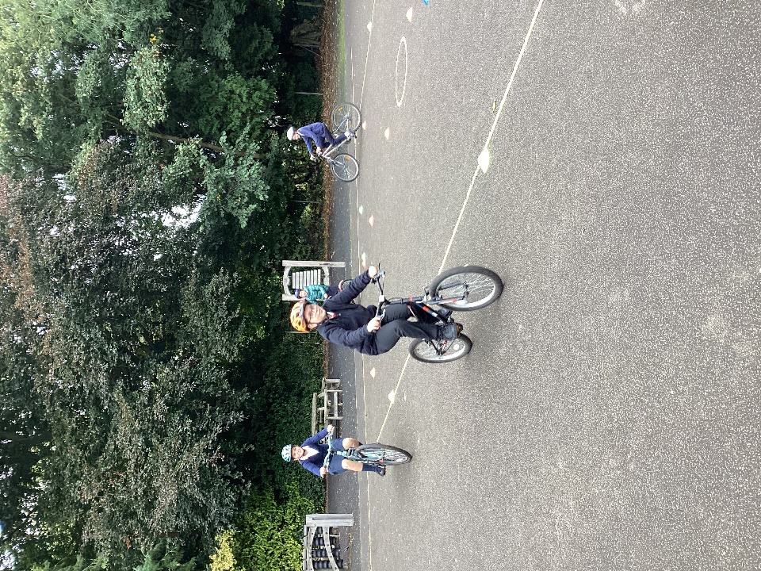
The second day progressed the training to busier roads a little further away.
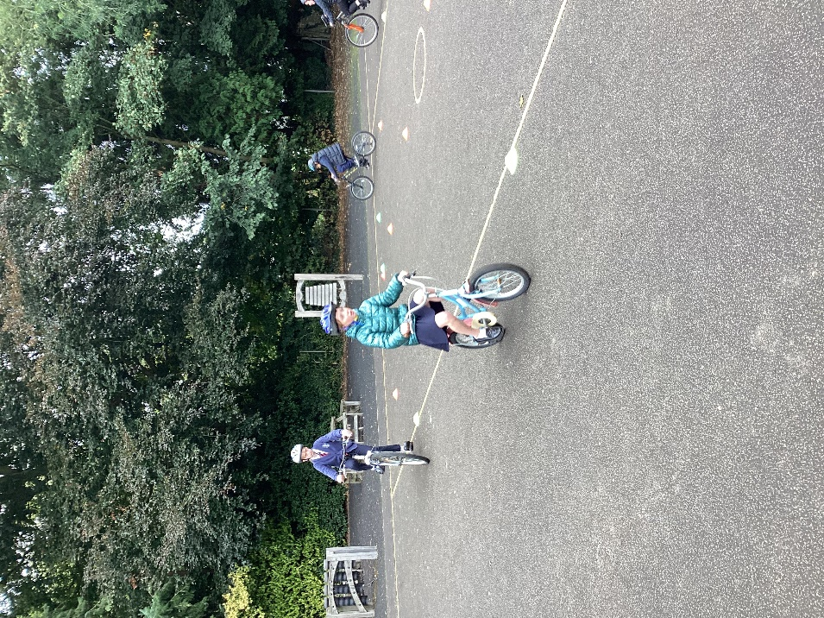

The children are now much more confident in making safe manoeuvres when out on the roads, in their road safety awareness and how to maintain a bike.

Well done to everyone who took part. We look forward to welcoming our trainers back later in the year to carry out Level 1 training to some of our Y3 and Y4 children.

