Class 4 Tag Rugby
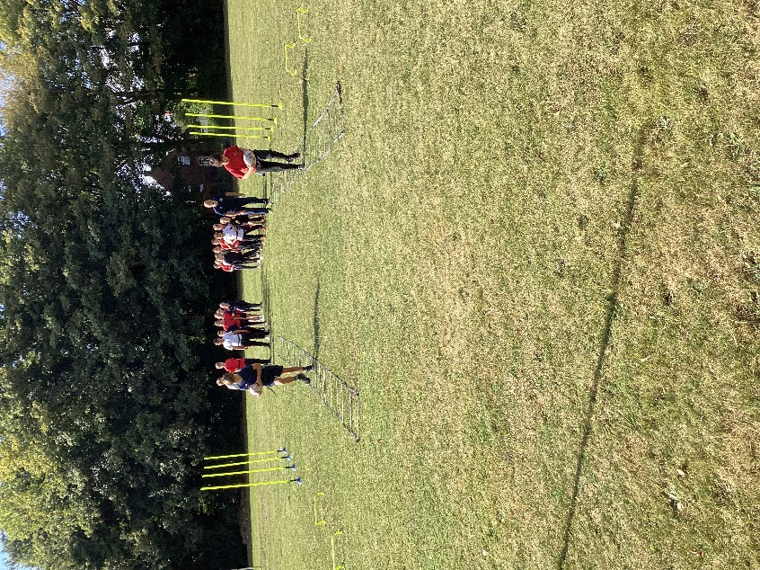

On Friday 13th September, Class 4 children began the first of seven sessions of tag rugby delivered by specialist coach James Burroughs from West Norfolk Rugby Club.
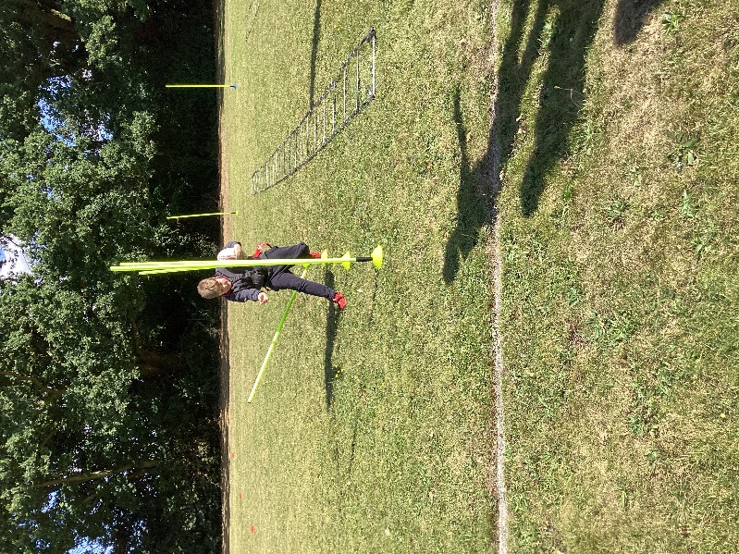
In the first session, the children performed drills that encouraged swift changes of direction and speed and how to place and pass the ball.
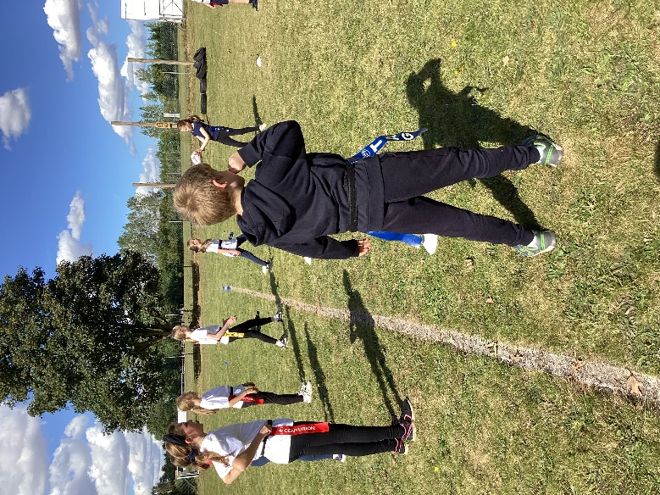
This then led to some practise in tagging one another to prepare for the first competitive game, tag rugby netball.

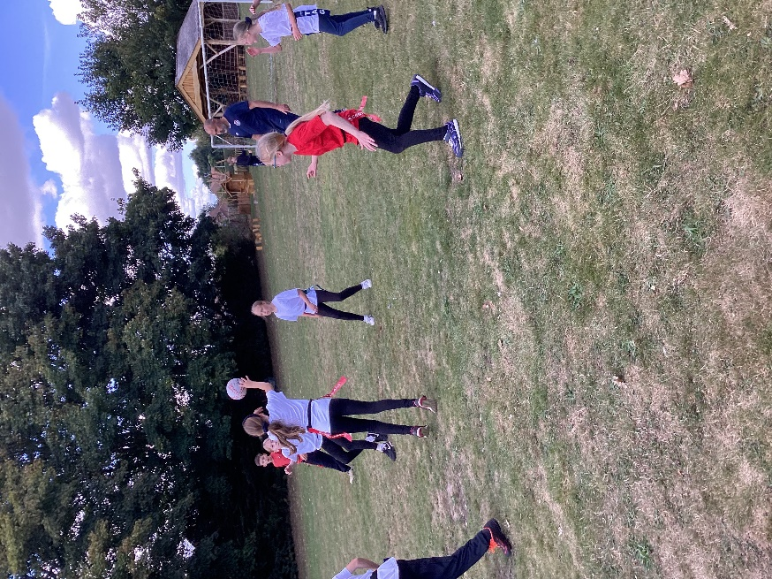
We look forward to next week.


