Area Sports 2024
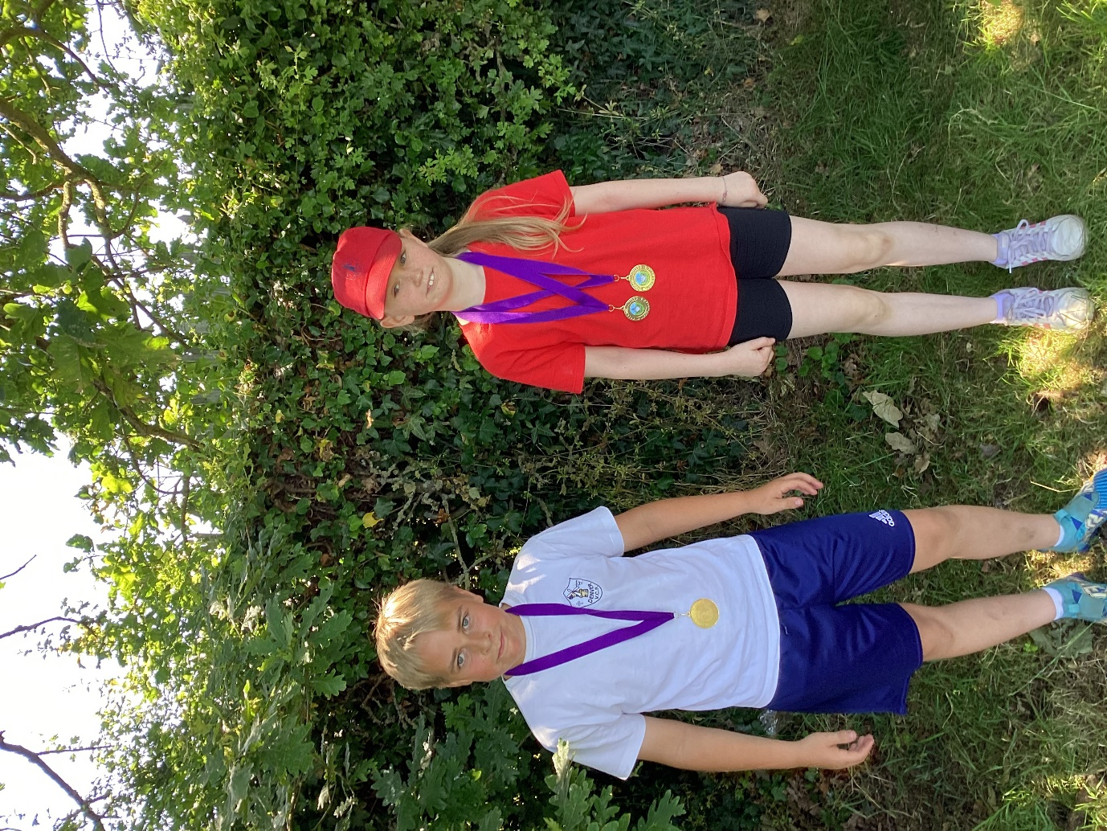
The annual Downham Market cluster Key Stage 2 Area Sports athletics event was held at Hillcrest Primary School on Tuesday 25th June.
As with all years since Covid, all schools, regardless of size, were competing together so there was no overall winning school. Instead, children competed on an individual basis with only the event winners earning gold medals.
Denver had many successes winning 4 of the medals. There were many other impressive results too with plenty of second and third places..
Regardless of winning or not, all members of the team showed determination and good sportsmanship. Everyone taking part should be proud of their achievements today.
Here is a list of our gold medallists:
, Finley for Y6 hurdles
. Flora for Y4 endurance
. Flora for Y4 sprint
. Flora for Y4 standing long jump.

Well done Team Denver!
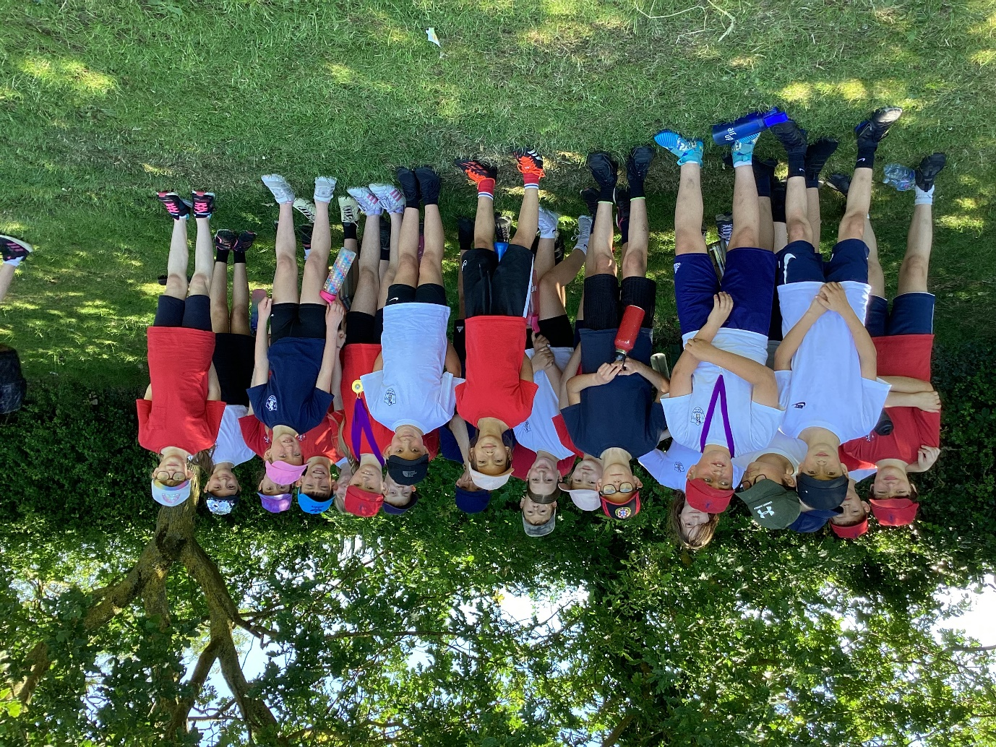

Thank you to Miss Waters and Mrs Stansfield for accompanying the visit.

