Girls Only Football tournament

Tuesday 4th June saw girls from across the Downham Market Cluster travel to Hillcrest Primary for an inter-schools tournament.
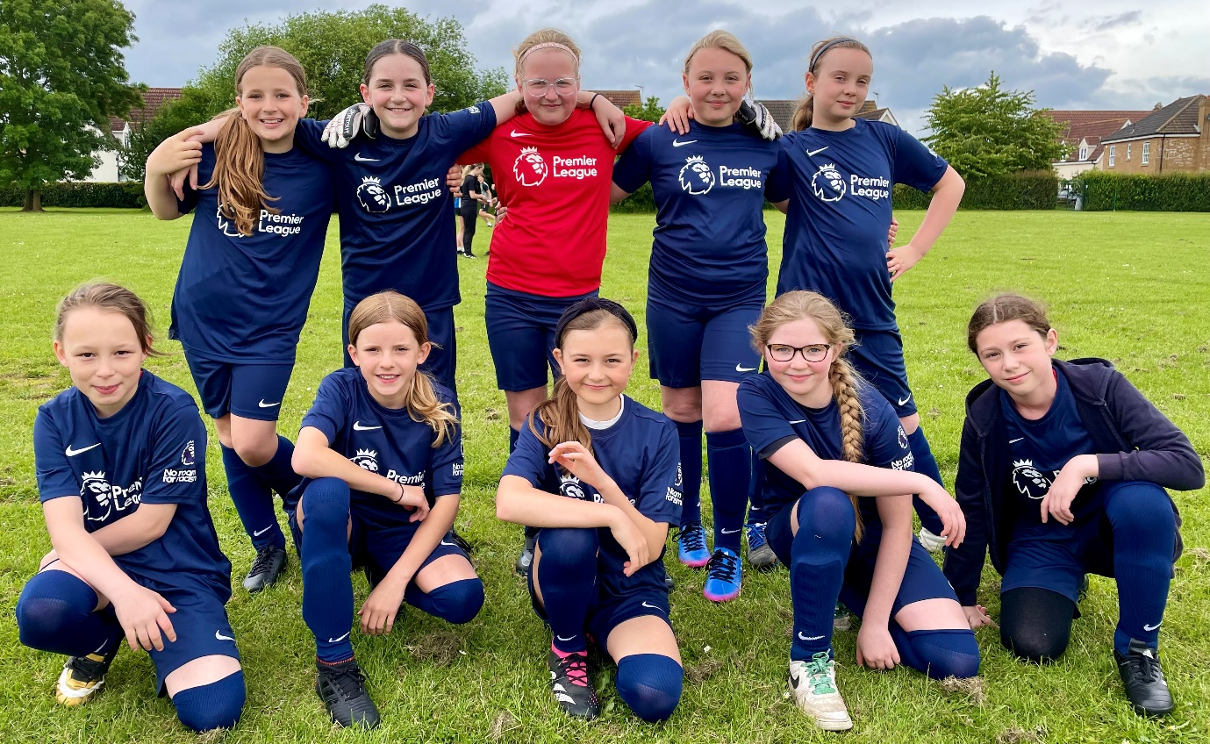

Our group of girls took it in turns to play matches to represent the school in a round robin against all of the other schools that attended and came back with silver medals. Congratulations! We are very proud of you.

Thank you to Mrs Stansfield and Miss Waters for taking them.

