Crucial Crew 2024
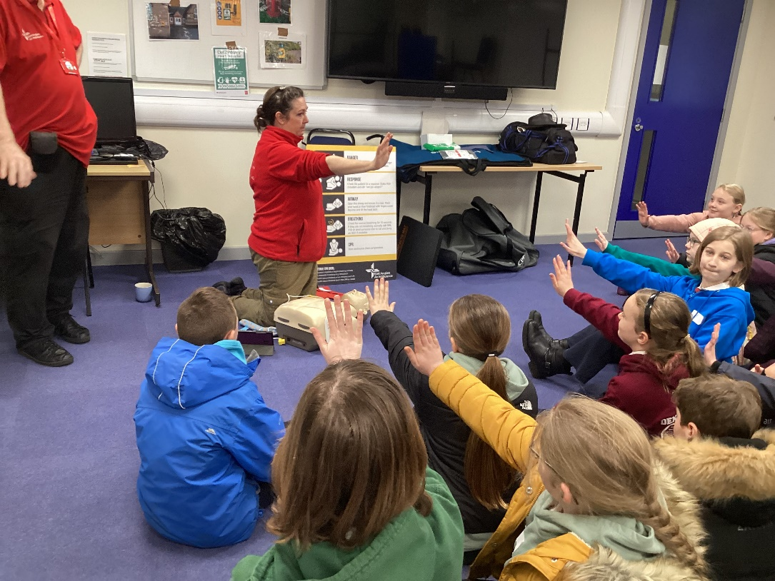
This year’s Crucial Crew for Year 6 children across the King’s Lynn area was a resounding success. We joined the penultimate group on Friday 3rd May.
Despite the dreadful weather and having to dodge the torrential rain between the different workshops at King’s Lynn Fire Station, plentiful knowledge was gained about how to be safe in a range of situations.
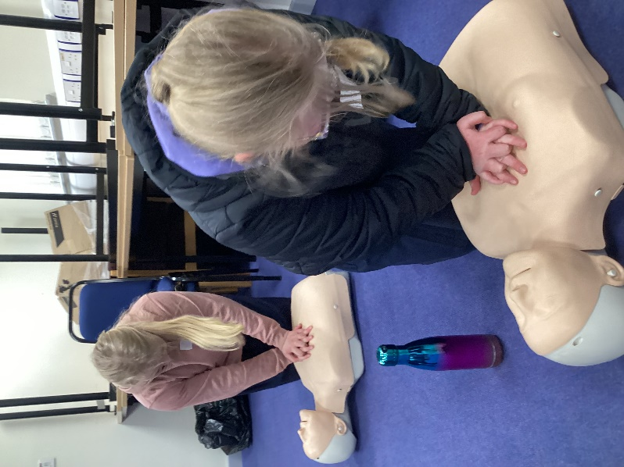
The first stop was with a group of paramedics who taught us how to make a 999 call, the information that would be requested in an emergency and how to perform CPR using dummies. It was an eye-opener what hard work it is to make continuous and deep enough chest compressions. Many of the children complained that their hands hurt after just 60 seconds. In a real event this could take 30 minutes before a responder arrives.
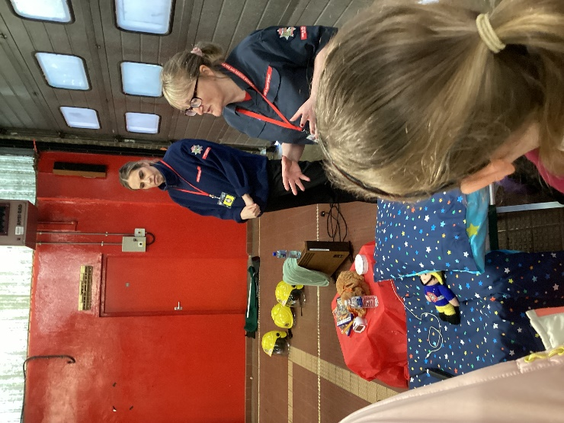
The second station was manned by Norfolk Fire Service fire volunteers. They had made a mock-up bedroom that had numerous fire hazards. Together the children found the hazards and worked with the experts to discuss how the risks could be eliminated using role play to help us remember.
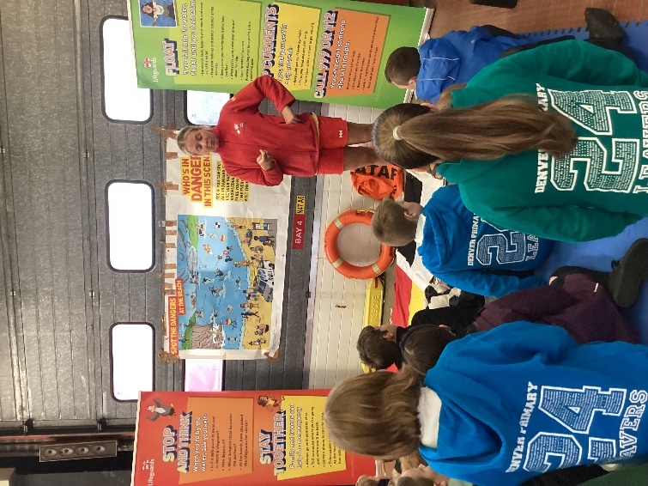
Next stop was with the RNLI station which was similar to the previous station: dangers were identified and then a full explanation of how to deal with them followed. Importantly we learnt that inland waterways are dealt with by the fire service and coastal issues by the coastguard but the emergency number, 999, remains the same.
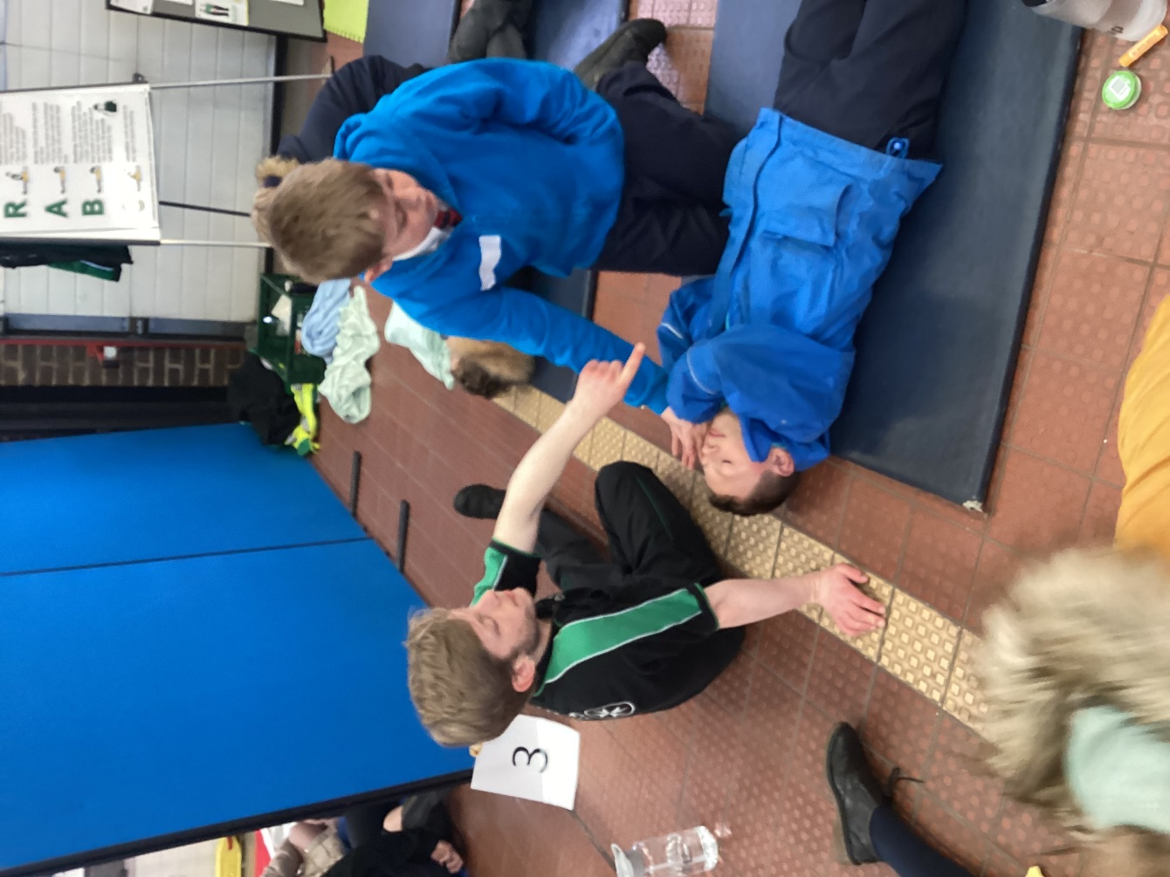
Onwards to St John Ambulance volunteers who reminded us of the DR ABC procedure for dealing with casualties then a hands-on opportunity to practise calling for help, checking for breathing and whether responsive, clearing the airway and putting our partners into the recovery position.

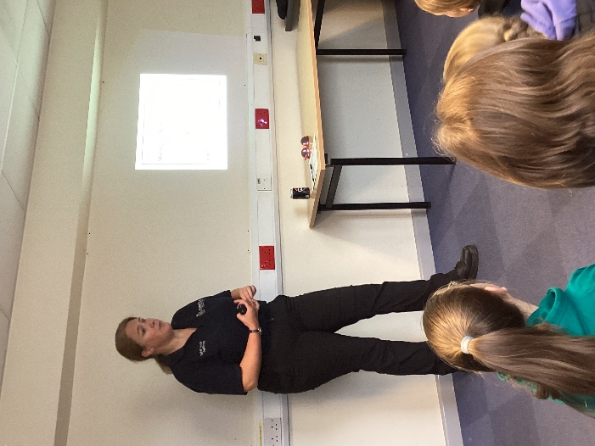
From here we went to meet a police officer from Norfolk Constabulary. She shared very common-sense advice about ‘owning’ what we do online and how we are criminally responsible from age 10 for the things we say or do. Through the video of ‘I’ve seen your willy’, we learnt how quickly information that is not protected online can go viral and how something that was intended as a joke can quicky become something much more sinister.
We were also reminded of the age restrictions for many of the Apps, platforms and games. The vast majority are set at well over 13 to be able to have an account. These platforms will not protect us in the event of a breach as they insist that all users are over the age restriction because to have an account in the first place, you must state that you are of age.
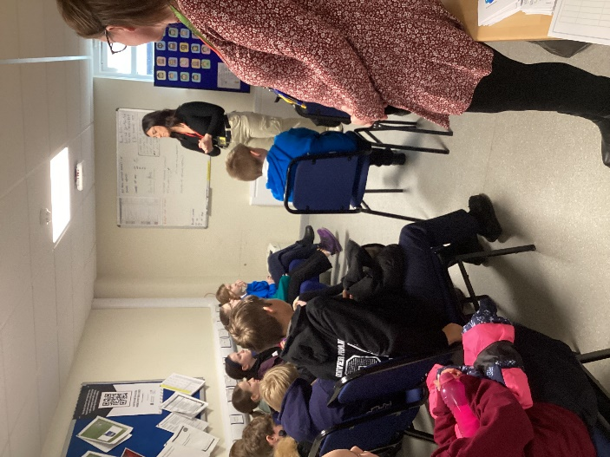
The sixth stop was with NHS wellbeing volunteers who taught us the science about why our bodies and brains react in certain ways, in particular when fight or flight reactions are triggered. They demonstrated some techniques for calming down in stressful situations such as stroking our own fingers to a pressure that feels comfortable.
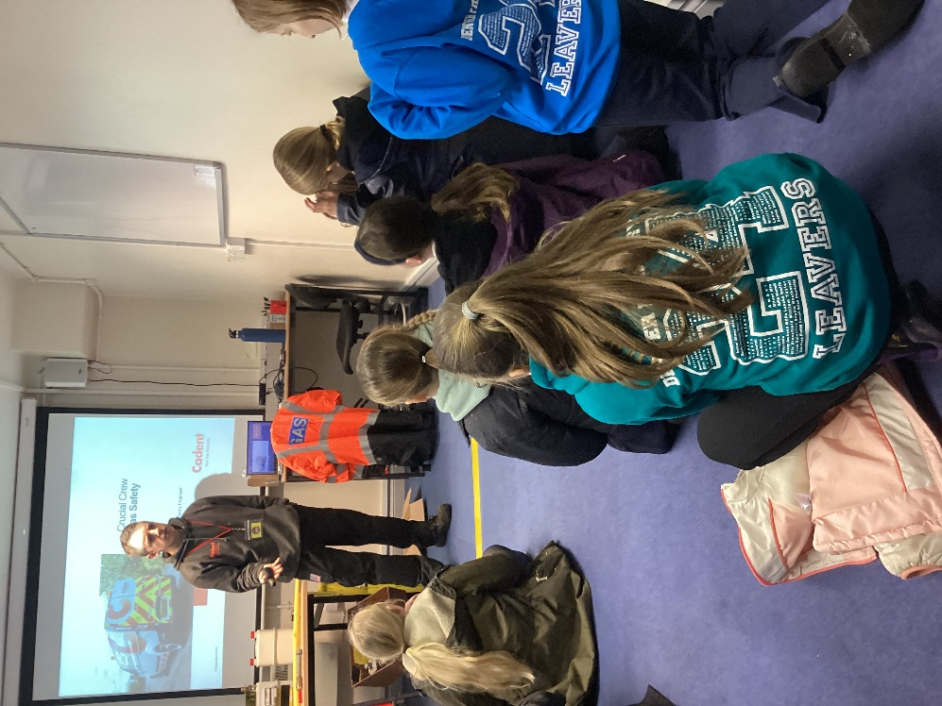
Last, but definitely not least, was Luke from Cadent. Every year he delivers and this year did not disappoint. In his trademark humorous style, he taught us how to detect problems with gas, how to deal with a potential gas leak and the all-important helpline number: 0800 111 999.
If we can take anything away from today that parents can help with, it is about making sure your child knows their postcode so that help can arrive in the most rapid way. This was set as homework. I’ll be asking in class to make sure this is the case.

The whole event was free thanks to the charitable institutions mentioned above that run these sessions on a voluntary basis.
Many thanks to Miss Waters for coming with us and for Mrs Jones teaching the year 5 children while we were out so that we could attend a valuably important event that could one day save a life.

