Dance Festival 2024
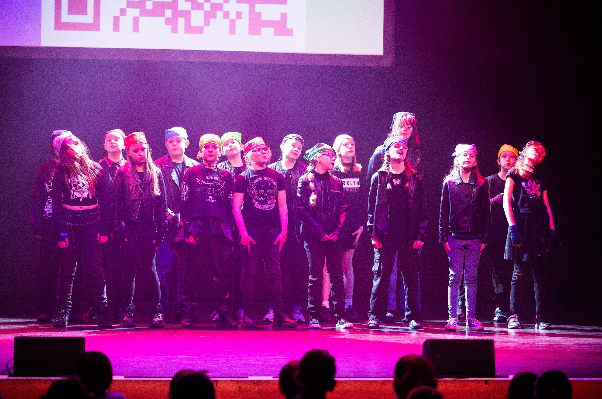
This year’s dance festival, held in front of a packed audience at the Corn Exchange theatre in King’s Lynn, was a great success.
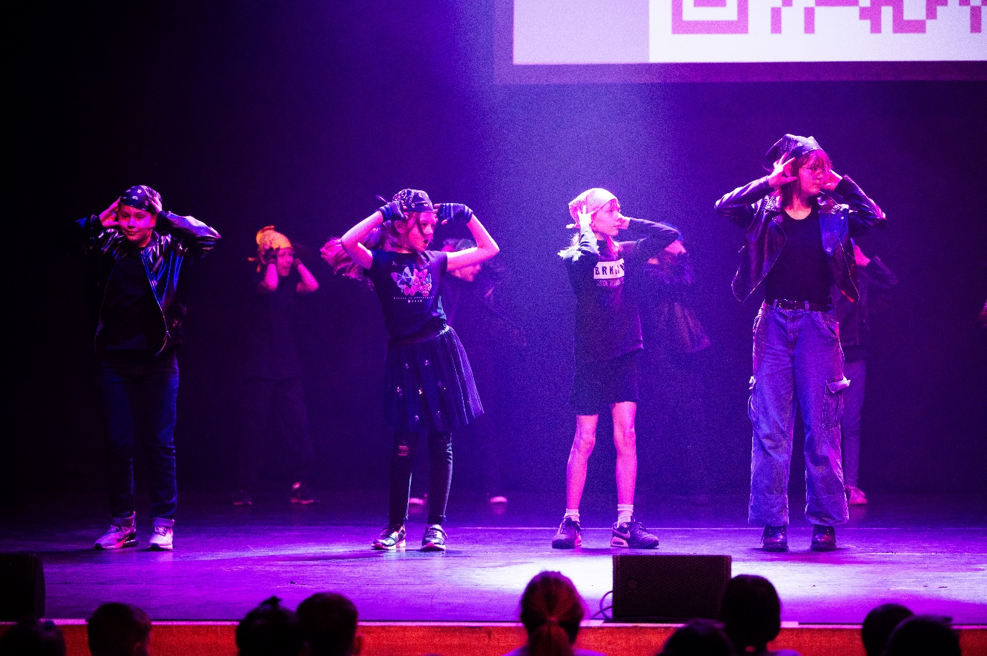

Schools across the area showcased dances they had learnt with the theme ‘Musicals and Movies’.
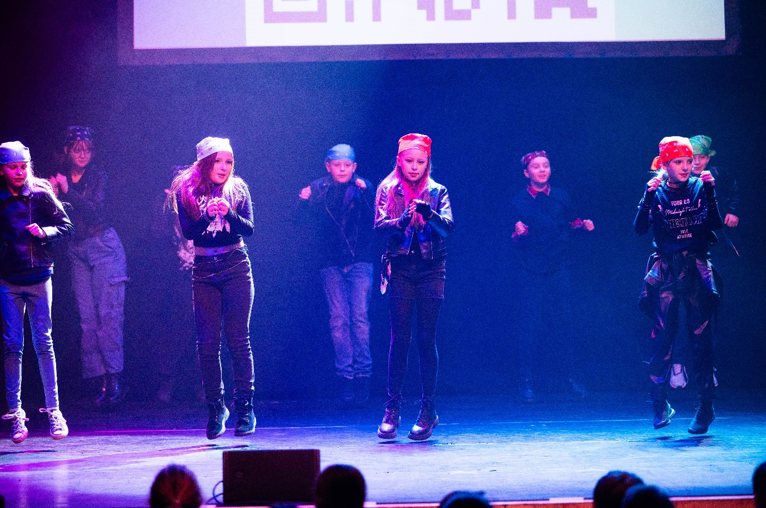

Denver children performed brilliantly to a dance choreographed by Ms DeVanche, supported by Miss Waters. Many thanks to them for their hard work and for providing an after school club to allow this to be possible.

