Bikeability Level 2 training

Catherine and Andy from Outspoken Training came to the school from Monday 4th March to Thursday 7th March to deliver Level 1 and 2 cycle proficiency training to children in Class 4.
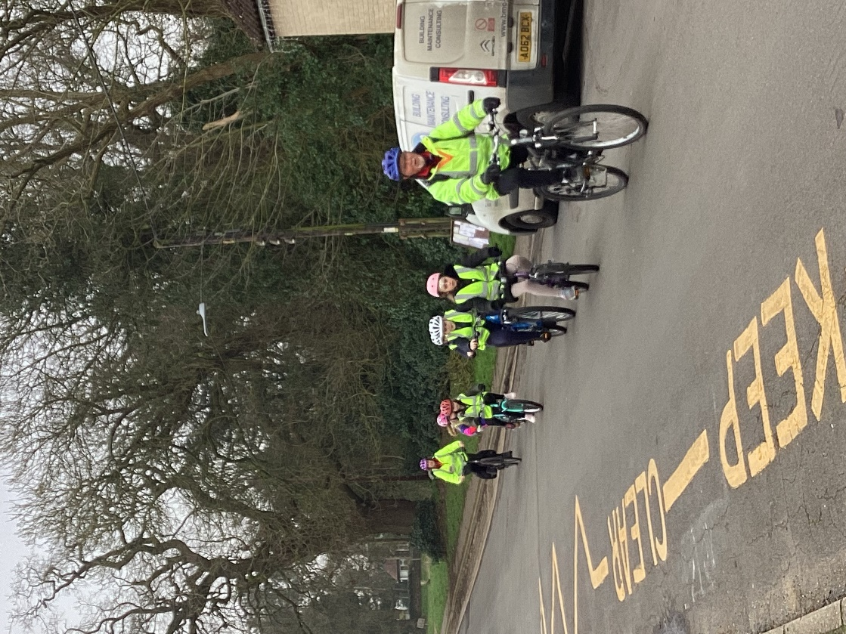
On the Monday session, the children stayed on site learning how to maintain their bikes safely and how to perform a range of manoeuvres that they would apply on the roads. The emphasis was very much on risk assessment rather than about danger which the children responded well to.

Successful completion of Day 1 meant that the children progressed onto the local roads. They worked on indicating their intentions to other road users, how to pull away safely, how to stop and progress from junctions and how to make turns, amongst other things.

At the end of the course, Andy and Catherine gave each child some specific feedback. They were very complimentary of both their skill development and their behaviour.
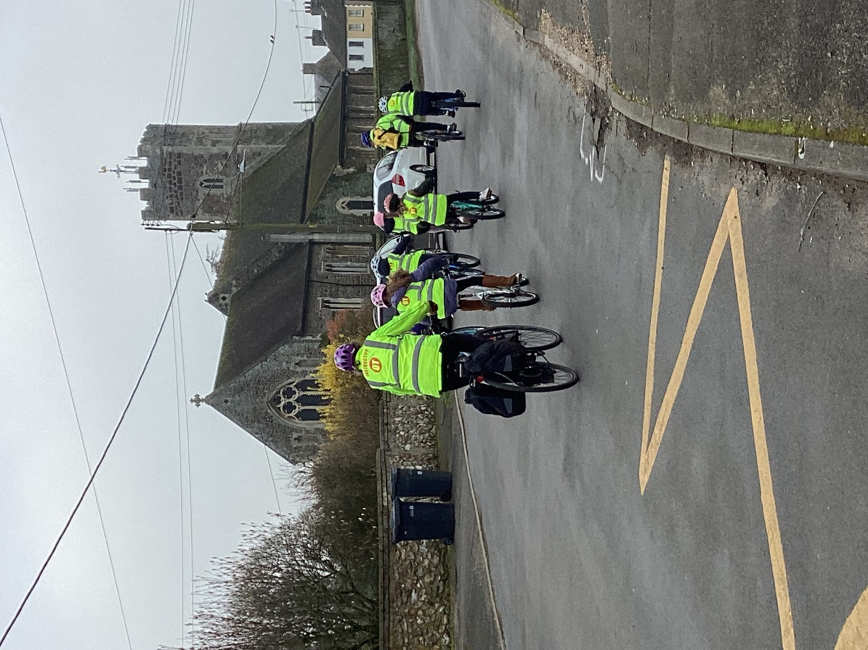
All of the children completed the course successfully and were rewarded with certificates and badges in our celebration assembly.

We are very grateful to our governors, Mrs Walton and Mrs Wilde, for supporting the children in this very useful initiative.

