The results are in!

You may recall that the children in Class 4 entered a competition open to Year 5 and 6 children in all primary schools under the Borough Council of King’s Lynn and West Norfolk. This was called ‘8 Billion Ideas’.
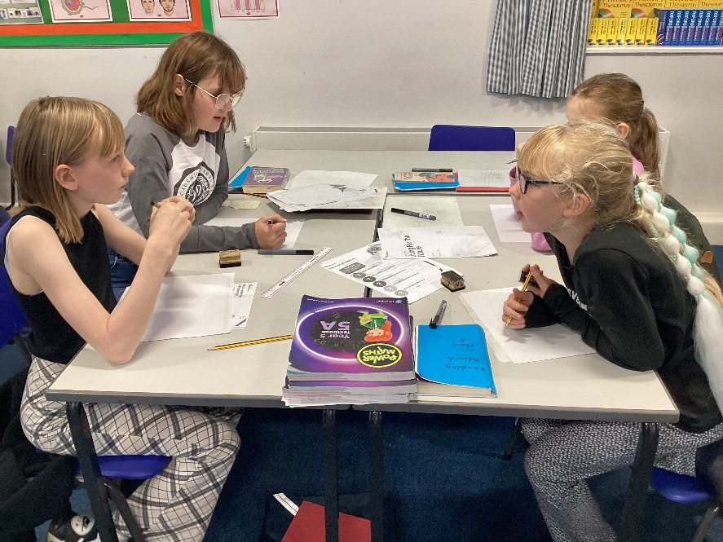
The competition was for teams of children to design, make and pitch a prototype of an eco-friendly, sustainable idea that will benefit our local area in the future. It encouraged teamwork, creativity and consideration of the future needs of society.
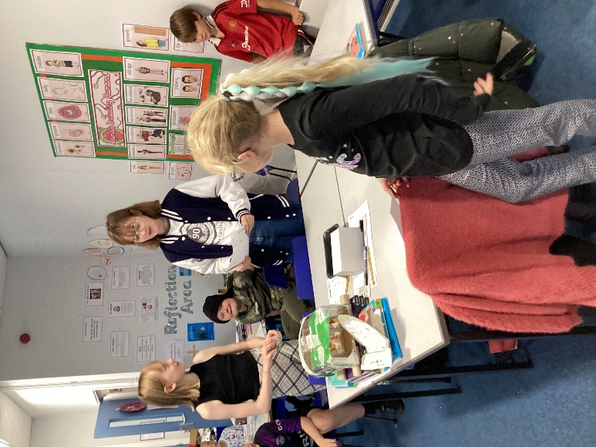

On Friday morning, there was a live screening via Zoom of the entries and winners. We were delighted that our team ‘Green Ride’ came an impressive third place! The judges were especially impressed by the quality of the pitch.
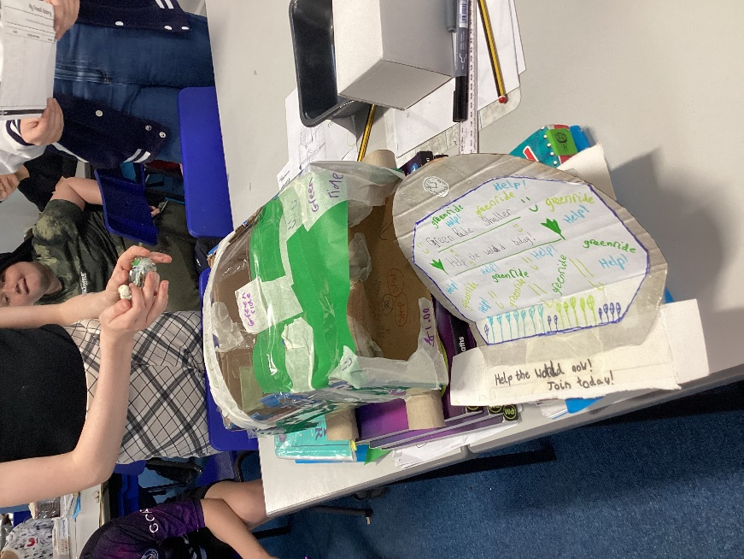
Congratulations to Charlotte, Hope, Rosie and Amelia. Their efforts have earned a £50 voucher for the school to be used for teaching resources relating to climate change and £10 vouchers for the children.


