Anti-bullying week 2023
To mark the start of anti-bullying week, we wore odd socks to celebrate our uniqueness.
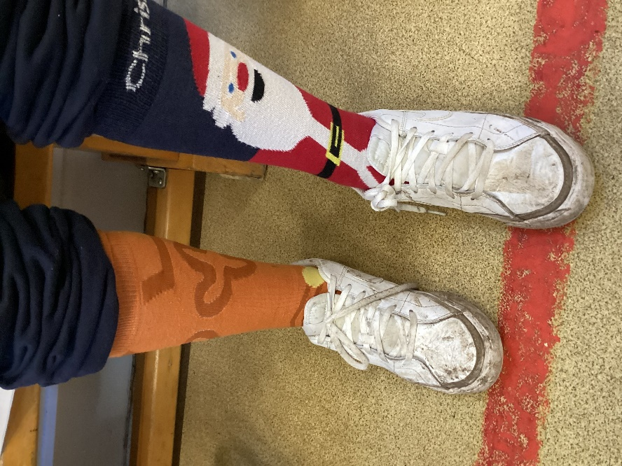
This was followed by our collective worship with Miss Pennock where she shared the inspiring story of Mohammed Ali.
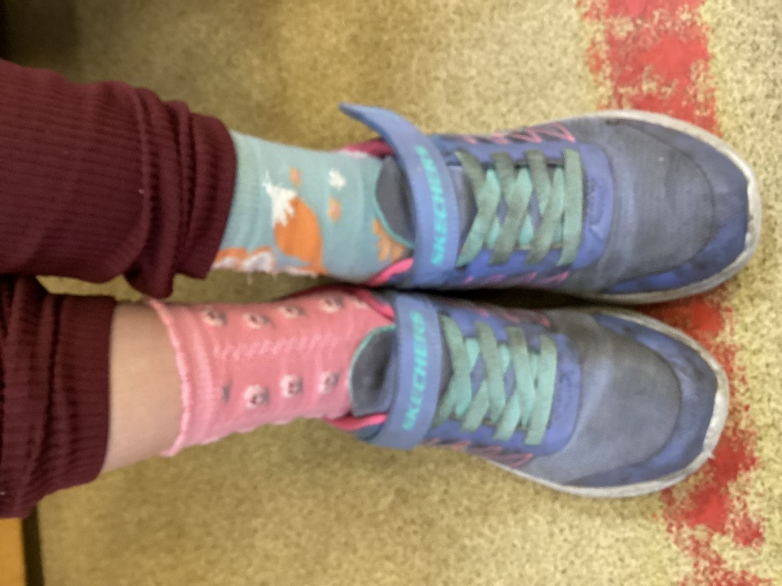
We shall explore the issue of bullying in our weekly wellbeing assembly later this week.


