Downham Market Cluster Football Tournament

On Thursday 9th November, two teams representing Denver travelled to Hillcrest Primary School to take part in a 6-a-side football tournament against other schools in the cluster.

Denver Dynamos (red strip) had a very successful afternoon, winning every match and not conceding any goals. They ended the day as the tournament winners. 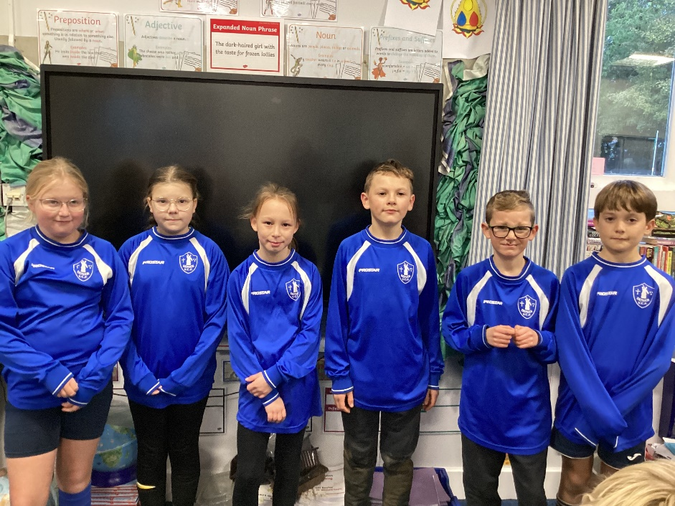

Denver Athletic (blue strip) had mixed fortunes but all played very well. Oliver received special recognition for saving 4 goals in a short space of time.
Well done to everyone and thank you to Mrs Kenna and Mrs Dawson for enabling this to happen by attending the event with the children.

