Young Leaders Training
Class 4 children began their Young Leaders Training on Monday 30th October. It was the first of three sessions that will equip them with the skills to be play leaders in a range of situations. This will include leading break and lunchtime activities, sports festivals and other team events.
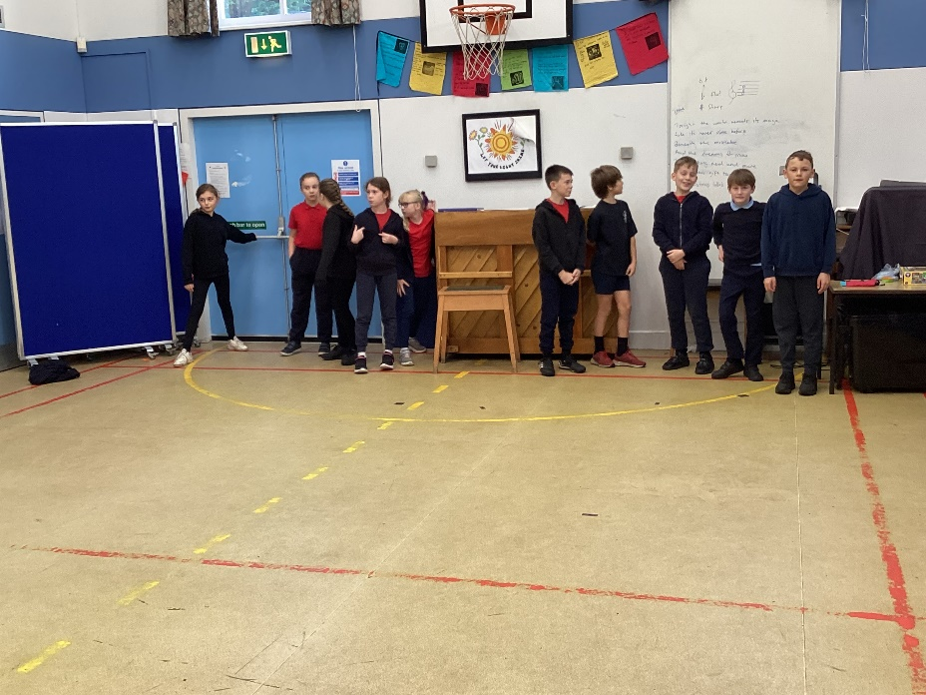
Shaun from Alive came to deliver the first session which focussed on two of the four main principles: people, area, communication and equipment (PACE).
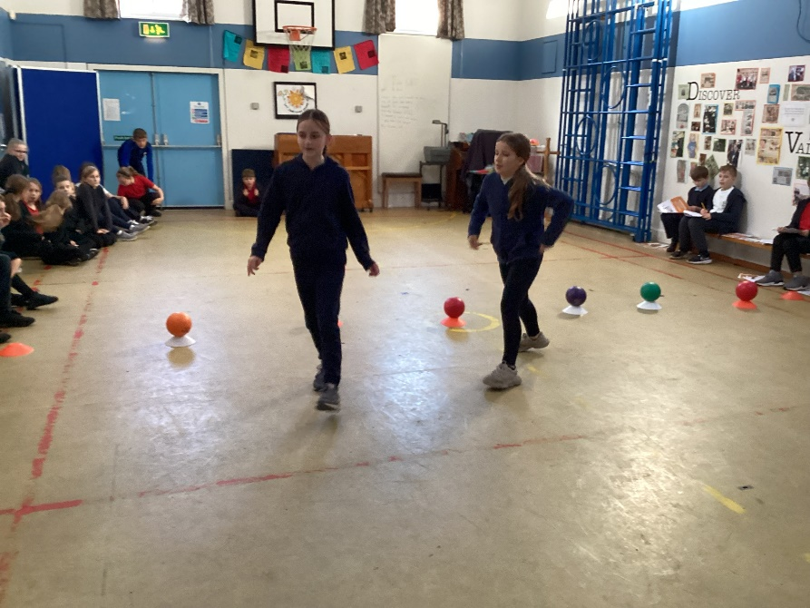
After spending some time considering how activities could be organised and made fair, the children were able to put into practise their learning by leading each other in games of dodgeball. Other children were the participants and all of hem were able to be peer assessors: explaining what was good about their leadership and what could be improved.
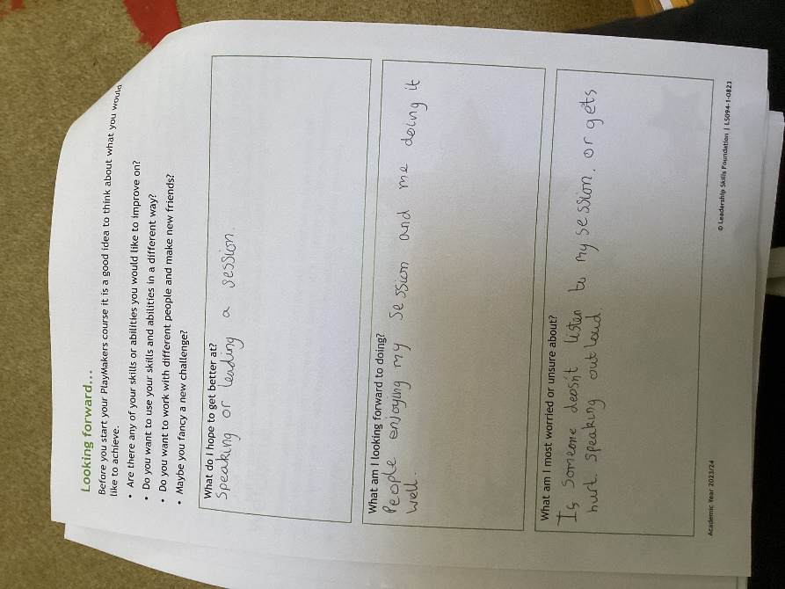
Some good skills were demonstrated and we look forward to the next session next Monday.


