Sports round-up for the week beginning 25th September 2023

In addition to the Active Kids reported in the September newsletter, there were a number of events taking place over this week.

Thank you to everyone who took part in the cycle to school week initiative. It was great to see the cycle racks full all week and to award 24 certificates in Celebration Assembly at the end of the week. Well done to everyone who took part and let’s hope the cycle racks continue to be full every week.
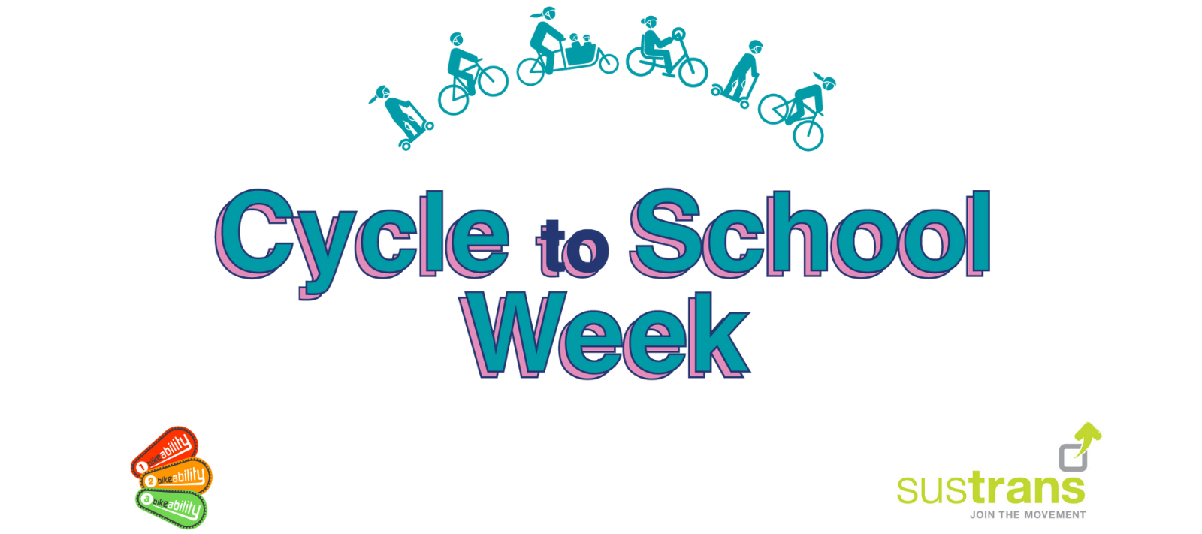
On Friday 29th September, Gary Hawkins from West Norfolk School Sports Partnership began the Fitness Tracker initiative with all children in KS2. He organised a series of activities that would provide a benchmark for individual children’s strength, agility and endurance. He will now analyse the data and suggest activities that can be done in PE lessons and breaktimes to boost their scores. He will then return later in the academic year to measure their progress.
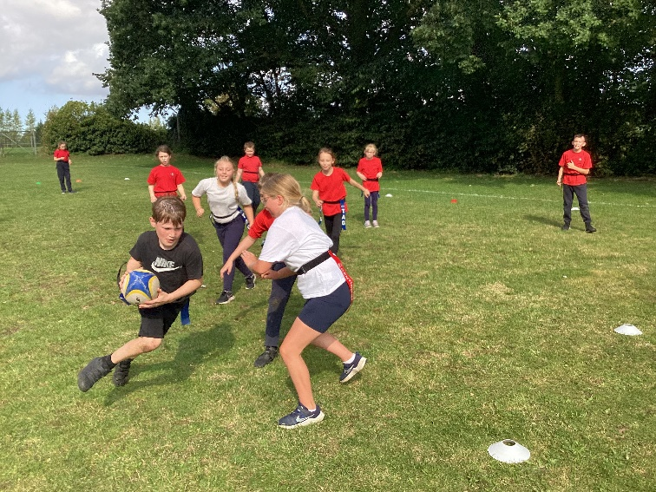
Also, on Tuesday 26th and Friday 29th September, we held our first intra-festivals of the season. Class 4 played a tag rugby tournament in their PE lesson with team 5 emerging as winners. Then it was the cross-country event. Each year group ran laps of the Golden Mile. Those with a top three finish in Years 2-6 will now progress to the cluster Cross country on Tuesday 10th October at Hillcrest.
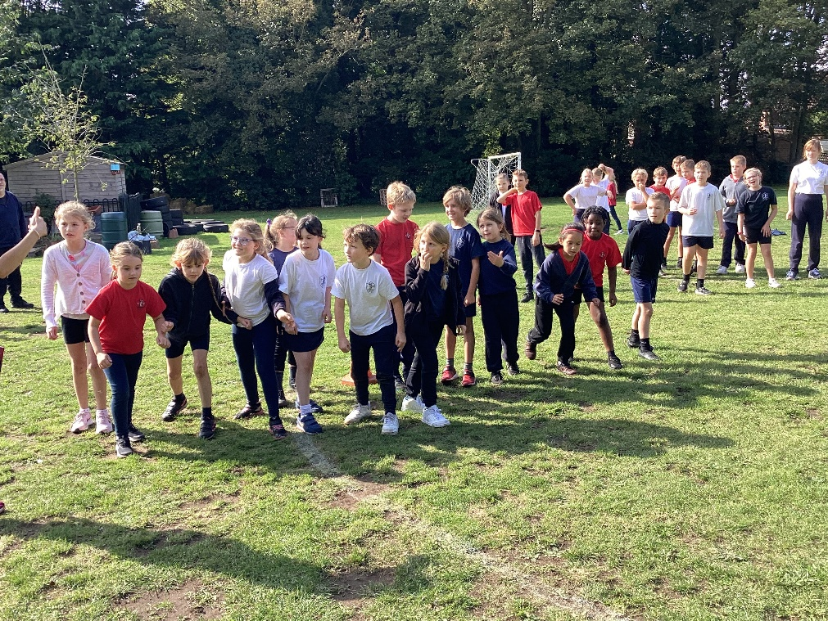
Here are the results:
Race | Boys | Girls
Y1 (2 laps) | 1st Barney  2nd Hector  3rd Alexander | 1st Ivy W  2nd Lily  3rd Ivy B
Y2 (2 laps) | 1st Jupiter  2nd Oliver  3rd Raife | 1st Libby  2nd Rebekah  3rd Ottilie
Y3 (3 laps) | 1st Osian  2nd Hugo  3rd Matthew W | 1st Evie  2nd Octavia  3rd Indi
Y4 (4 laps) | 1st Chase  2nd Arthur  3rd Drew | 1st Esther  2nd Edith  3rd ----
Y5 (5 laps | 1st Max  2nd Alfie Cl  3rd Eric | 1st Amelia  2nd Isla  3rd Hope
Y6 (5 laps) | 1st Oliver  2nd Finley  3rd Sonny | 1st Ella  2nd Emie  3rd Mia

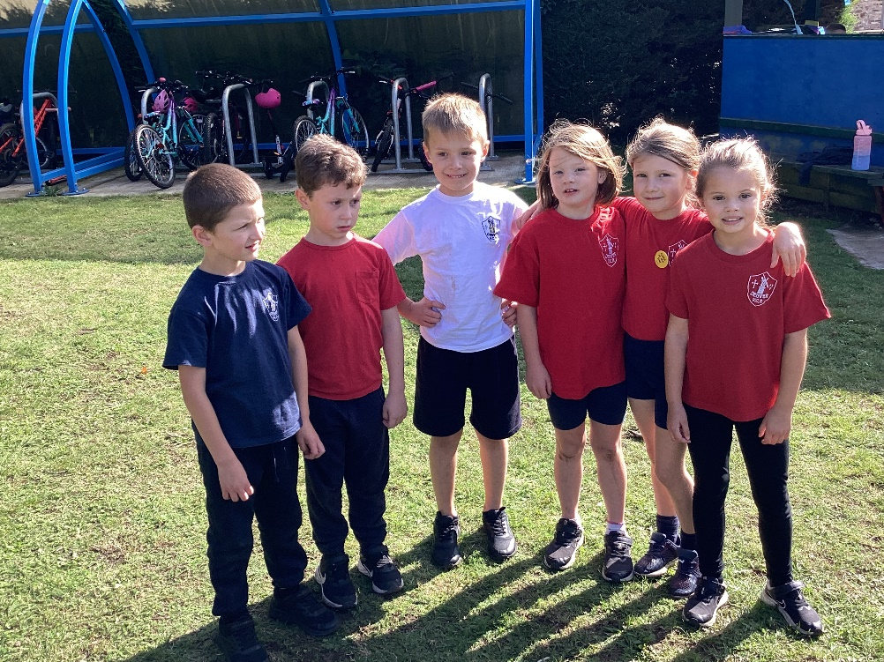
The best part of the afternoon was seeing the kindness shown to each other, supporting them to complete the races and helping when they were struggling. There was excellent sportsmanship shown from everyone. What great children we have at Denver School!



