Denver School Games Festival 2023
Young leaders from Class 4 organised and ran a multi-skills festival for the rest of the school on Tuesday 11th July.
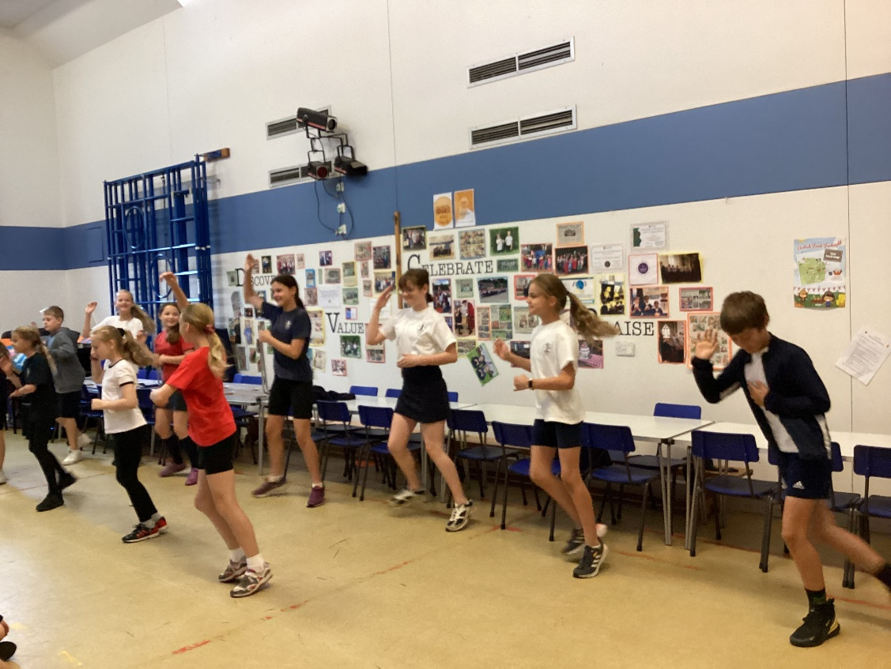
The children decided on a range of games that would use different skills of throwing, running and jumping whilst promoting teamwork and resilience by working alongside each other to earn points for their teams.
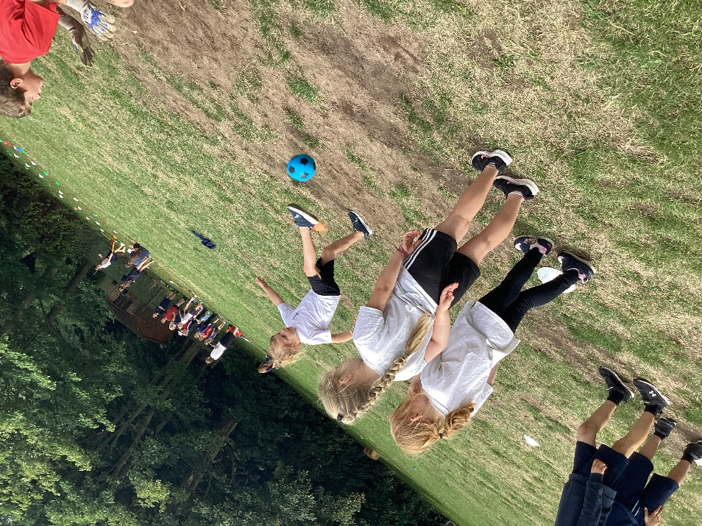
The day began with a short assembly to introduce the theme: equality. Young leaders had been tasked with thinking of ways to ensure that there was equality of opportunity within their games to give every child, regardless of age, sufficient challenge. They had been challenged to create their own scoring systems and sets of rules that they had to communicate to the children visiting their activities. Our dance festival group performed their routine to get everyone in the festival mood.
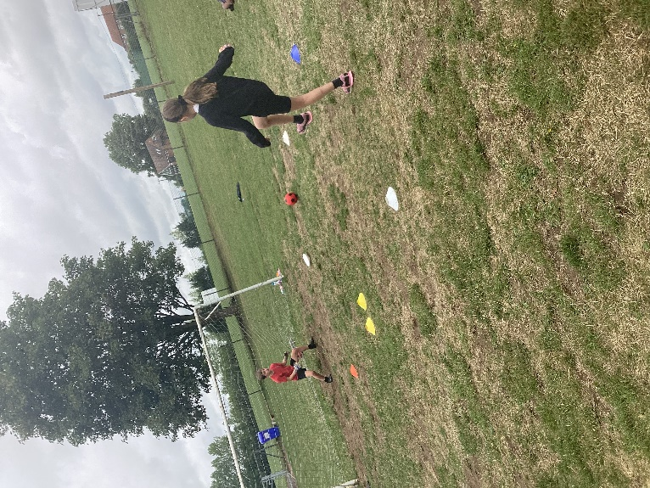
The morning ended with another assembly where the winning team was revealed. Congratulations to Team 3 who amassed a whopping 2112 points!
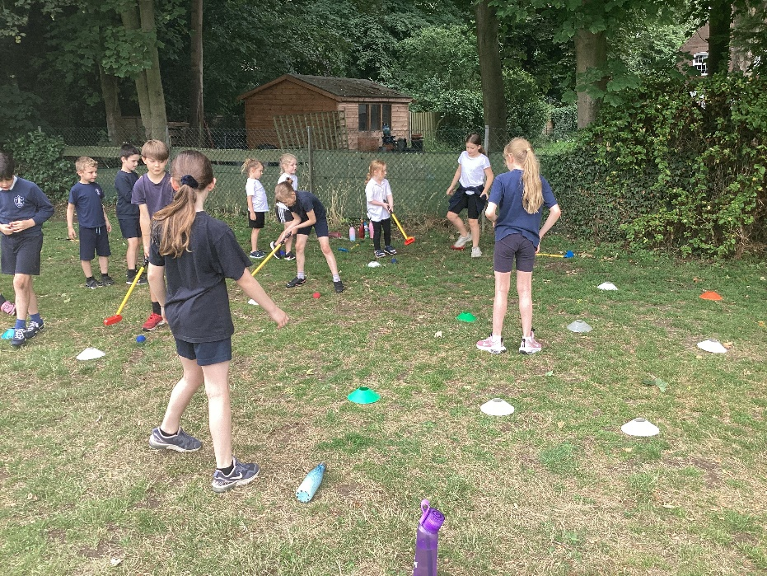
It was a really enjoyable morning with superb participation. Class 4 leaders did a fantastic job. Well done!

