Sports Day 2023
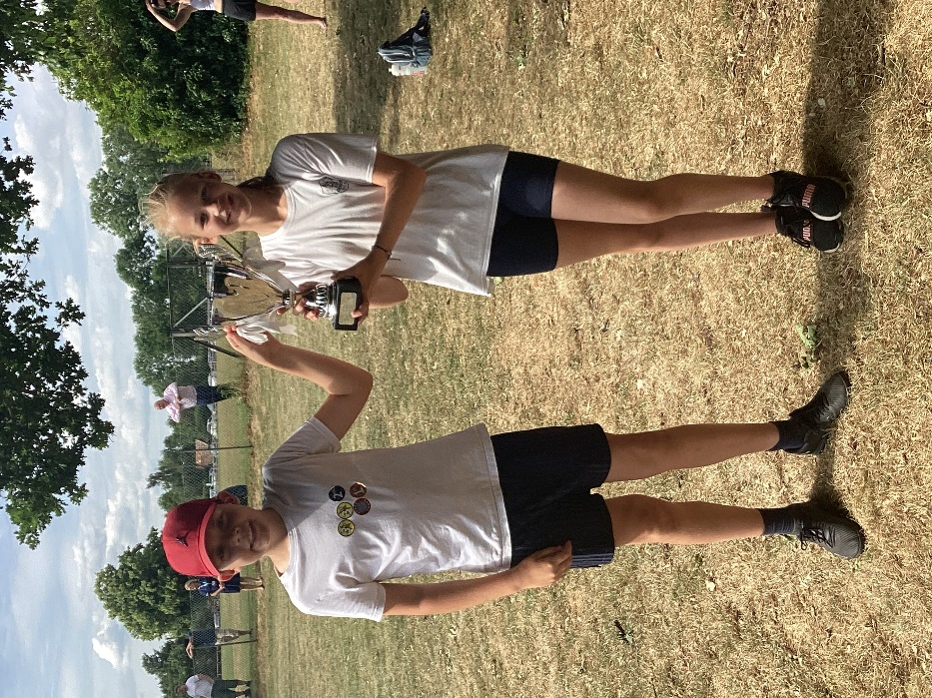
After a weather-delayed wait, we were pleased to be able to hold our annual Sports Day on Friday 23rd June.

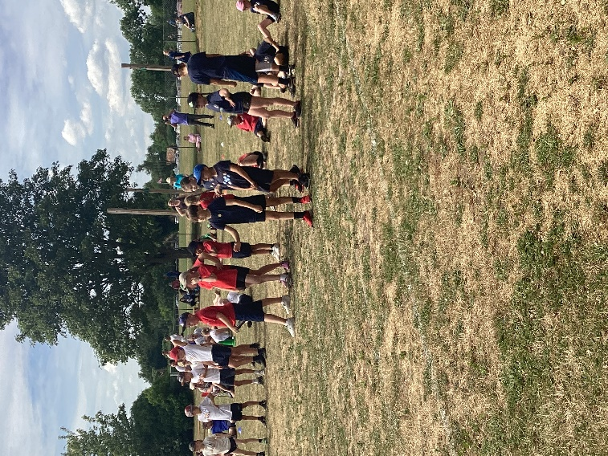
The event was well-attended by spectating families thanks to the perfect weather.

The afternoon began with the Key Stage 1 and Reception carousel. The little ones enjoyed a range of activities that used their fundamental movement skills.
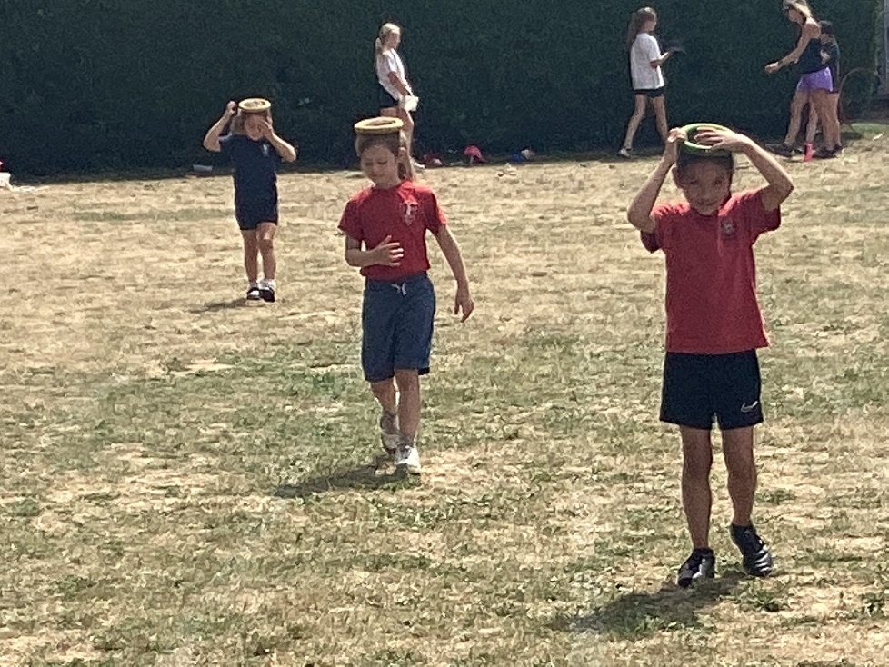
Straight after was the more traditional track-based KS2 event.

Overall winners were the Whites. Congratulations to them but to everyone who took part.
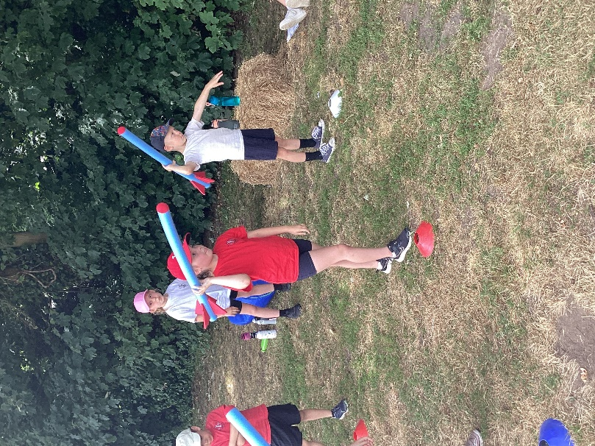
We would like to express our thanks to Miss Cronin for organising the day, all staff and parent/governor helpers who gave up their time and especially to Class 4 who did a tremendous job f running each activity.

