Under 9’s rounders friendly
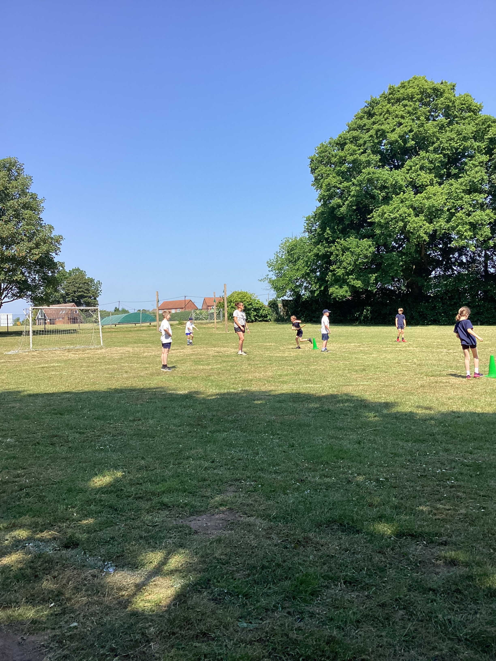
Children from Downham Prep visited children from Class 3 for an under-9s friendly rounders match on Friday 9th June.
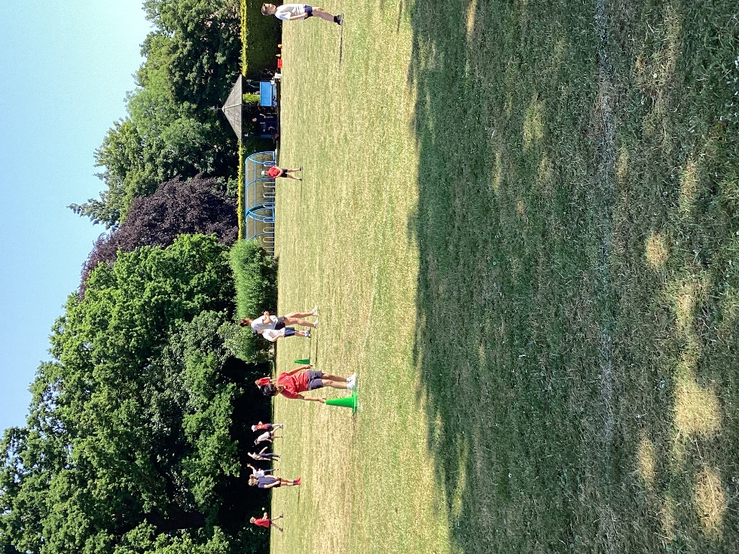
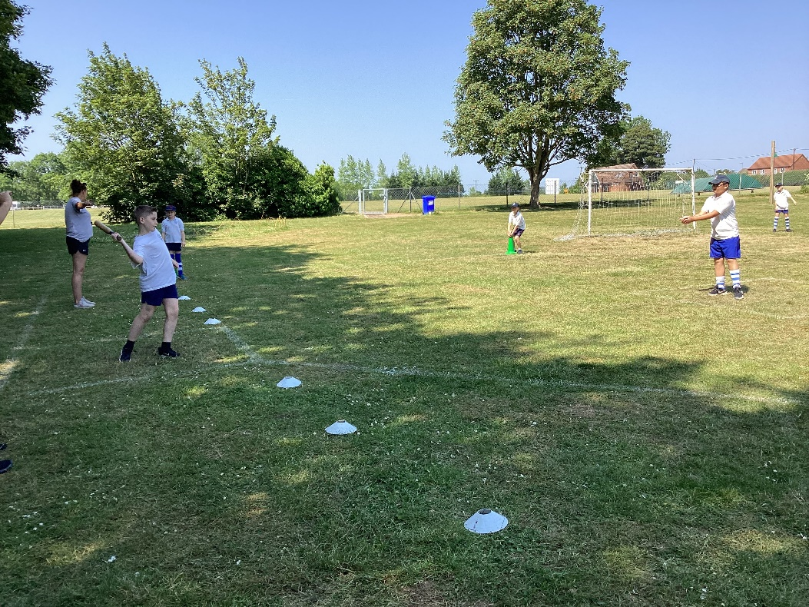
Downham Prep were the overall winners.
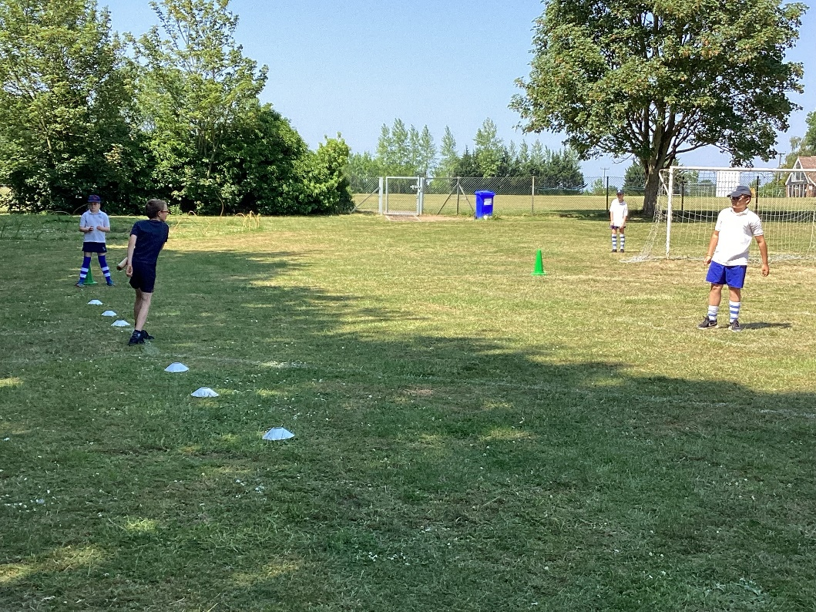

They bought along with them their sports coach, Jesse Tierney, who was once a pupil here at Denver!

