Cluster Kwik Cricket tournament
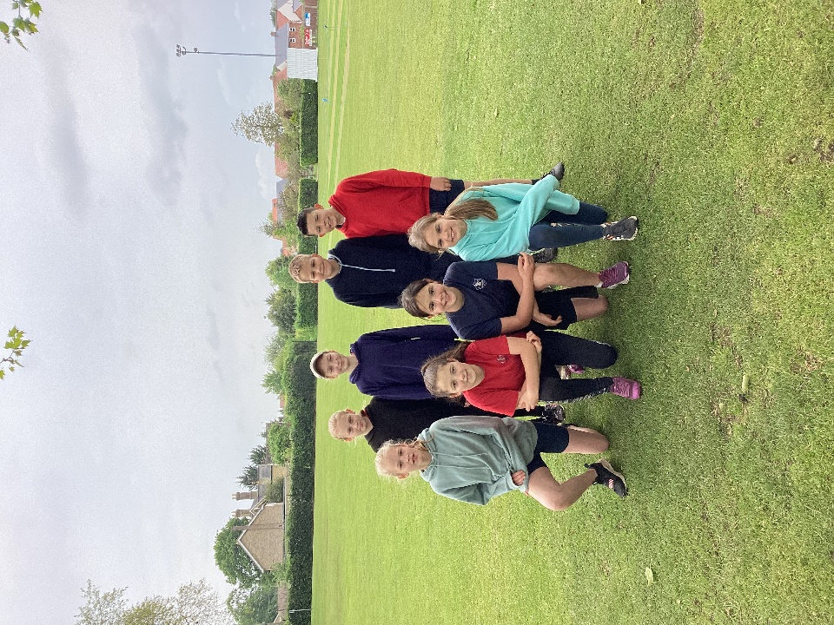
On Friday 19th May, two teams from Class 4 attended the cluster Kwik Cricket tournament at Downham Market Memorial Field.
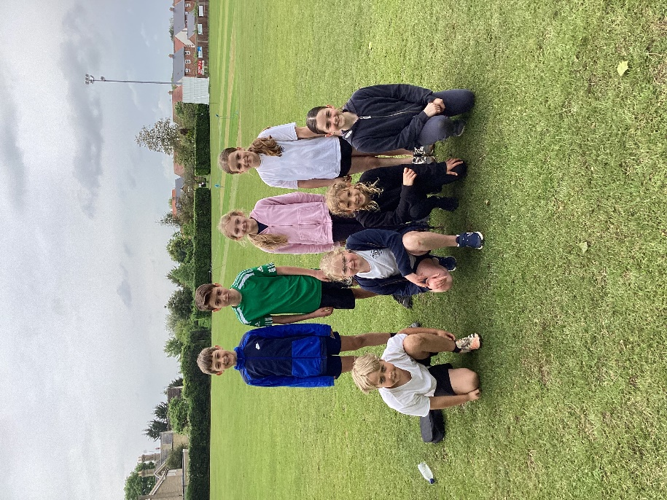
The conditions were dreadful for much of the time but that didn’t spoil their enjoyment. The teams came a very respectable 3rd and 5th and were good ambassadors for the school.
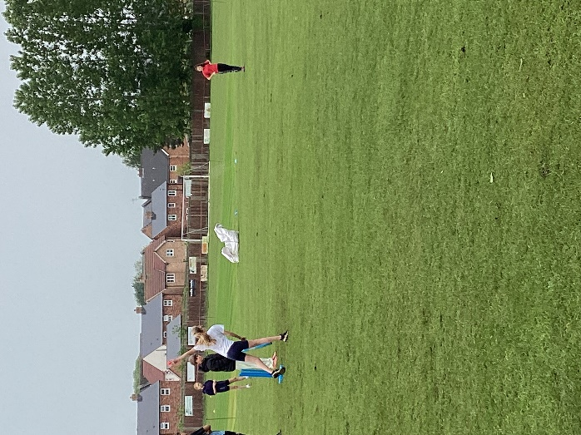
Many thanks to Martyn Wardle of Denver Cricket Club for preparing them for the tournament by running after school sessions on Wednesdays. His final session will be this coming week.
Thanks also to Mrs Collins and Miss Loveridge who attended the tournament with the children.


