Crucial Crew 2023
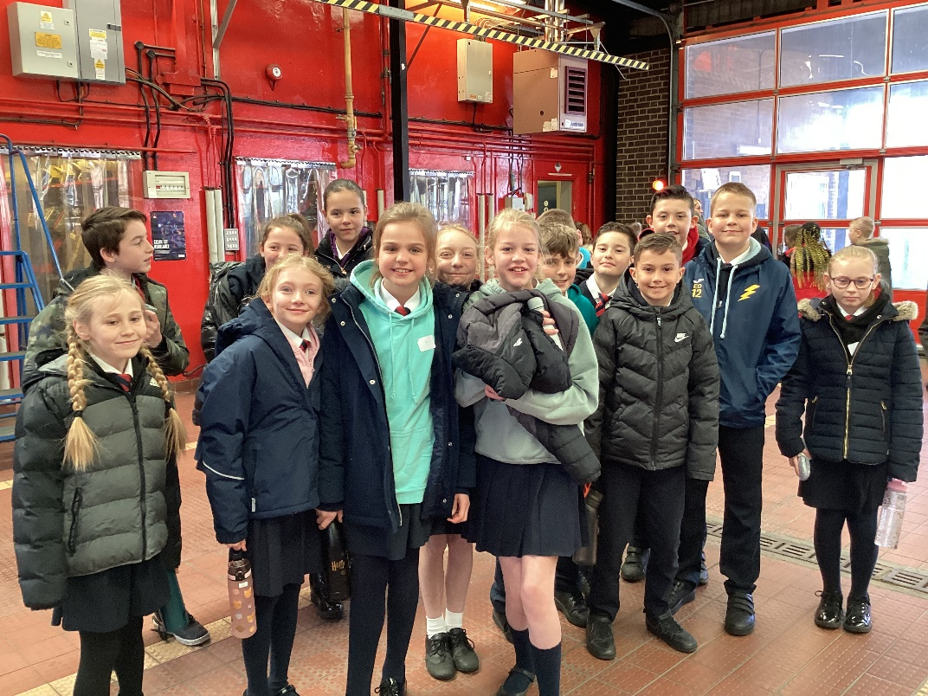
Year 6 children took part in the annual Crucial Crew event at King’s Lynn Fire Station on Tuesday 25th April.
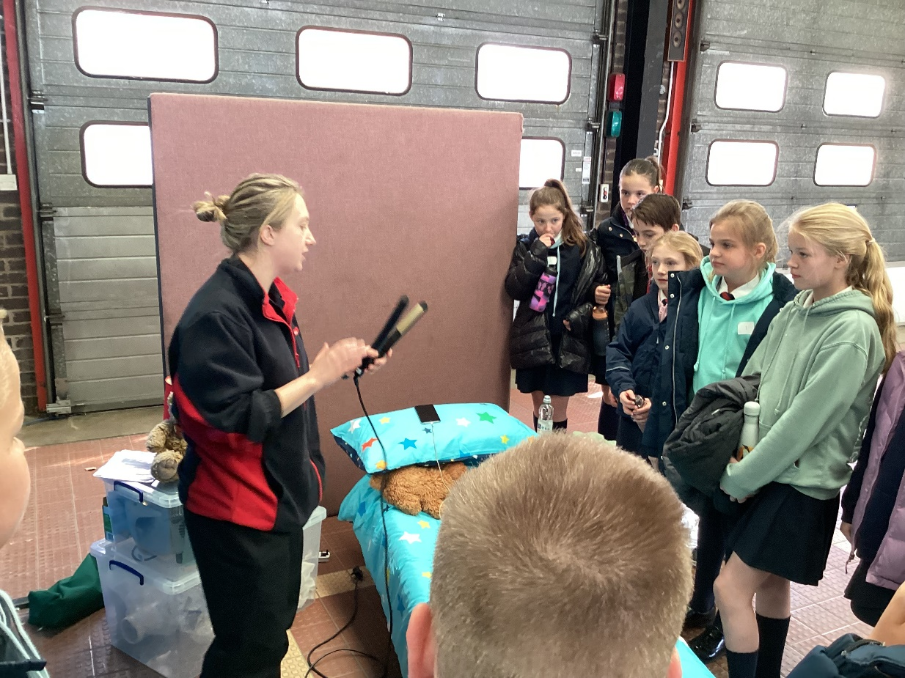
Crucial Crew supports the RSHE and citizenship curriculum by sharing workshops that explore safety in a range of situations. The Fire and Rescue Service taught the children to be more fire aware in the home. They discussed potential hazards and also what to do when faced with a fire.
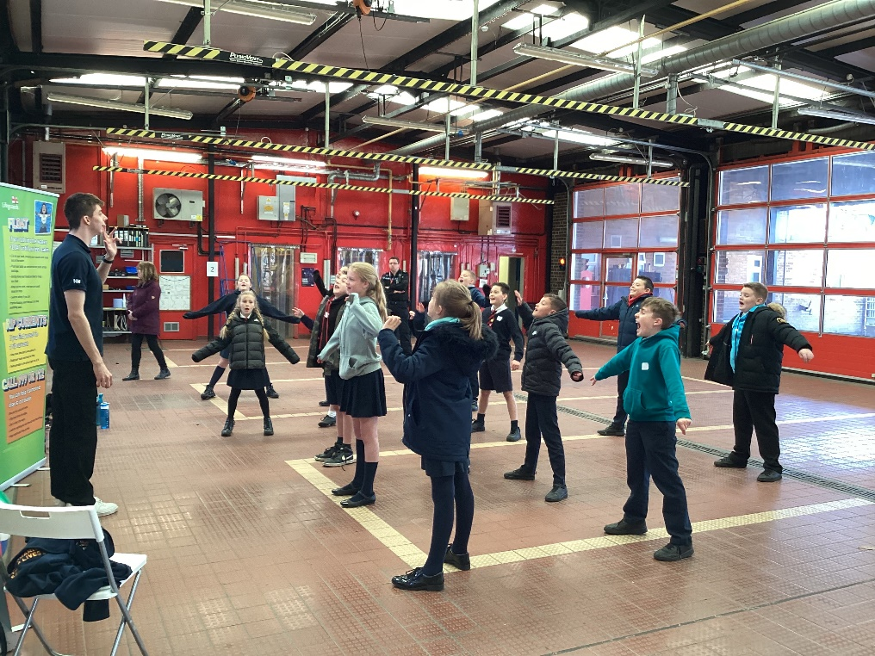
The next station was run by the RNLI. This was about what to do if swept away at sea and how to get the attention of people who could rescue you.
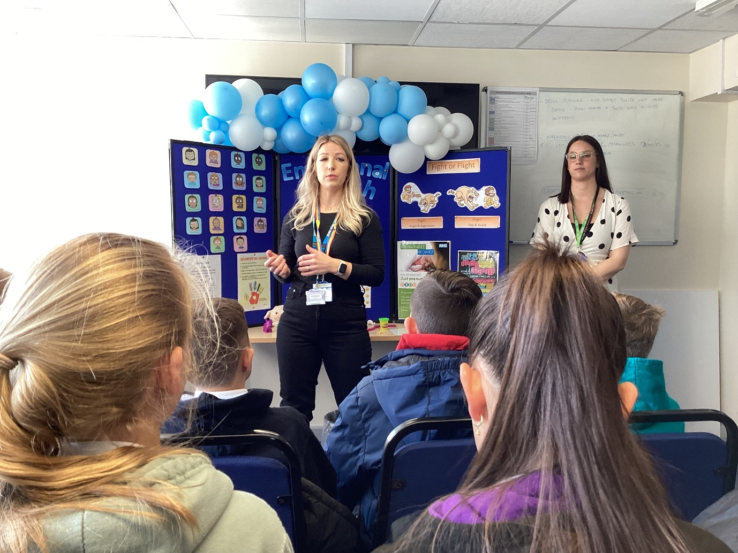
We then moved on to an NHS mental health and emotional wellbeing workshop where the children were shown some very simple strategies for grounding themselves when feeling anxious or angry.

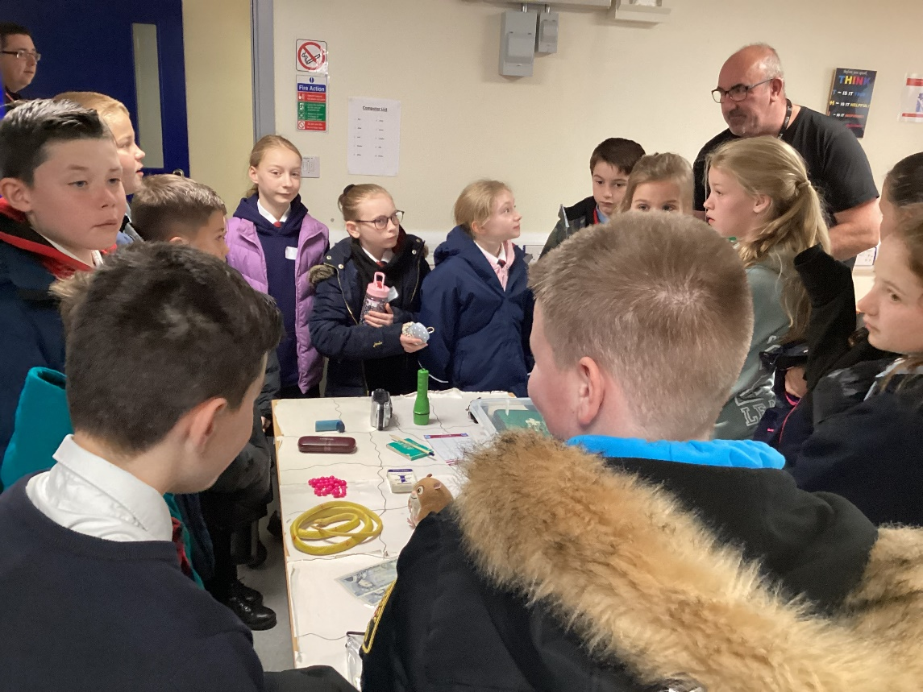
Soon after, we were asked by the Environment Agency to think about what might happen if our area was so badly flooded that we had to evacuate our homes to a nearly school or leisure centre. What would and should we take to cope?
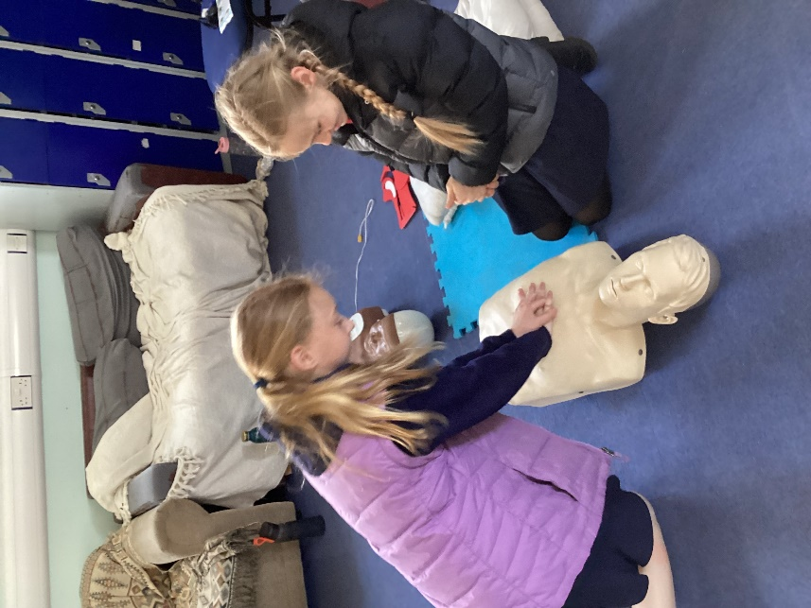
The East of England Air Ambulance Crew then taught us valuable lifesaving first aid skills, how to call for emergency services and how to find and use a defibrillator.
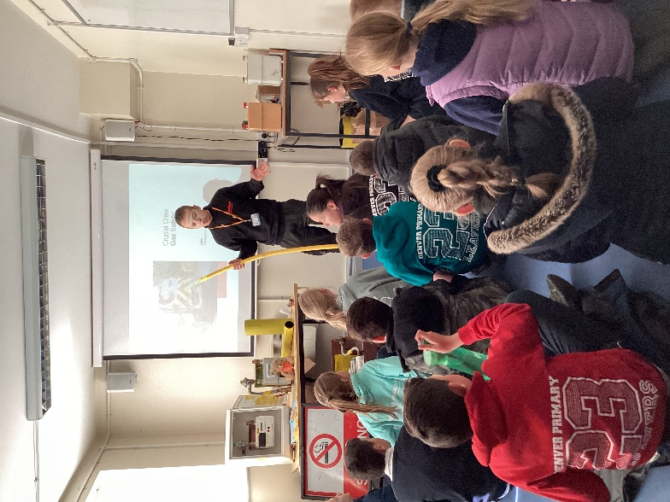

Onwards to Luke, a representative from Cadent, and such an engaging character. He explained how we can prevent, detect, report and deal with gas leaks.
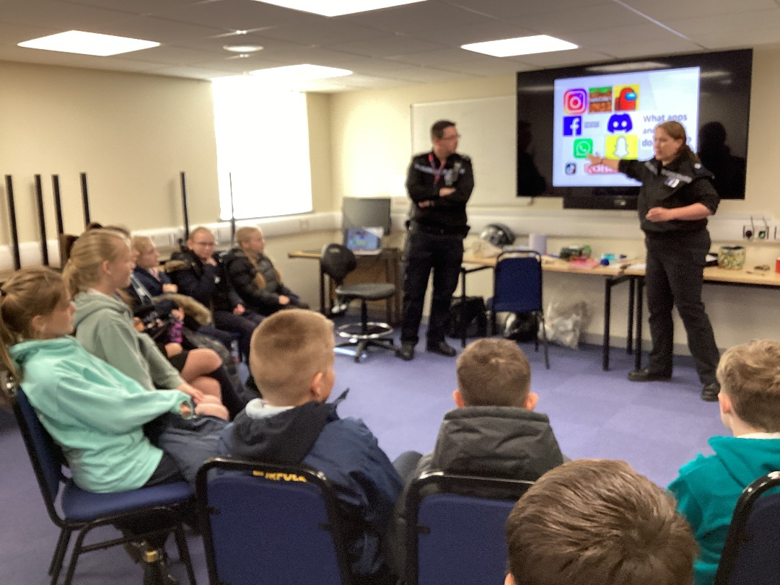
Last but not least, police representatives from Norfolk Constabulary discussed social media and how to protect ourselves online. The children were bemused by the cartoon where Alex’s willy goes viral but underneath the giggles was a valuable lesson about protecting our privacy and images.
We are very grateful to the Friends of Denver School for funding the coach for this valuable experience.

