Cluster football tournament
On Friday 24th March, our two football teams travelled to Hillcrest Primary School for the latest cluster football tournament which was much better attended than the last.
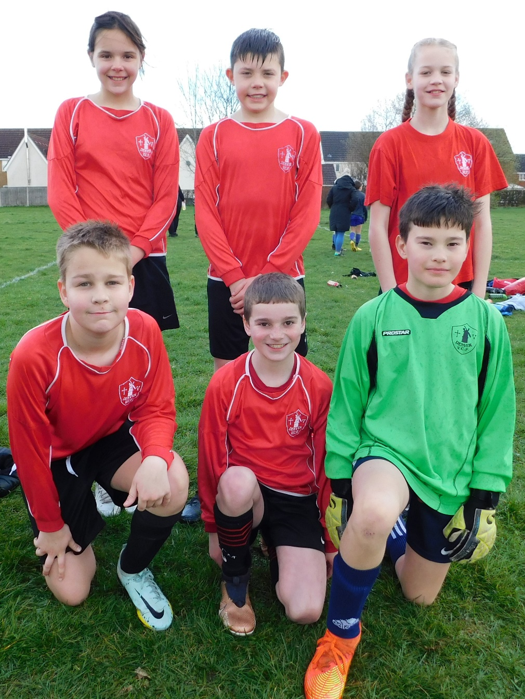
Denver Dynamos (in red) played in Pool 1 and Denver Jets (in blue) played in Pool 3.

There were some great matches with both teams playing impressively.

Denver Dynamos were runners up in their pool and Denver Jets third. Great results for a small school facing some giants. Well done everyone!

Thank you to the adults who gave up their time to allow this to happen.

