Game Changers
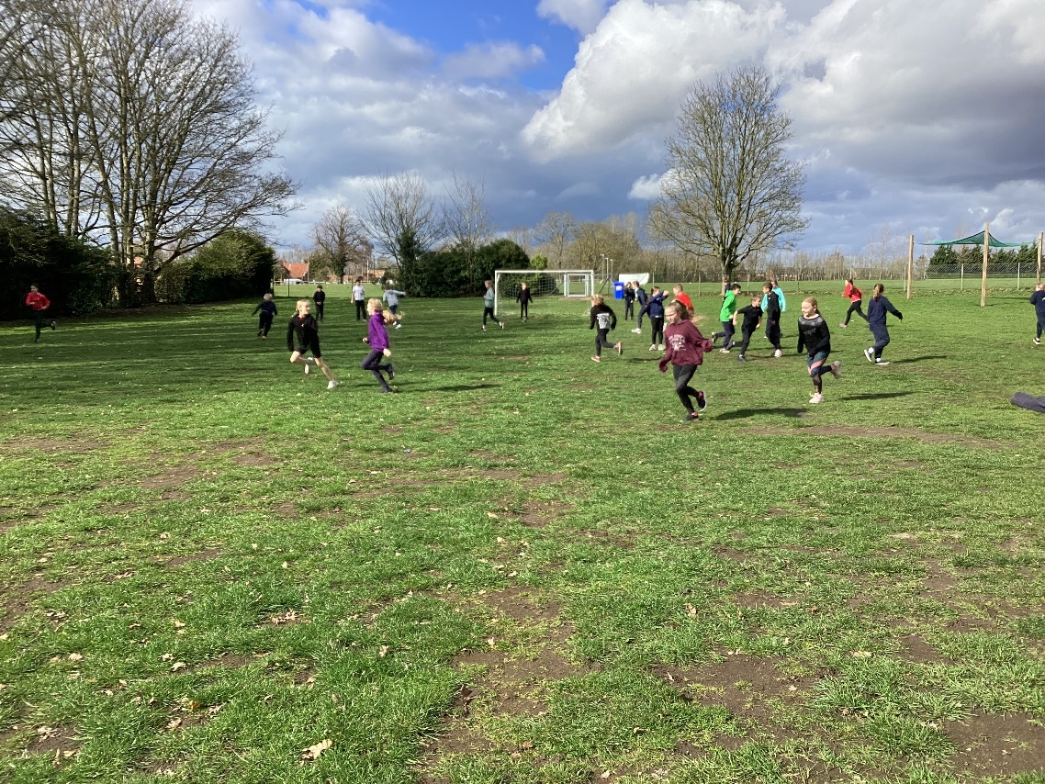
On Tuesday 21st March, Class 4 continued with Game Changers.
This week the focus was on resilience. We began by considering what it is and when we have shown it.
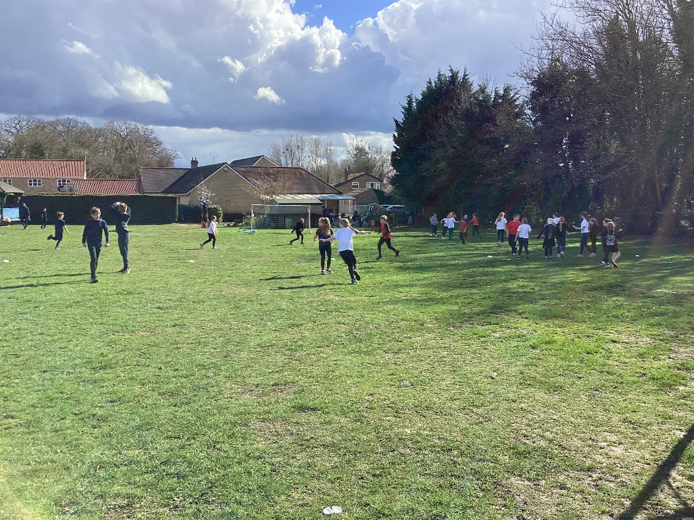

We discussed the difference between long-term and short-term goals and how reliance will ensure that both are achieved.
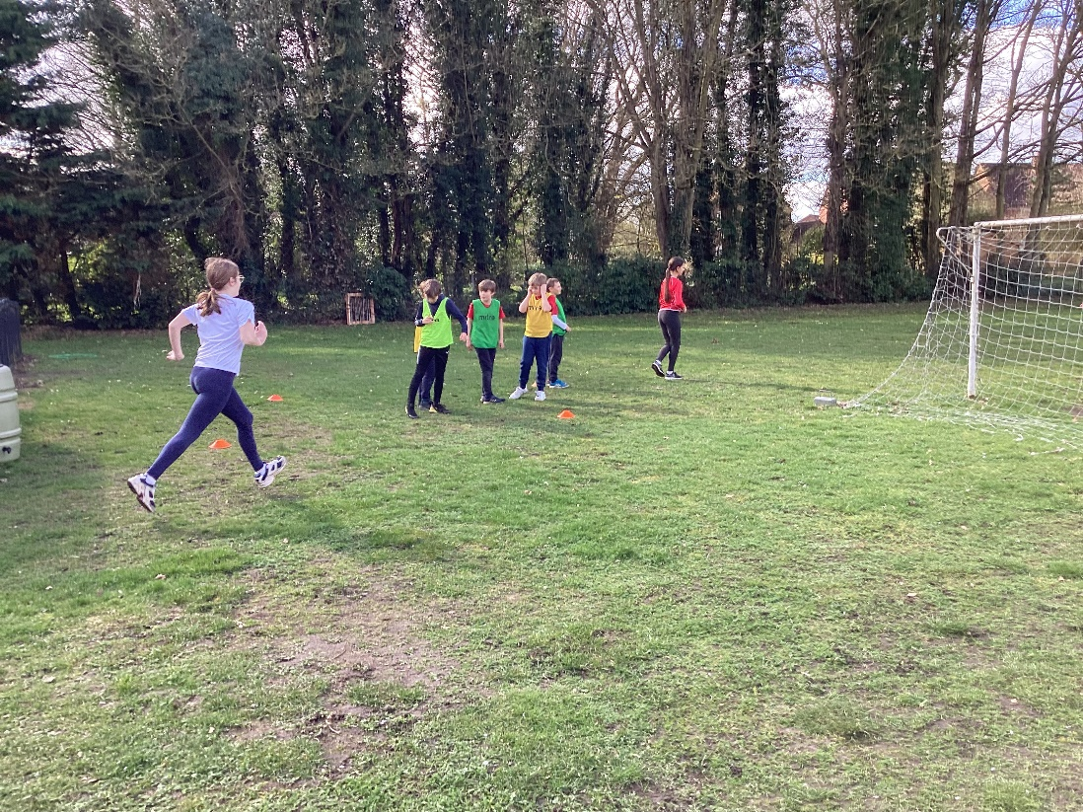
The children thought about which sporting stars/athletes had demonstrated resilience. This led on to a discussion about what it means to be inclusive.
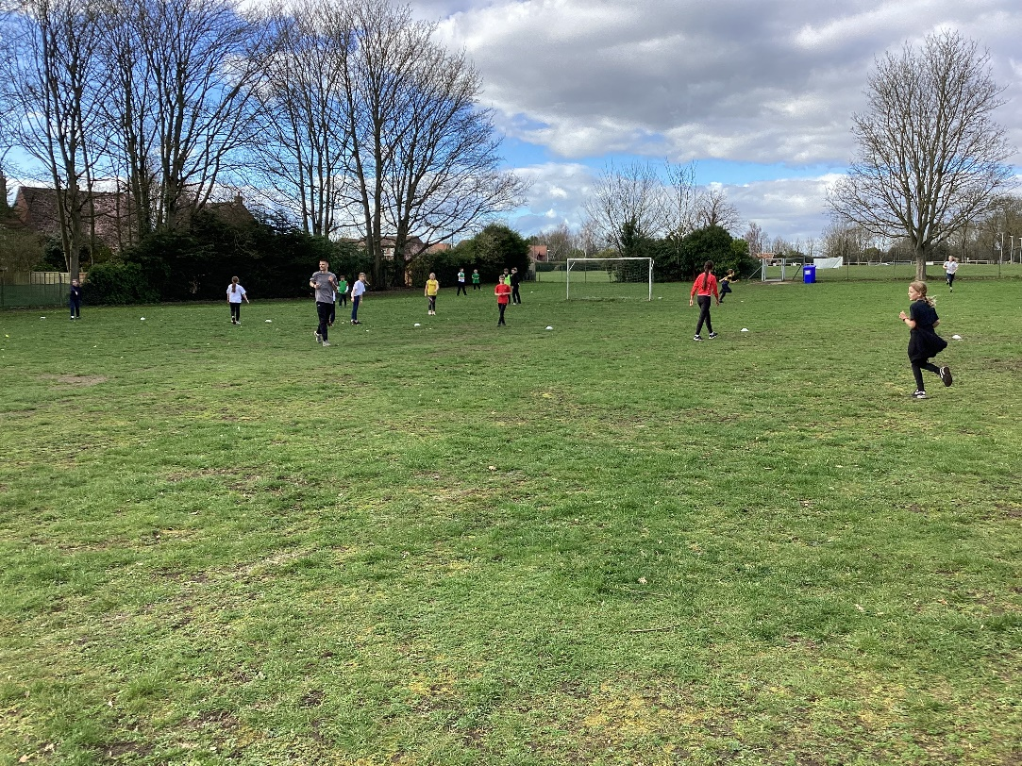
The next step was to explore PE activities that enabled the children to be both resilient and inclusive. The main game was ‘Capture the flag’. Neither team won after 40 minutes of continuous attempts – a testament to their resilience.


