Downham Market Cluster Bee Netball tournament

On Tuesday 21st March, a squad of 6 children from year 6 travelled to Downham Market Alive Leisure Centre to take part in the cluster Bee netball development tournament.
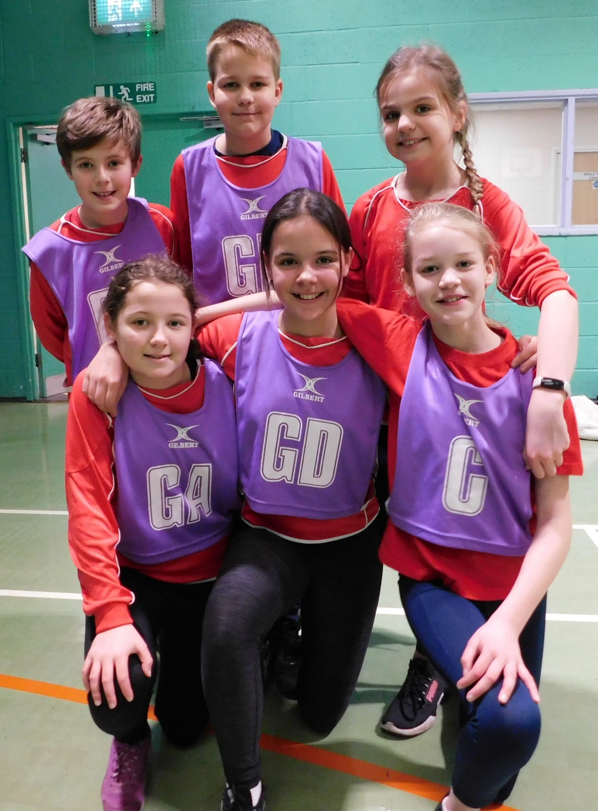

It was an opportunity to try out a new game in a friendly competitive format.

The squad rotated around the different netball court positions to gain experience of defence, attack and centre tactics.

The team showed very good sportsmanship throughout and were a creditable 3rd out of 6 in their first ever attempt at this adapted game.

Well done to everyone and thank you to Mrs Dawson and Mrs Williamson for taking the time to ensure this could happen.

