Christmas Play
To celebrate Christmas, Classes 1 and 2 have worked incredibly hard together to perform this year’s Christmas performance: ‘The Boy who Made Santa Cry’.
Similar to RE, where we have been learning about why Christians perform a nativity at Christmas, we included the nativity story in our own play this year as part of the performance to help us remember the importance of Christmas to Christians.
We learnt a selection of songs with Mr Lawrence that were performed through the performance and some of us even had key roles in the play, acting as children visiting Santa and even Noah from the nativity!
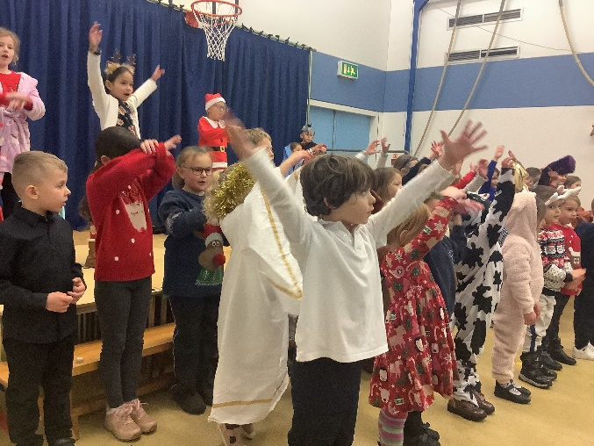
The performance went fantastically and all of the parents enjoyed our work. We loved doing the play and singing the songs and thank you to Mr Lawrence for creating the play for us!

