Under 11s Girls Only King’s Lynn Town Football League Tournament 2023
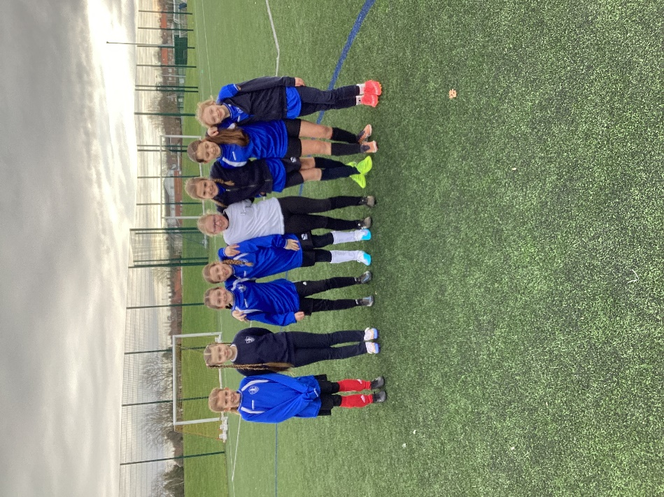
Our all-girls football team travelled to Lynnsport to compete in the area National League event organised by The Linnets and West Norfolk School Sports Partnership on Friday 3rd February.
They were one of twelve local teams and came 9th place overall in their debut as a team.
These are the results of the matches they played:
Denver O, Docking 1
Dersingham , Denver 1
Denver 0, Terrington St. Clement 1
Denver 1, South Wootton 3
Denver 1, Ashwicken 1
9th and 10th place play off: Denver 1, Hillcrest 0
The children were excellent ambassadors of the school earning recognition for their politeness and sporting behaviour. They should rightly be proud of their efforts.

