Under 11s King’s Lynn Town Football League Tournament 2023
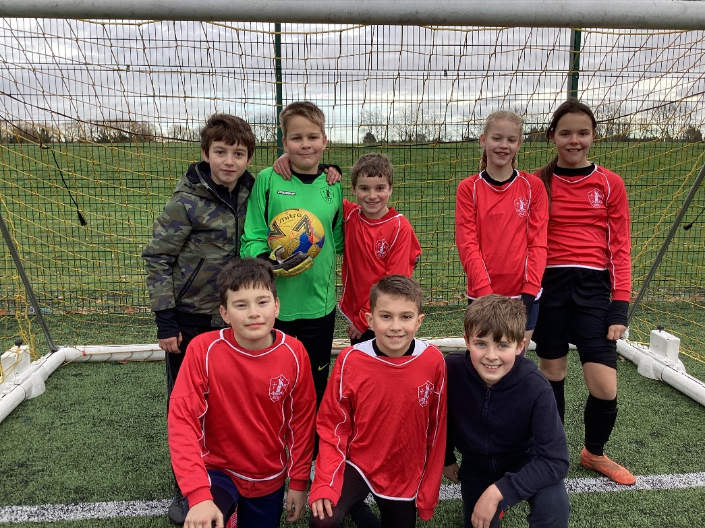

Our mixed football team travelled to Lynnsport to compete in the area National League event organised by The Linnets and West Norfolk School Sports Partnership.
They were one of twenty local teams and came a very credible 7th place overall with some close and exciting matches.
These are the results of the matches they played:
Denver 1, Holly Meadows 0
Greshams 3 (overall tournament winners), Denver 1
Denver 2, Sandringham 0
Dersingham 1, Denver 0

7th and 8th place playoff: Denver 4, Terrington 1
Sonny was also recognised for his individual talents by KLTFC.
The children were a credit to the school with impeccable behaviour and sportsmanship throughout the whole day. We are very proud of them.

