Area Cross country finals at Lynnsport

On Thursday 24th March, children who had qualified with a top ten finish in the Downham cluster cross country tournament travelled to Lynnsport to compete in the area finals.
The children did fantastically well showing a whole wealth of School Games values such as determination and resilience.
Mr Peach, who was spectating, kindly offered this review of the Year 3 girls race:
On Thursday 24th November, Esther and Lorelei competed for Denver in the 2022 West Norfolk Cross country competition. On a very fresh November morning, both girls arrived on time and excited to represent the Denver year 3 girls. Lining up against more than 50 competitors, both Esther and Lorelei made strong starts, with Lorelei storming to 4th place over the first 400m. Esther made a steady but strong start in the middle of the pack. Over the next half of the race both girls who were jostling for position made their way round a long and challenging course, both giving everything and doing Denver proud. As they rounded the final bend, Esther and Lorelei found themselves in a pack of around 10 children; they both managed to finish strongly out sprinting competitors to finish in 30th for Esther and 35th for Lorelei. Amazing achievements and both girls should be very proud of themselves!
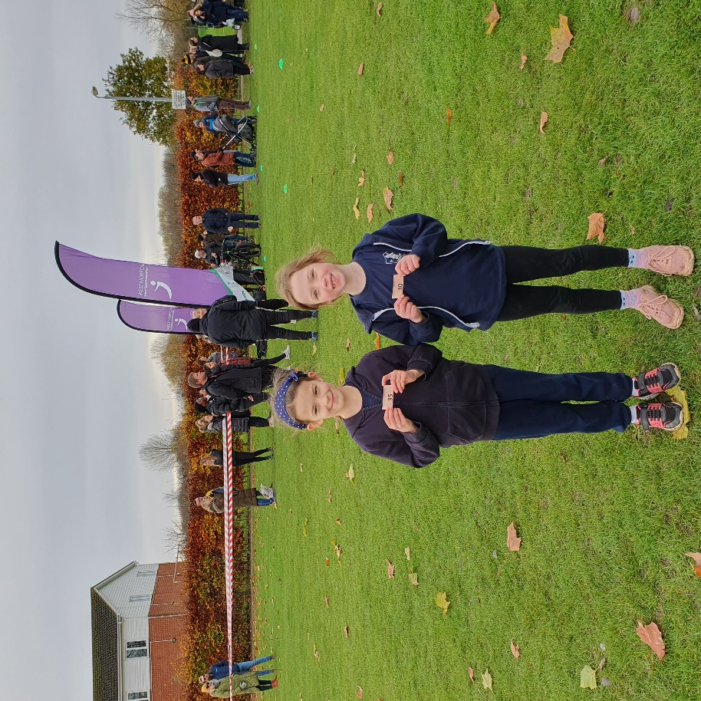
A top ten place would see the competitors through to the county finals. Well done to Mia and Joshua-Jon in Class 4 whose 9th places secured their advancement to the next stage.

Thank you to the parents and carers who took the time to take the children to the event.

