Class 4 support the Denver Christmas Fayre
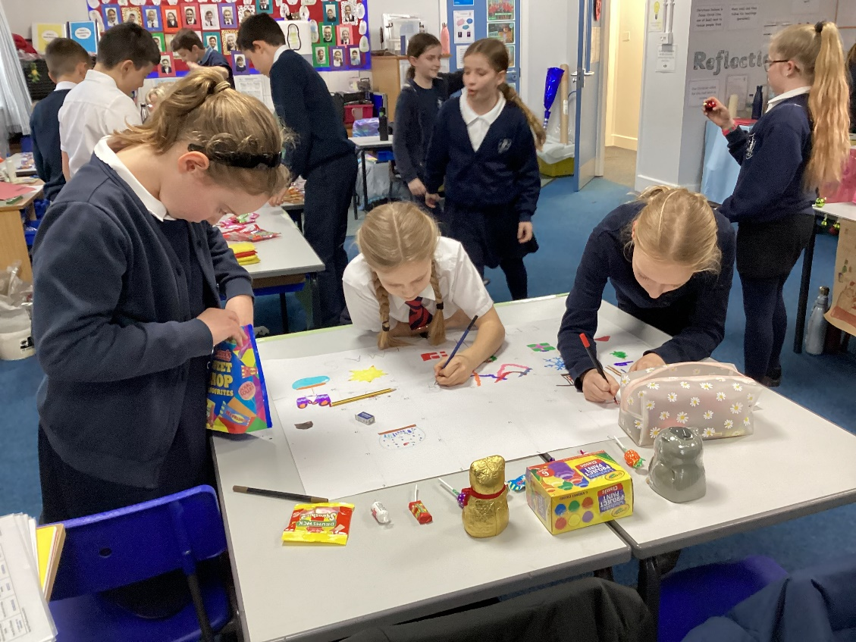
The children in Class 4 did an excellent job of running stalls in support of the Denver Primary Christmas Fayre on Thursday 24th December.
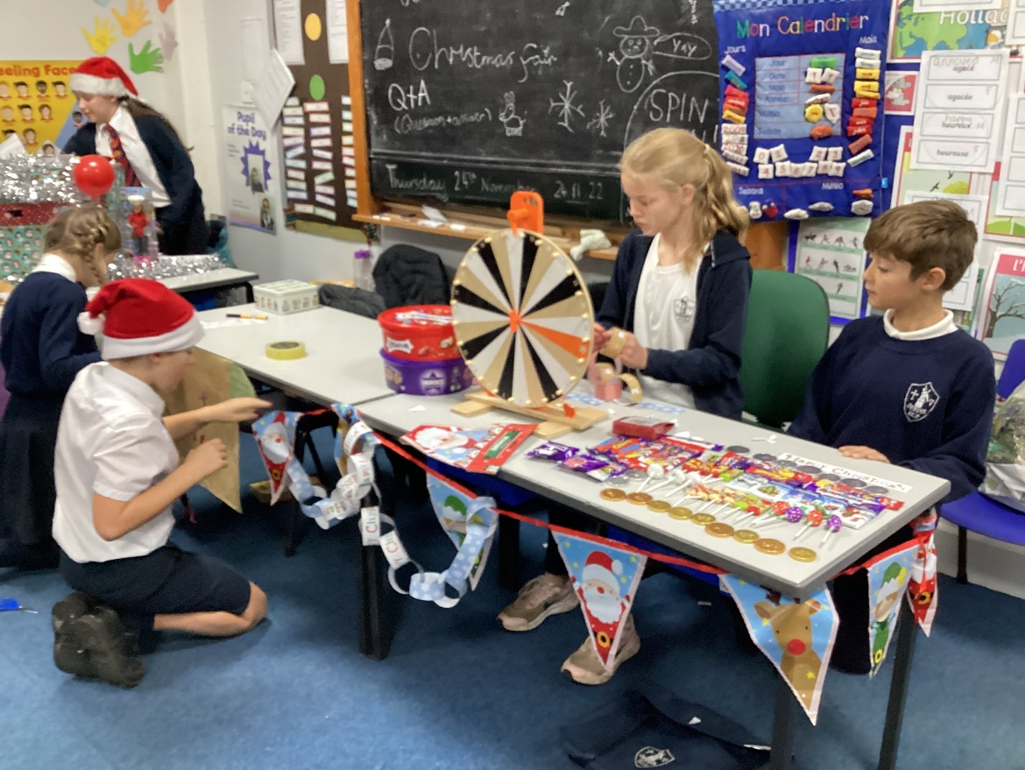

The children had planned, made and resourced the stalls by themselves with the support of their very generous families. The teamwork was incredible.
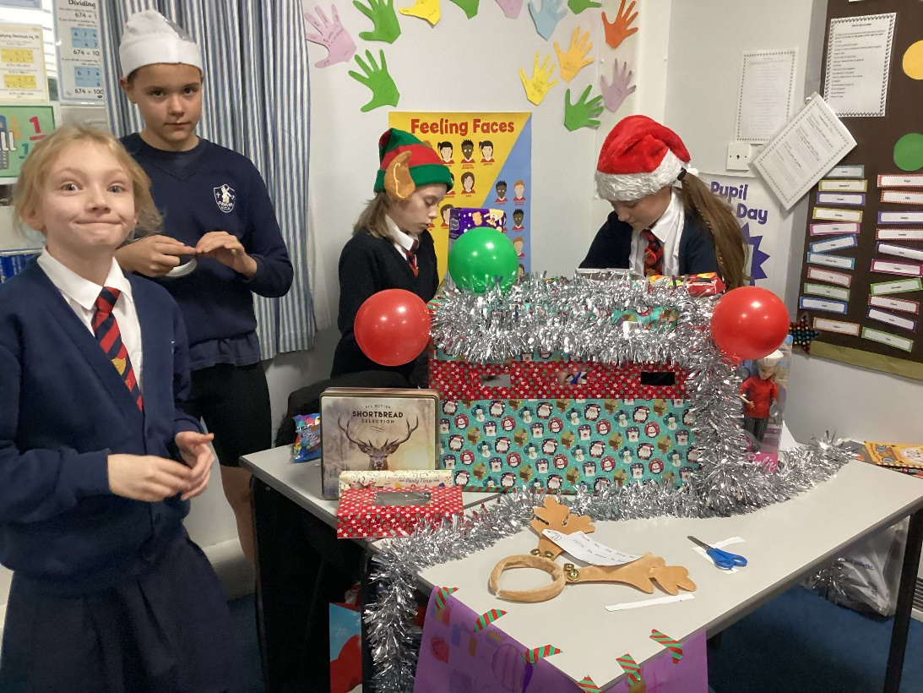

The event itself was a resounding success. People gave generously with some of the stalls taking in excess of £30 each. Full totals are to be announced as soon as possible.
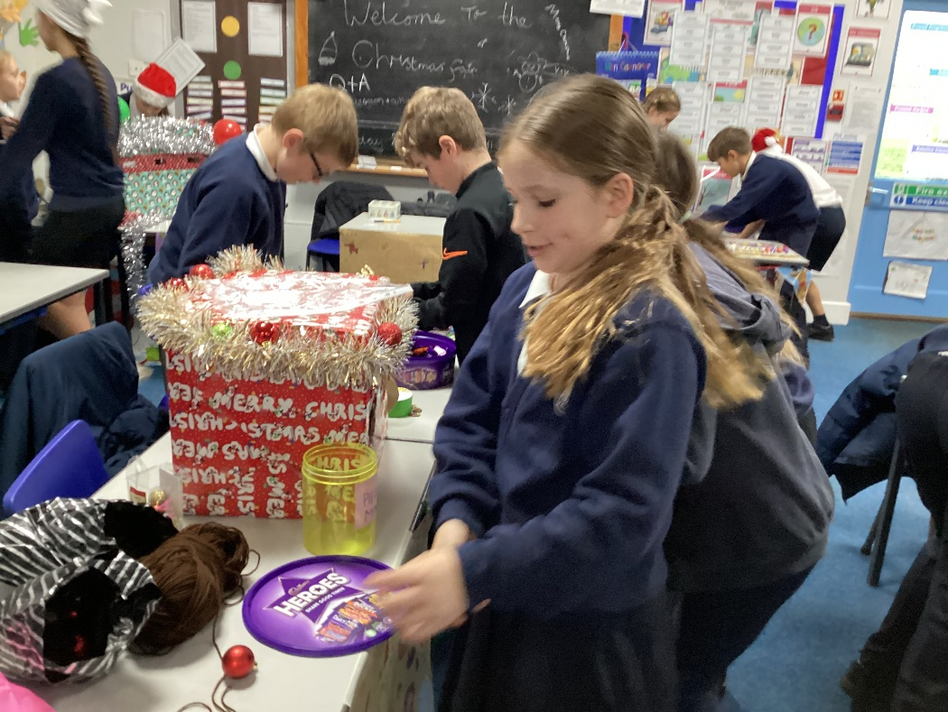
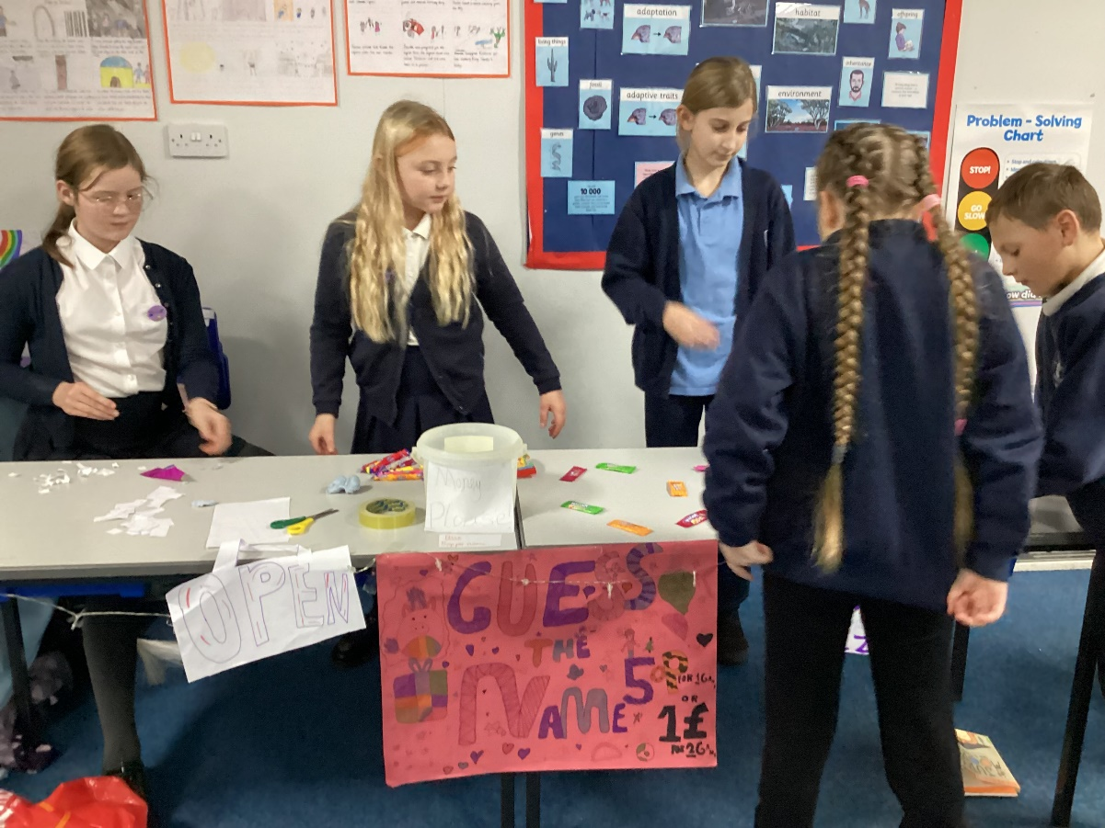
As a class we are very grateful to everyone who supported us and our cause and would like to offer our sincere thanks.


