Class 1 Pizza Making
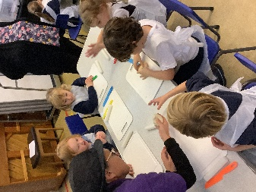
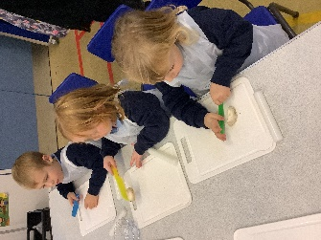
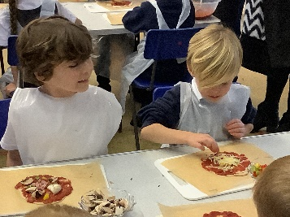
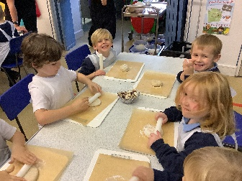

Class 1 had some special visitors come into school to show them how to make their own pizzas.
The class first learnt about how dough is made through feeling flour used to make the base and what it feels like after it has been mixed.
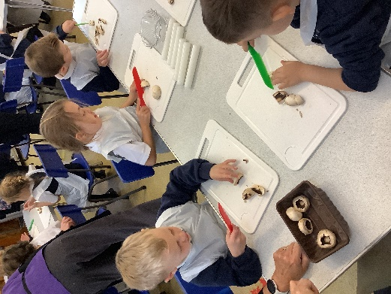
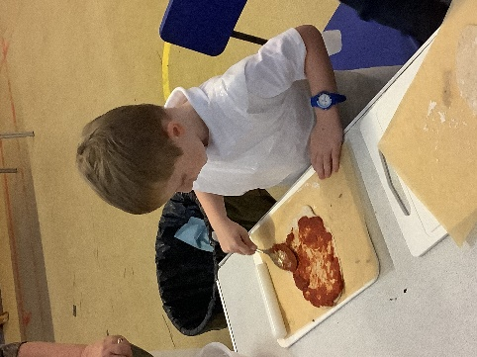
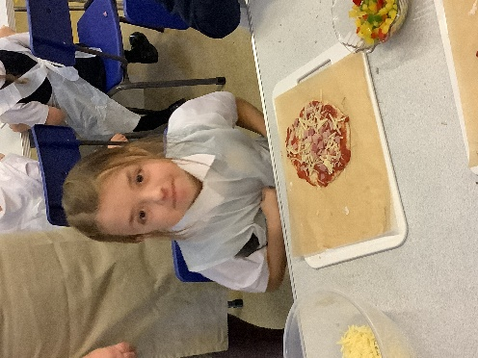
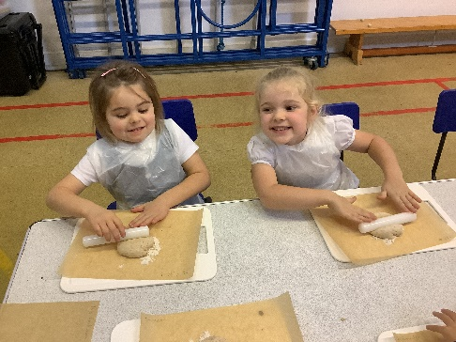
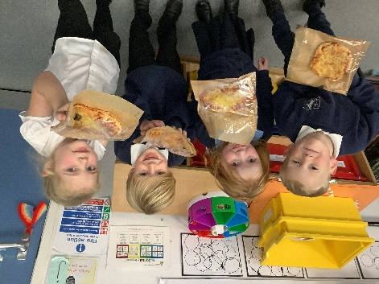
We then learnt how to cut using a knife and chopped up some mushrooms before also using a rolling pin to roll out our own dough ready for our own pizzas. With a bit of sauce and a selection of tasty toppings added, the class ended up with a delightful selection of pizzas ready to take home and enjoy!

