Downham Market Cluster Cross Country Competition

Children in KS2 who achieved a top three place in our intra-competition attended the annual cluster cross country competition which was held at Hillcrest Primary School in Downham Market on Wednesday 2nd November 2022. For the first time since the initial lockdown, all schools in the cluster were in attendance with a very high turnout of competitors.

There were girls’ and boys’ events for each year group with children in Years 3 and 4 completing 2 laps of the field and Years 5 and 5 completing 3 laps.

A top three finish resulted in a medal and a top ten finish allows the children to progress to the next level of competition which will be the area finals. Letters will be issued by the end of the week.
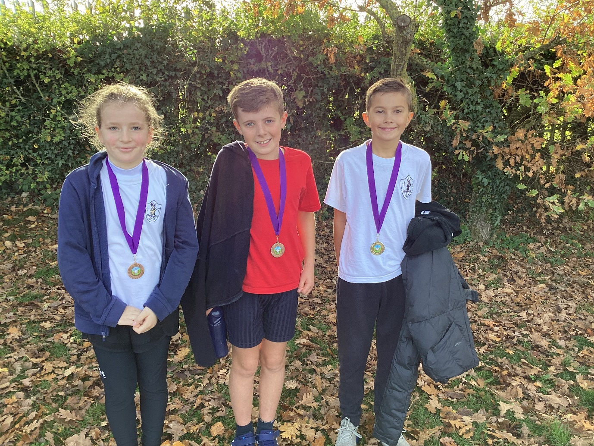

All of the children tried their very best. Our medallists were Mia in 3rd place for the Year 4 girls and Joshua-Jon 2nd place for Year 6 boys and Theo Ratcliff right on his heels in 3rd place.

Other top ten finishers and qualifiers were Lorelei (Y3 girls), Max (Y4 Boys), Emie (Y5 girls), Sonny (Y5 boys), and Brooke (Y6 girls).

Well done to everyone who took part.



