Denver Primary Cross Country Intra-festival
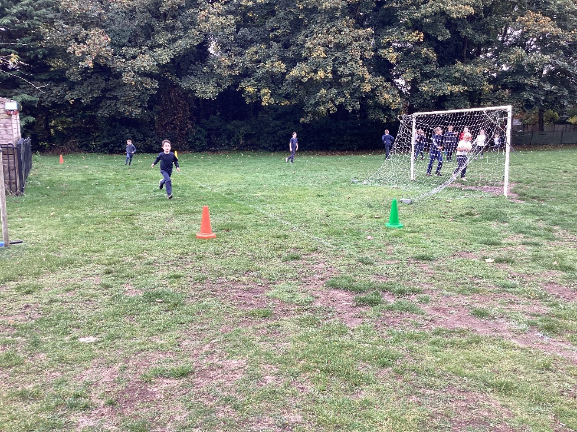
For the first time, children from Key Stage 1 were invited to join in with our annual cross country intra-tournament which took place on the final Friday afternoon of the half term.

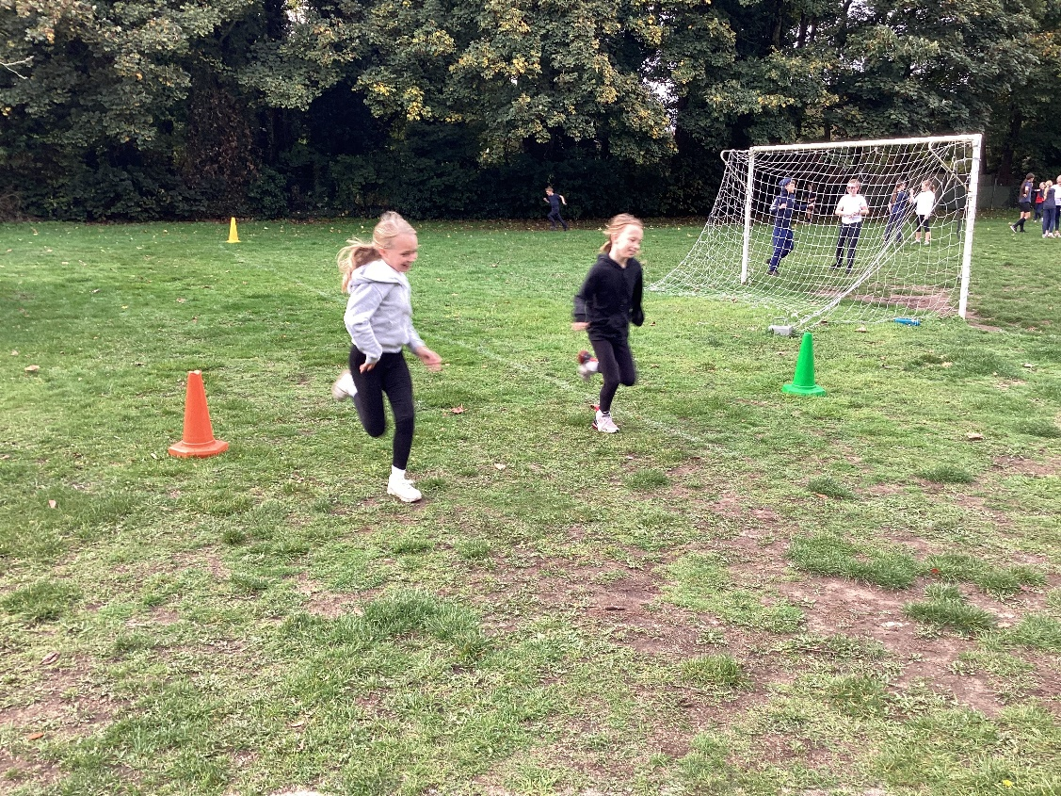
Children raced in their year groups laps of the Golden Mile track with years 1 and 2 running 2 laps, year 3s running 3 laps, year 4s running 4 laps and years 5 and 6 running 5 laps. All laps counted towards their individual Golden Mile tallies.
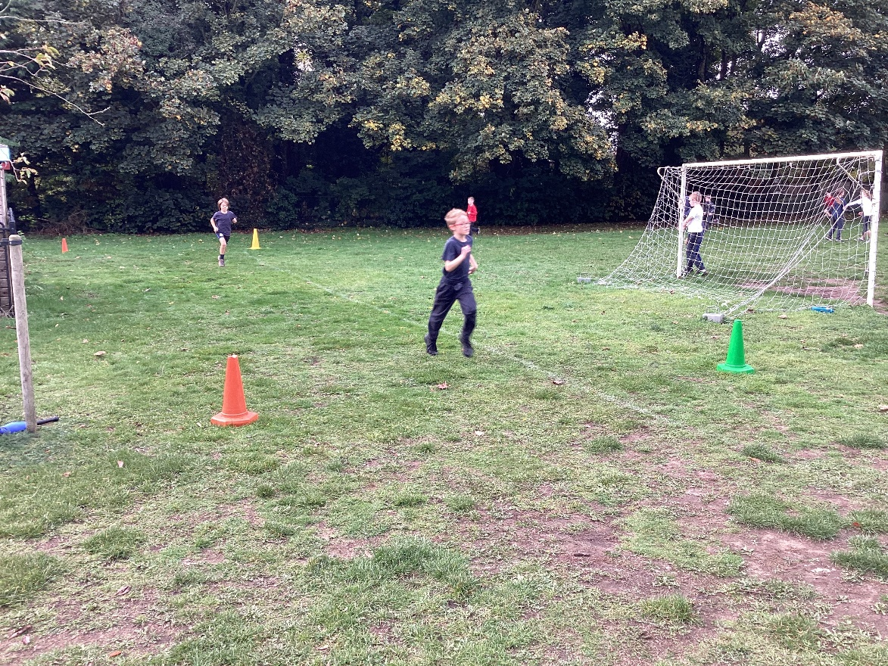
Everyone was very encouraging of each other resulting in a successful event.
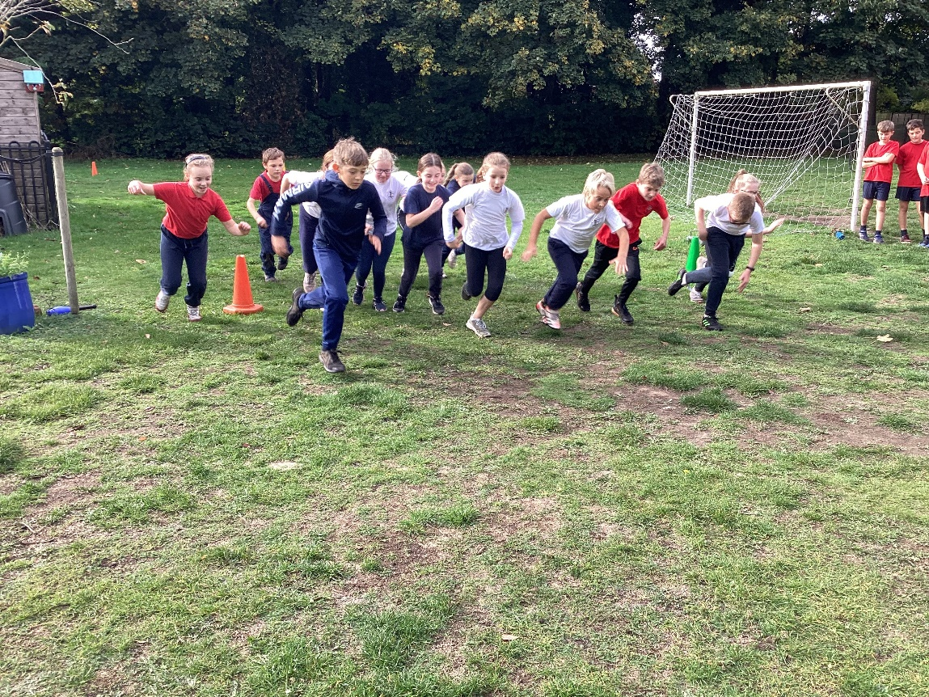

Children in Key Stage 2 with a top three finish progressed to the cluster cross country tournament which will take place on Wednesday 2nd November.

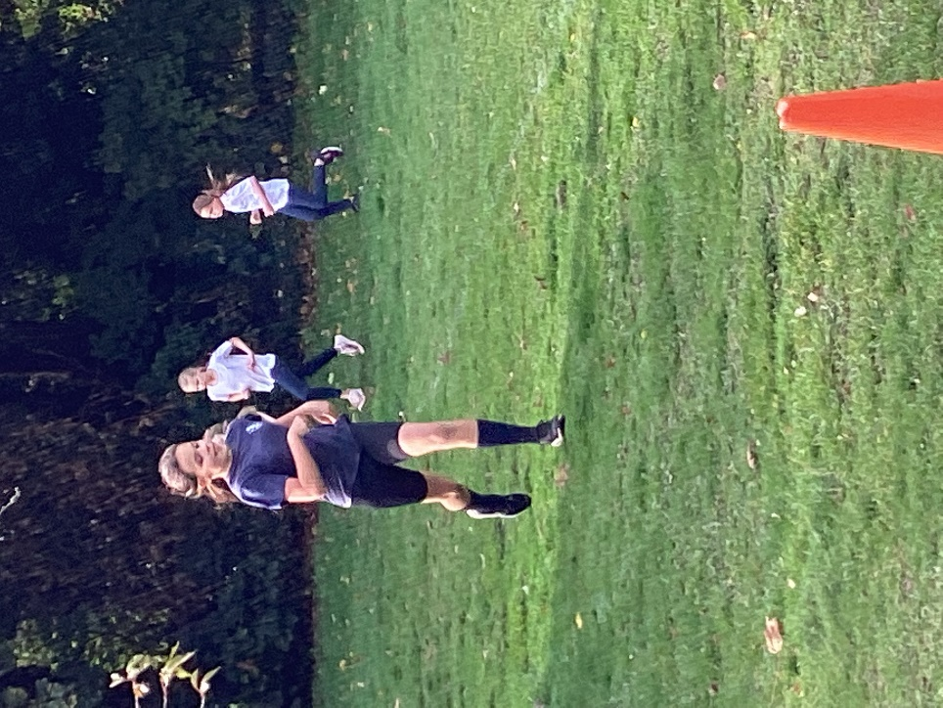
These are the results of the afternoon:
Year Group | First 3 boys | First 3 girls
1 | Monty  Raife  Oliver | Rebekah  Ottilie  Lily
2 | Charlie  Hugo  Matthew L | Evie  Lauren  Octavia
3 | Arthur  Flynn  Rowan | Lorelei  Lyla  Esther
4 | Max  Alfie Cl  Eric | Amelia  Rosie  Hope
5 | Sonny  William  Finley | Ella-Rose  Mia  Emie
6 | Theo  Edward  Riley | Evie  Kayla  Brooke



