Class 1 Dodgeball
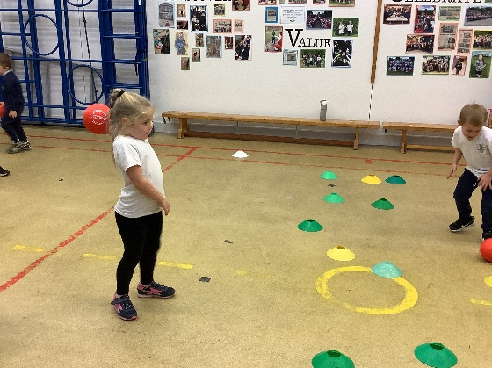
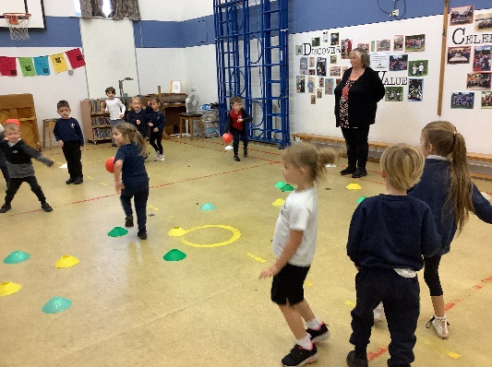

Class 1 got the chance to have a go at dodgeball today. Mr Smith showed us lots of fun dodgeball games which we could play and we loved trying them all! There was some lovely teamwork on show alongside the children practicing their gross motor skills in throwing and dodging.

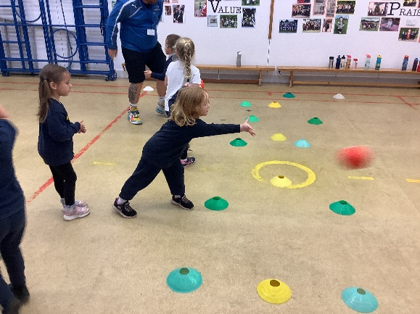
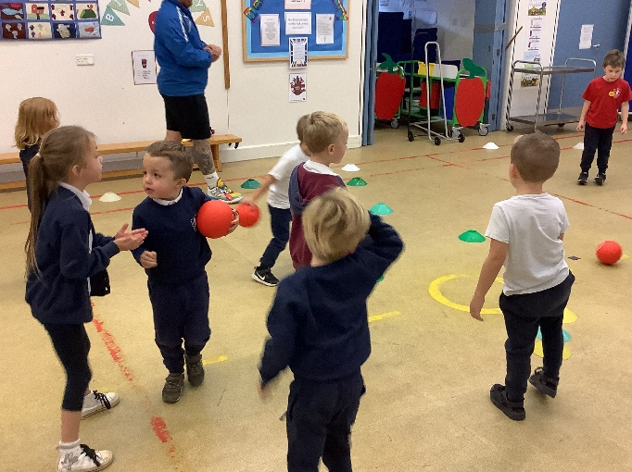
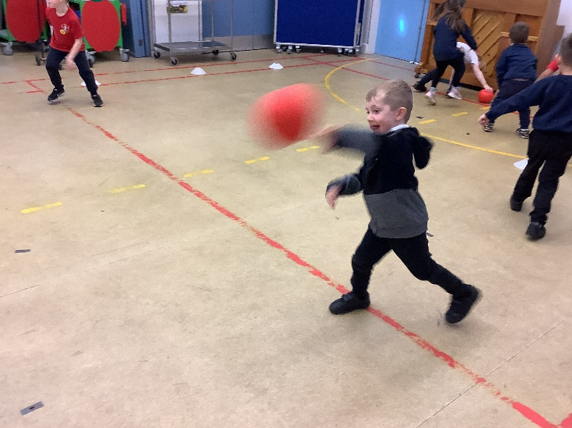
Thank you again to Mr Smith for coming in to provide the opportunity for the class as we all had a fantastic time!

