Bikeability Levels 1 and 2 training for Year 5 children
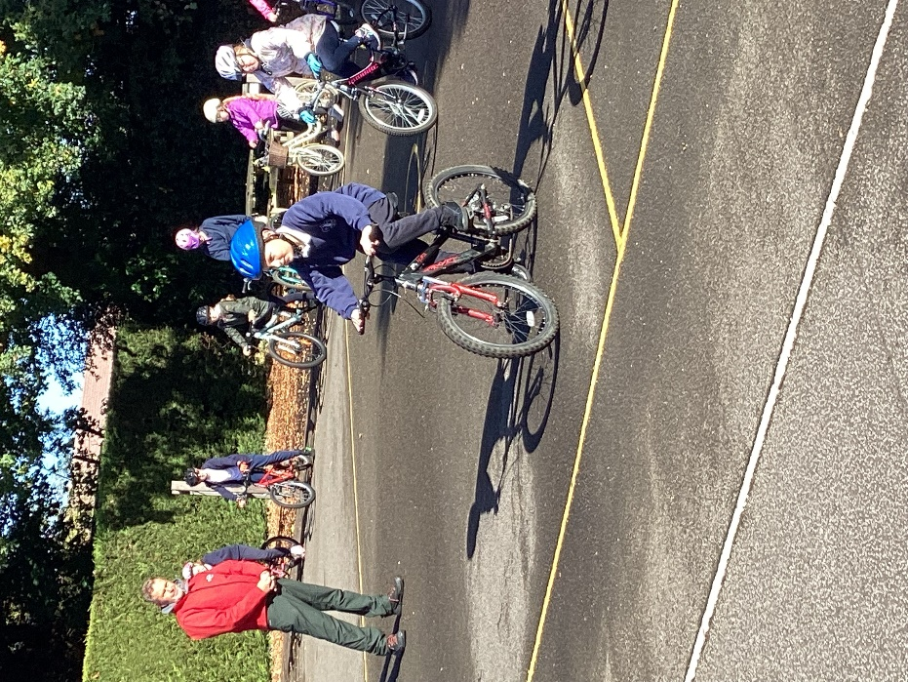
How fortunate we were to have been blessed with a week of autumn sunshine for our annual Year 5 Bikeability training!
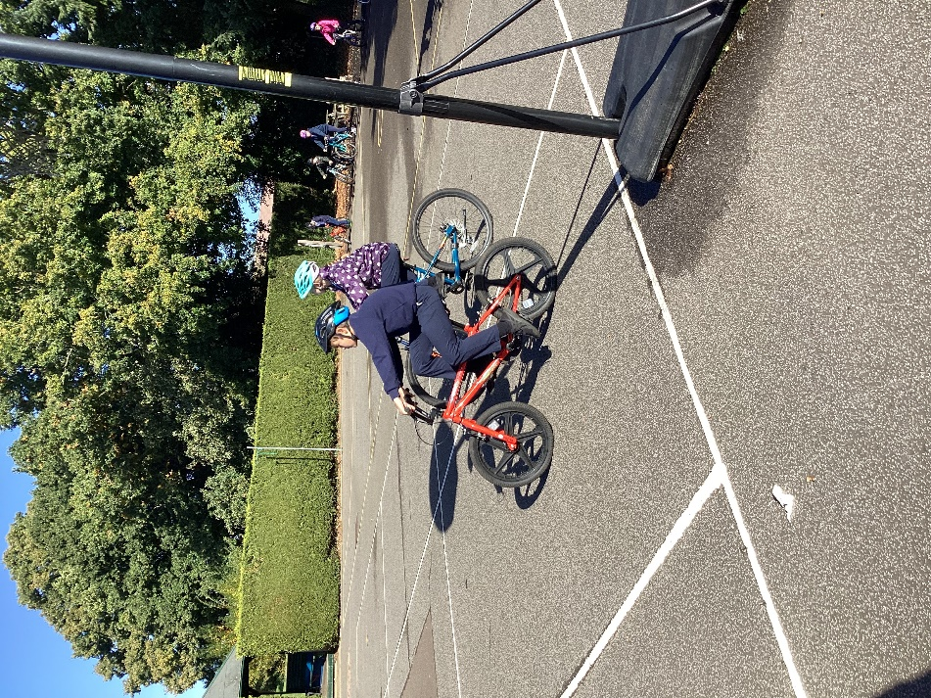
Instructors from Outspoken Training arrived on Monday 10th October for a four day course to train the children in being safe to cycle on the roads.
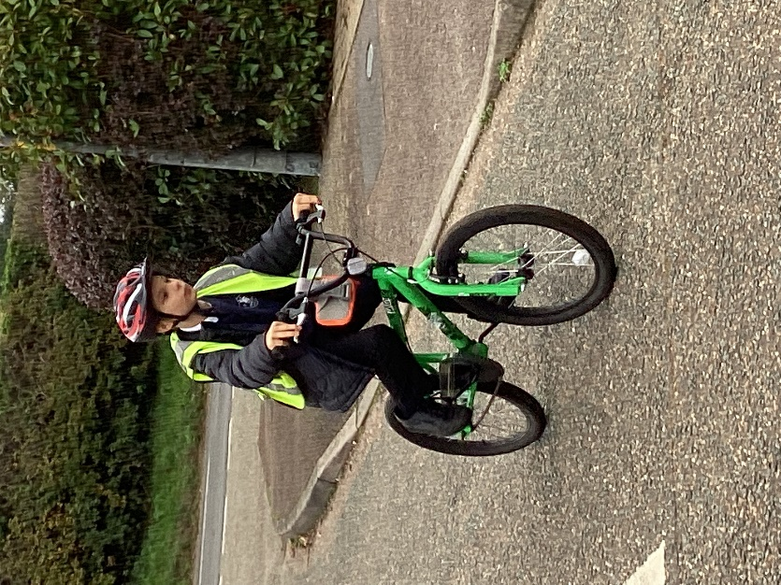

The training began with onsite Level 1 training which involved understanding how to check whether your bike is roadworthy as well as how to make signals and a number of manoeuvres to avoid obstacles.
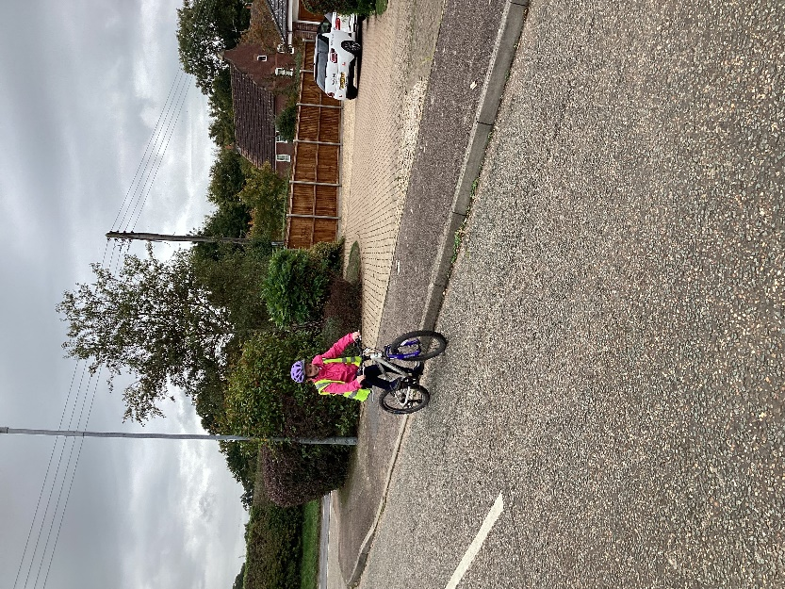

Days two to four were spent out on the public roads developing their initial training with increasing confidence, pace and technicality. This was to help them to attain Level 2 in Bikeability cycle proficiency training.
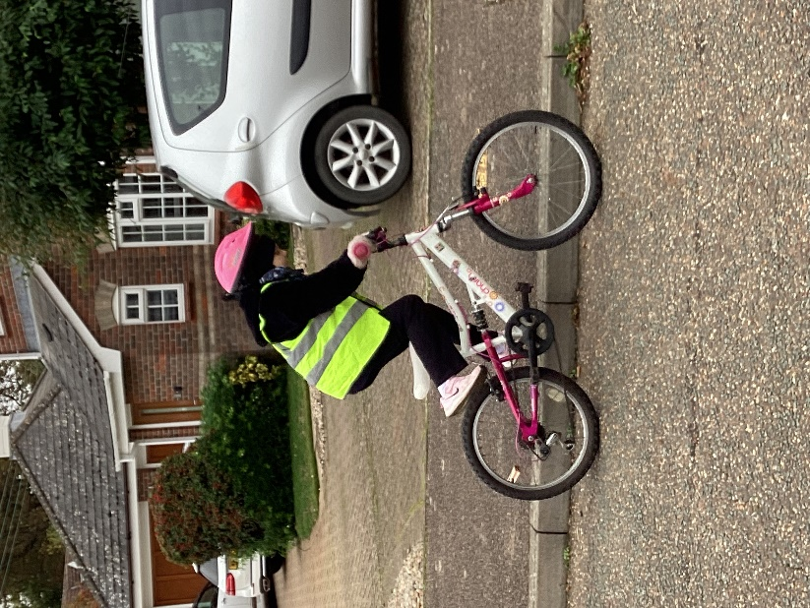

The children made excellent progress, impressing the instructors. We are also very proud of the children for how well they conducted themselves earning rich praise from our visiting guests.
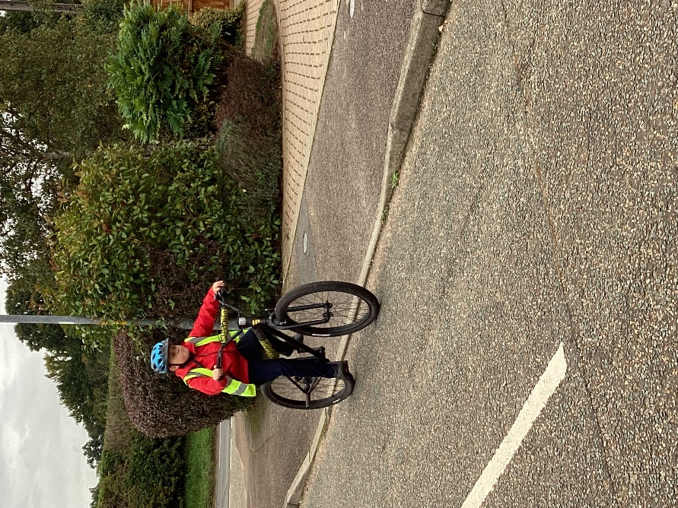

We are also very thankful to Miss Waters and Mrs Dawson for taking their time to be with the children to ensure their safety.


