KS2 Rounders Intra-Festival Friday 15th July
On a beautiful morning, Classes 3 and 4 joined together to enjoy a rounders festival.
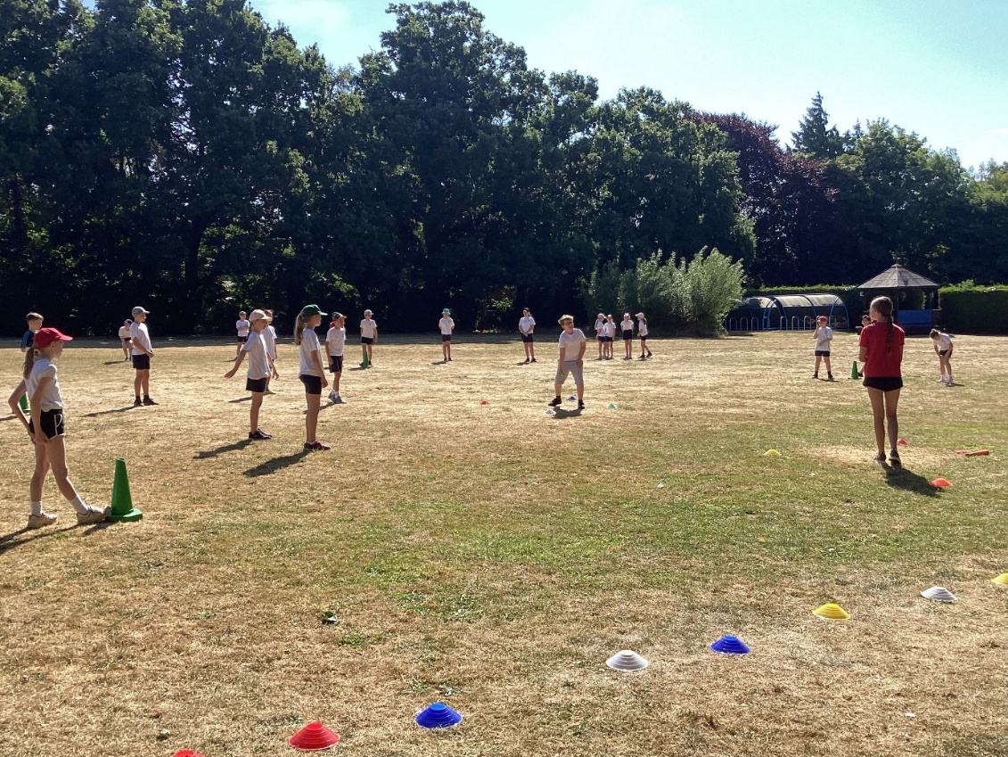
The children were competing in their house teams.
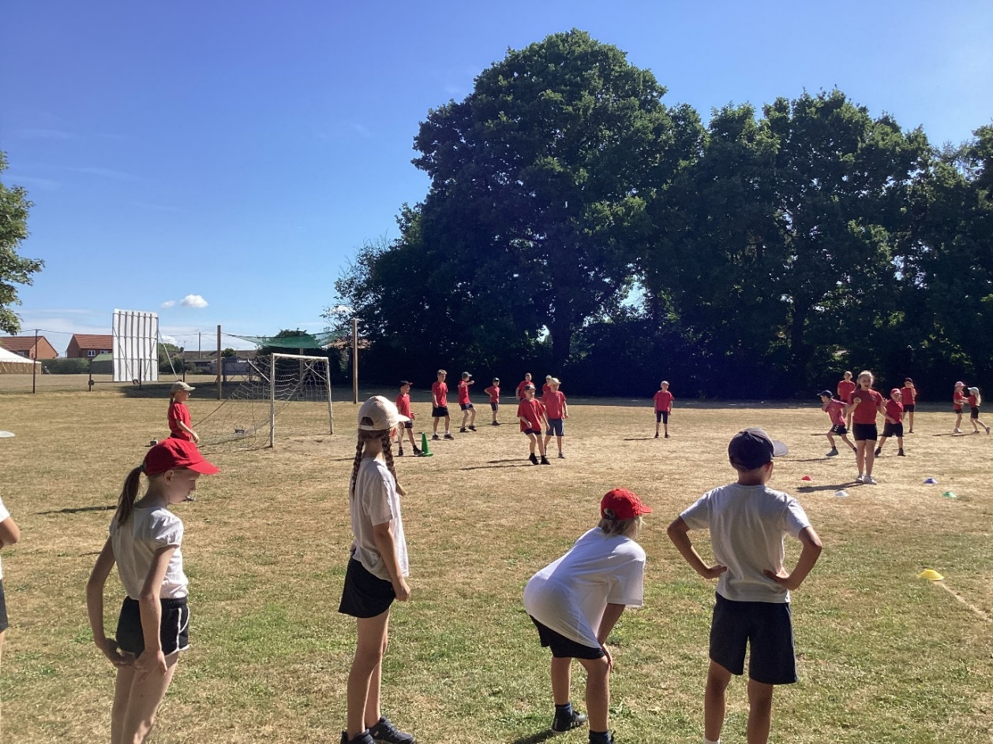
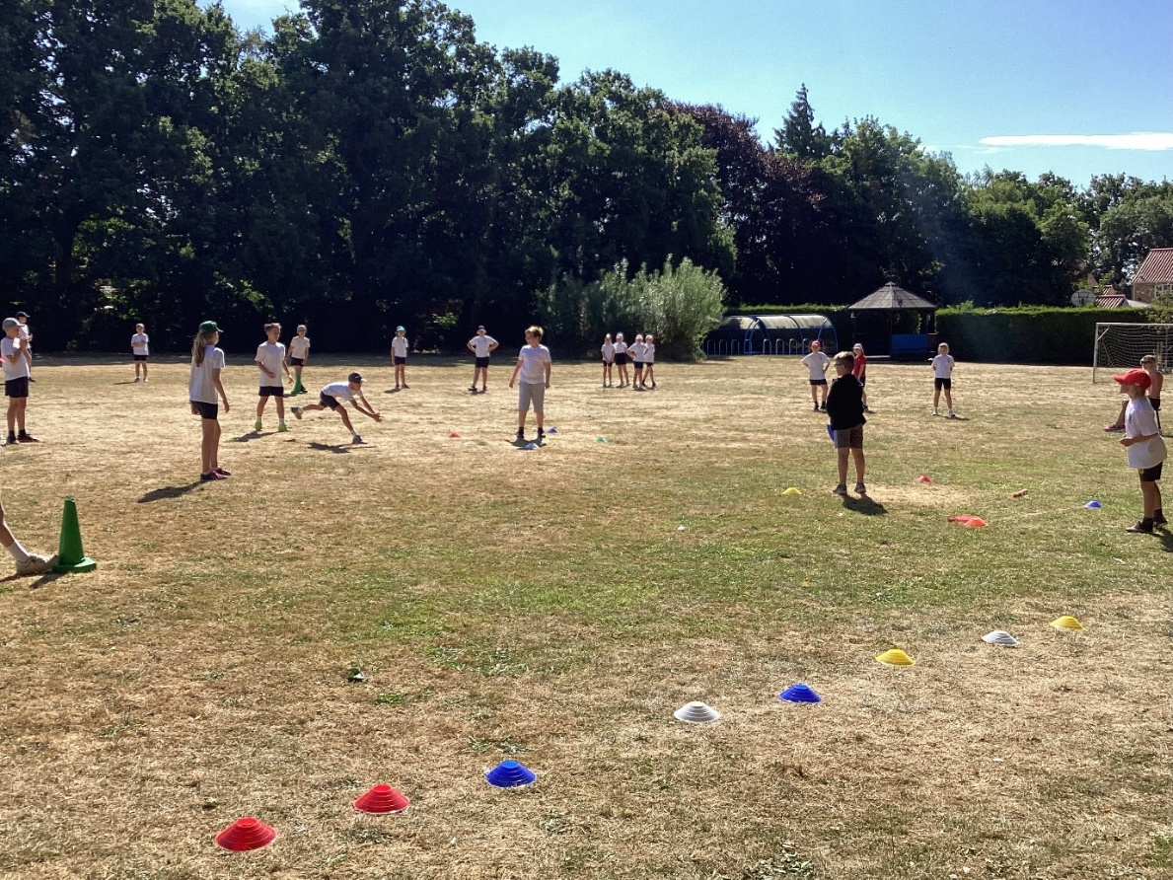
Each of the three teams batted and fielded against each other.
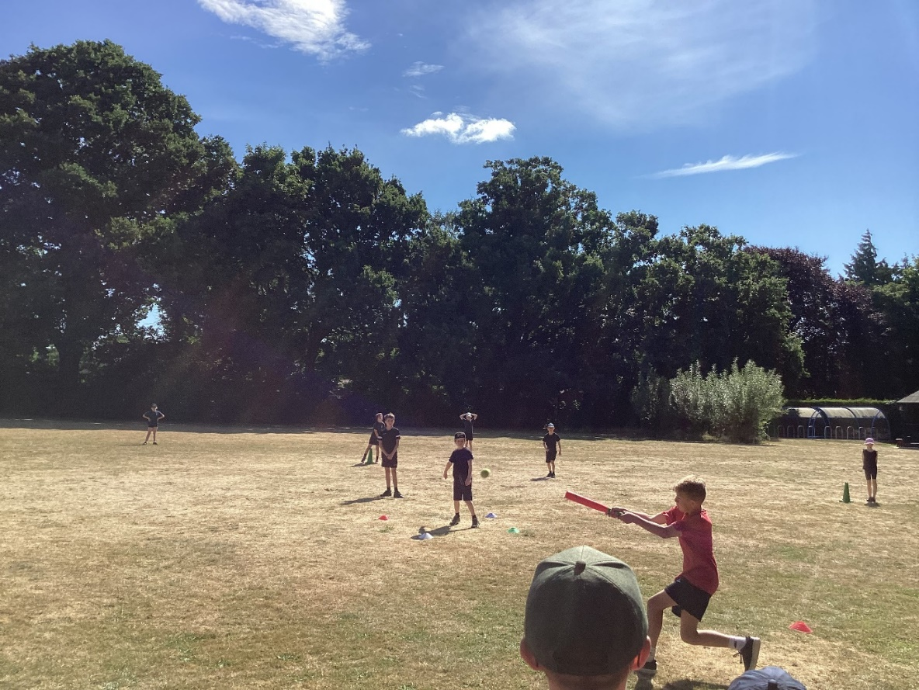
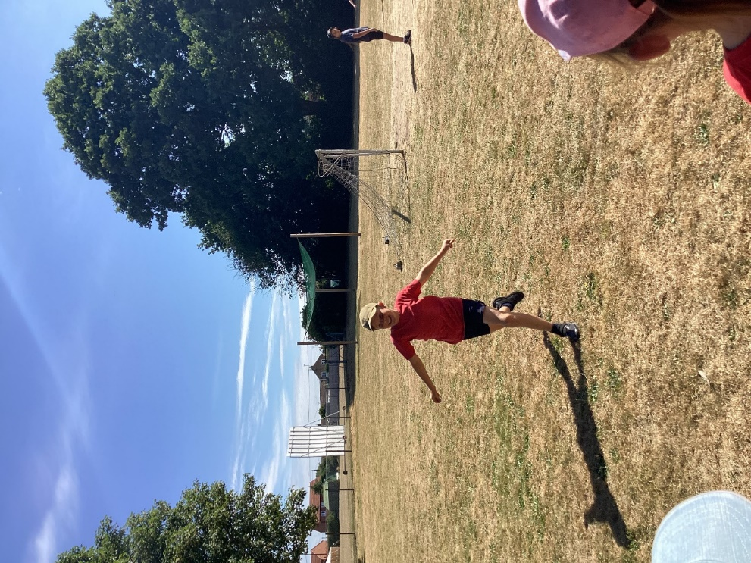

In the end White team were the winners with 2 wins, Red team scored one win and Blue team none. All teams were very sporting and it was an enjoyable morning.



