Dodgeball taster
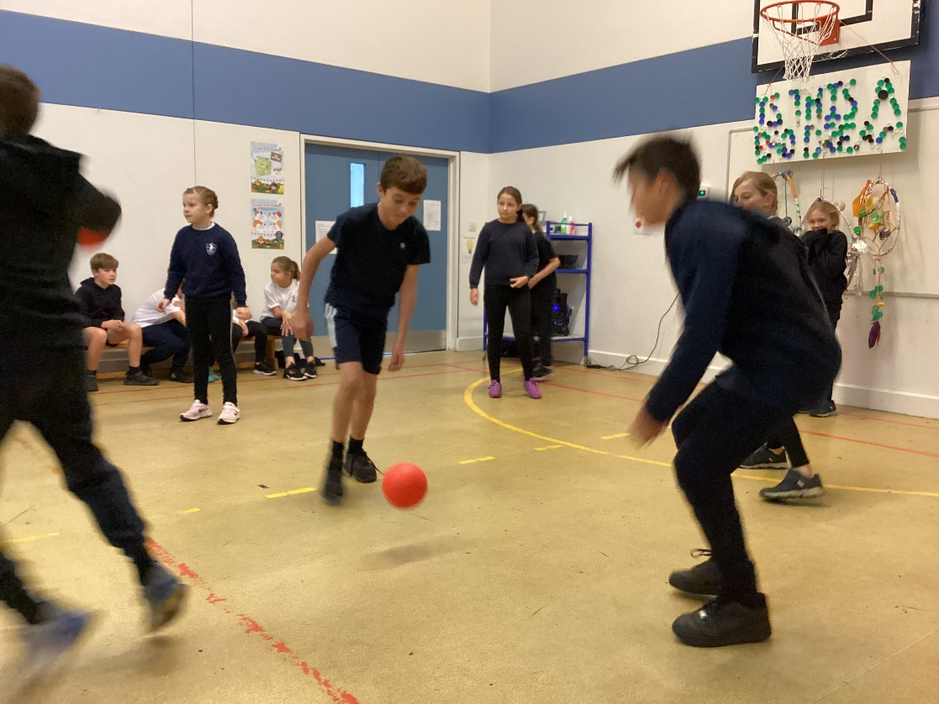
Today (Friday 30th September) we were joined by Ryan from Wereham Dodgeball for a free taster session to enrich our community links and our learning in games.
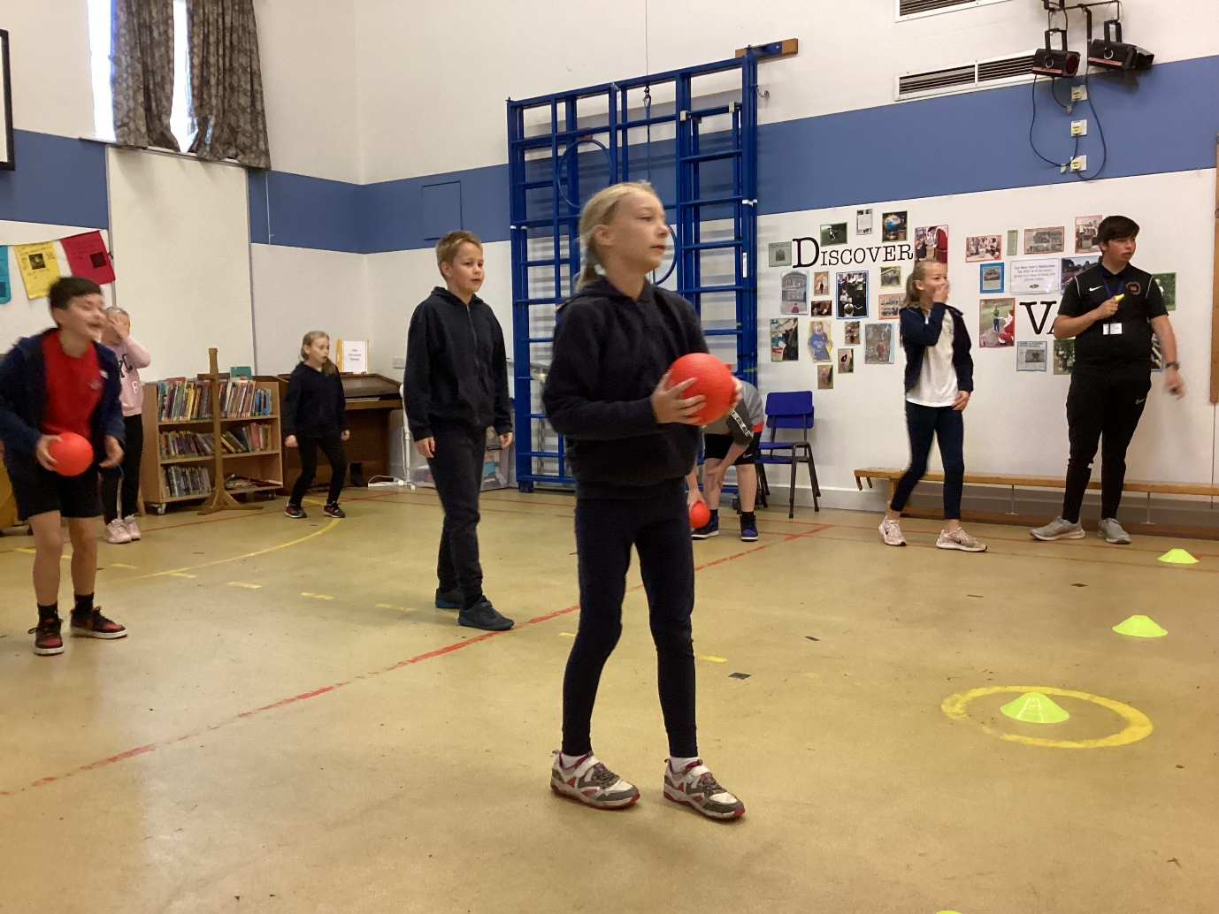
Ryan taught us a range of tactics that we then applied in a succession of fast-paced, energetic and 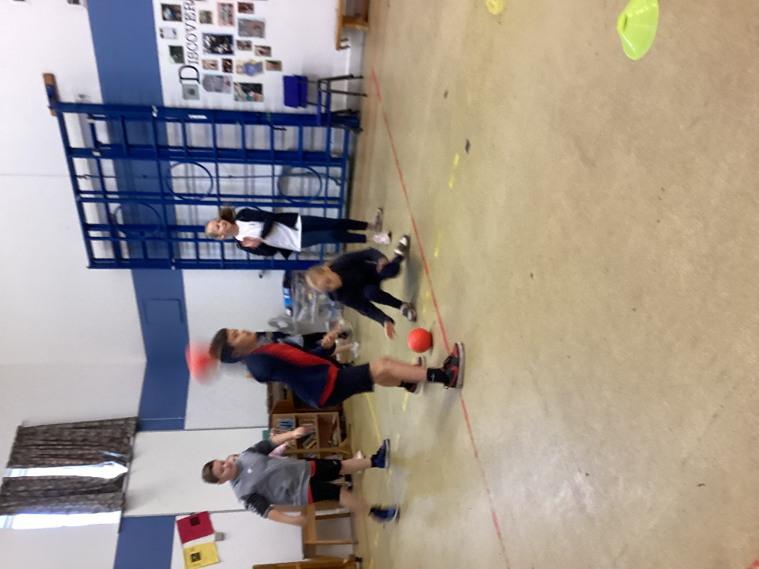
exciting games.

Many of our children are already members of Wereham Dodgeball group and, as a result of today, many more are keen to sign up.

