Fitness tracker return
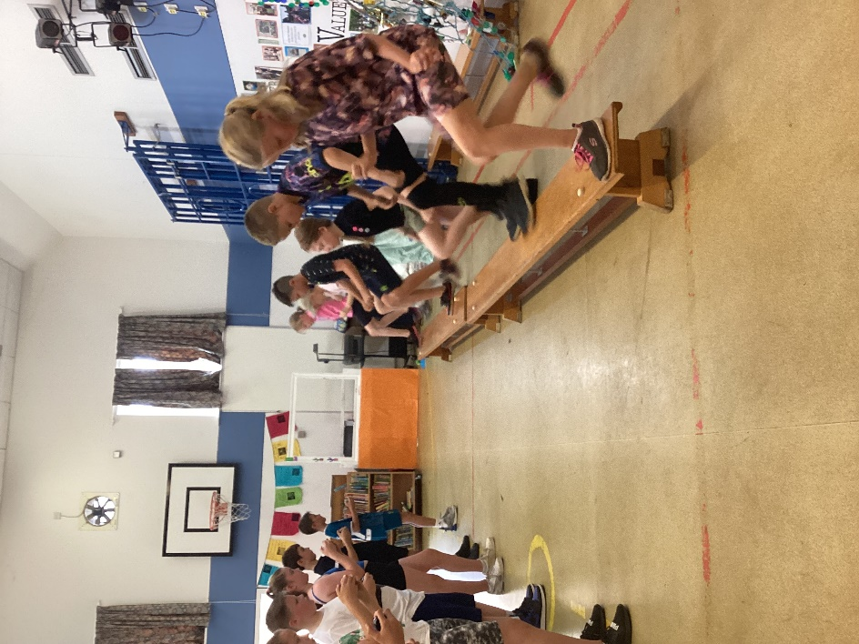
On Tuesday 12th July, Gary Hawkins from West Norfolk School Sports Partnership returned to track the progress of KS2 children against their fundamental sports skills: flexibility, coordination, jumping, throwing, stamina and endurance.
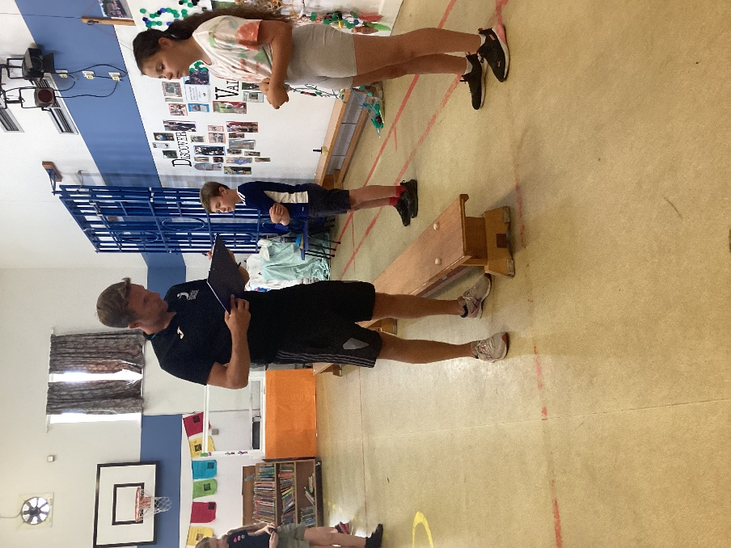
The children had been assessed earlier in the year and given specific targets and ideas for training that would improve their overall fitness.
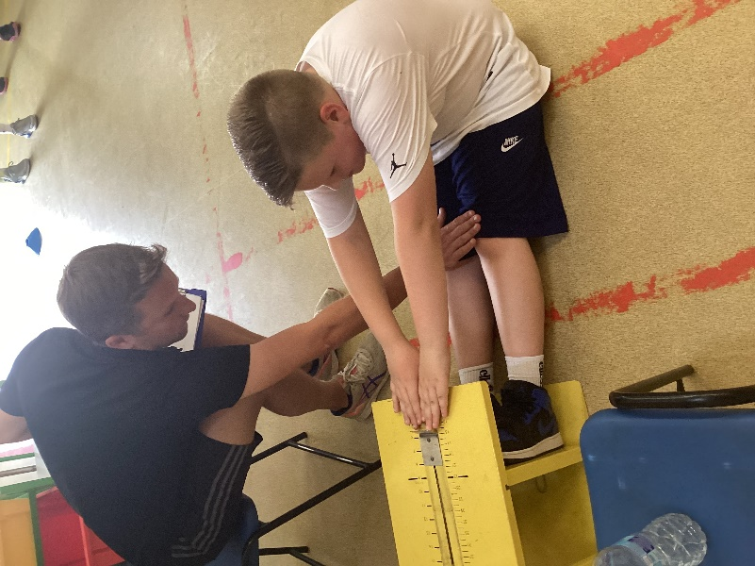
The weather was not on our side with very high temperatures and humidity and some of the year 6 children were on transition visits. However, some good progress was made, especially in Class 3.
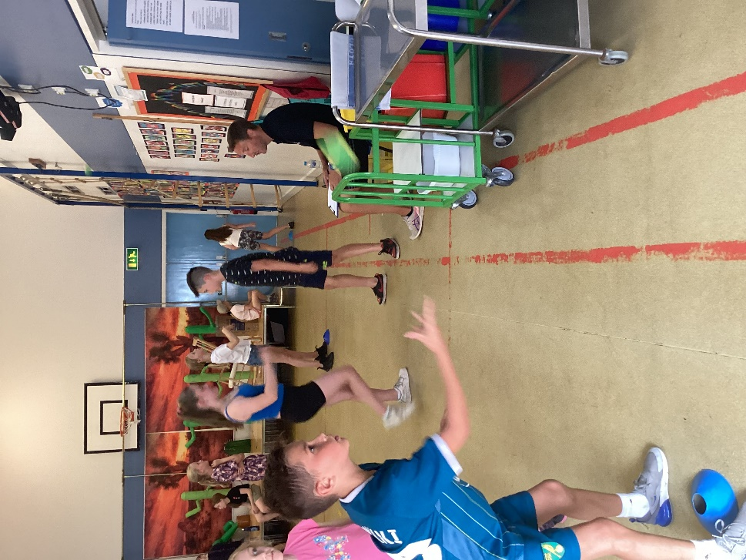
Full results will be given to the school soon which will help us to drive forward our provision next year.


