West Norfolk Dance Festival
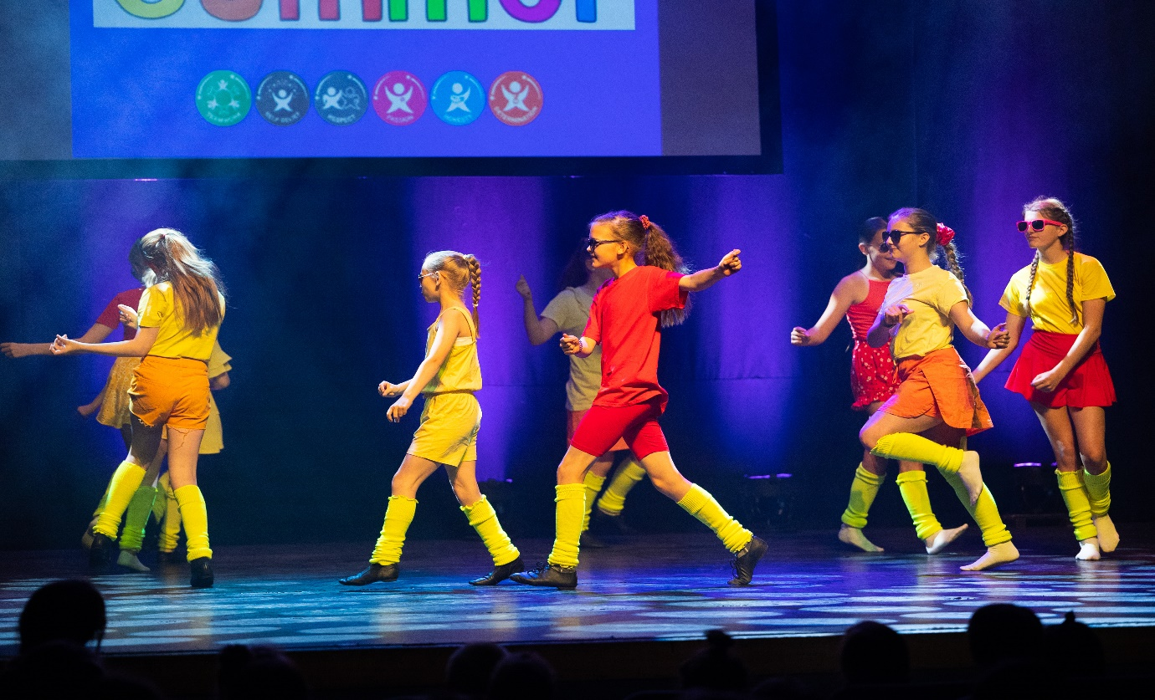
On Tuesday 5th July, our dance club travelled to King’s Lynn Corn Exchange to perform in the local dance festival.
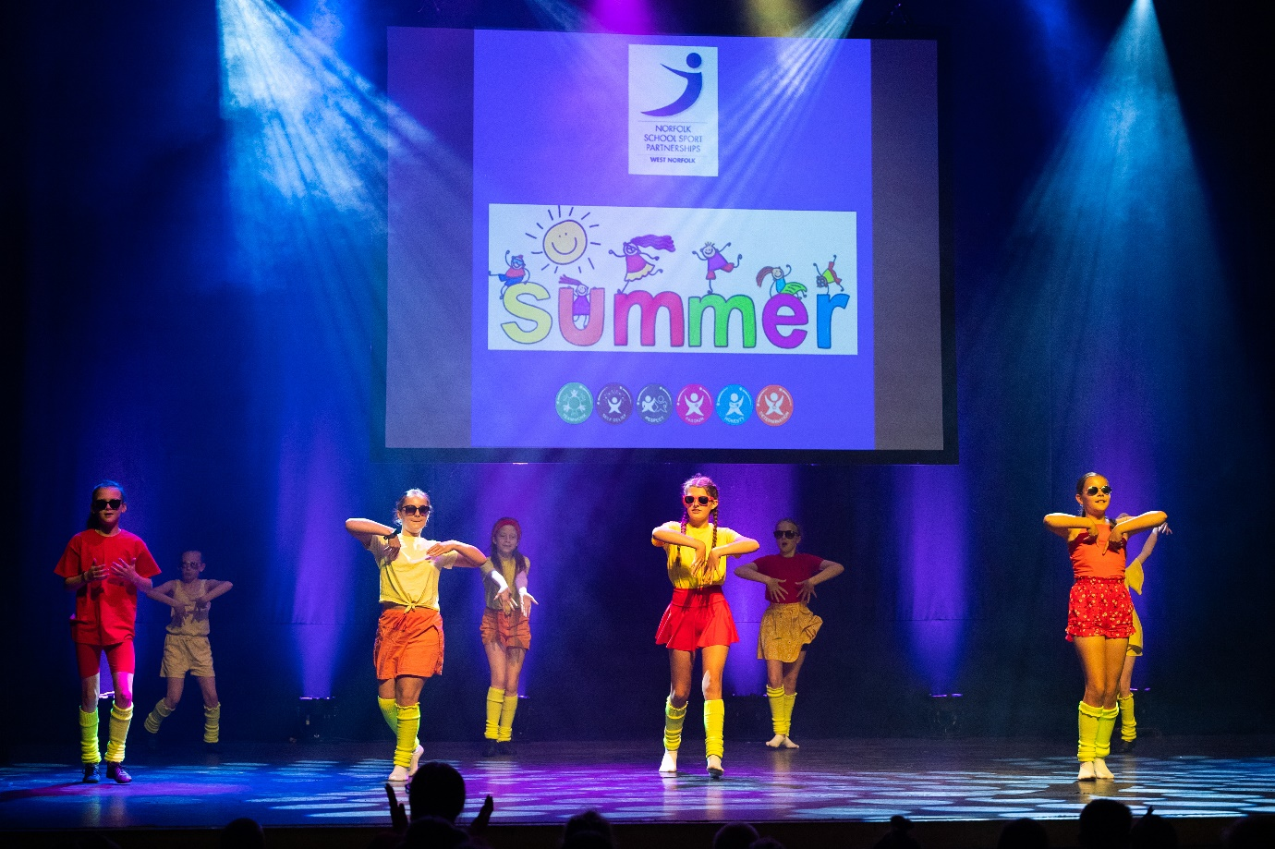

The event was well attended with many paying guests in the audience.
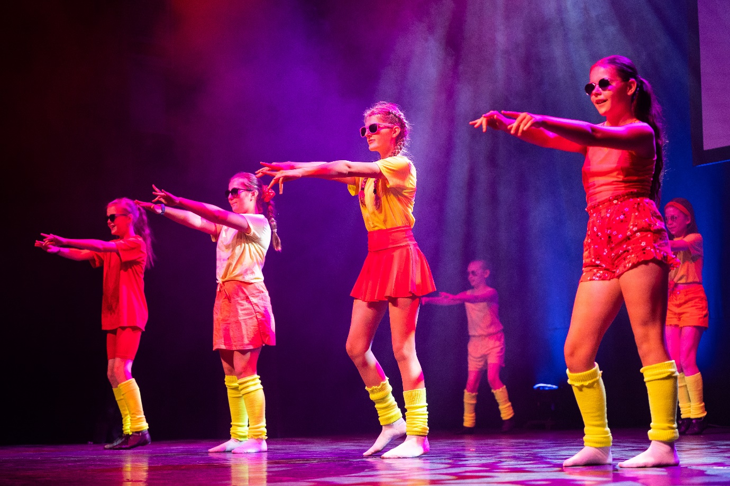
The show was a resounding success.
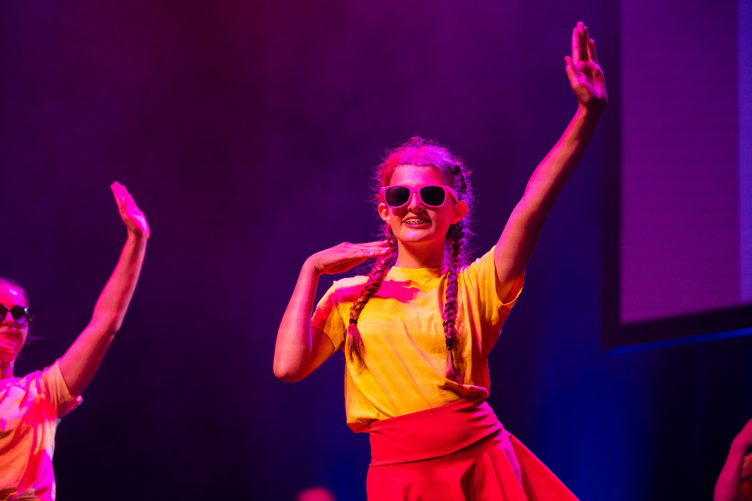Many thanks to Miss DeVanche and Miss Waters for running the club and preparing the girls.

